Datastore Communications Framework

Osprey DCS

Available for public release.

June 21, 2023

OSPREYDCS/TM-2023/002

Osprey Distributed Control Systems

DATASTORE COMMUNICATIONS FRAMEWORK: Version 1  
Network Communications, gRPC Implementation, and API Libraries

Author:

**Christopher K. Allen**

Date Published:

June 21, 2023

Prepared by

OSPREY DISTRIBUTED CONTROL SYSTEMS, LLC

304 Blue Heron Court

Ocean City, MD 21842-2452

Table of Contents

Table of Contents iii

Table of Figures viii

Preface ix

1 Introduction 1

1.1 Background 1

1.2 Communications 1

1.3 Organization 2

2 The Datastore 4

2.1 Architecture and Operation 5

2.1.1 Implementation 6

2.1.2 3rd Party Databases 6

2.1.3 Core Services 6

2.1.4 Synchronous and Asynchronous Communications 6

2.1.5 API Libraries 7

2.2 Data Archive 7

2.2.1 Time-Series Data 8

2.2.2 Metadata 8

2.3 Ingestion and Query Operations 9

2.3.1 Snapshots 9

2.3.2 Data Ingestion 9

2.3.3 Data Query 10

2.4 Code Repositories 10

2.4.1 gRPC Communications Framework 11

2.4.2 Datastore Core Services 11

2.4.3 API Libraries 11

2.4.4 Data Simulators 12

2.4.5 Project Configurations 12

3 Datastore Communications Framework 13

3.1 Remote Procedure Call and gRPC 13

3.2 Framework Overview 13

3.2.1 Streaming and Non-Streaming Operations 15

3.2.2 Clients 16

3.2.3 Datastore Services 16

3.2.4 Streaming and Asynchronous Communications 16

3.3 The datastore-grpc Project 17

3.3.1 Source Files 17

3.3.2 Generated Files 18

3.3.3 Language Options 18

3.4 Common MessageS Definitions 19

3.4.1 Protobuf Messages 19

3.4.2 Time-Series Data 20

Datum 20

Data 20

Timestamp 21

AggregatedData 21

3.4.3 Datastore Supported Types 21

Images 21

Arrays 22

Data Structures 22

3.4.4 Data Attributes 22

3.5 Common Messages Realization 22

3.5.1 Java gRPC Implementation 22

3.5.2 Message Classes 24

3.5.3 Message Interfaces 24

3.5.4 Message Builders 25

3.6 Ingestion Service Definition 26

3.6.1 Ingestion Service Interface 26

Provider Registration 27

Non-Streaming Ingestion 27

Streaming Ingestion 27

Sustained Ingestion 27

3.6.2 Ingestion Service Messages 28

Snapshot Data 28

Time References 29

Timestamp Iterators 30

Timestamp Lists 30

3.6.3 Warnings: General Ingestion 30

Snapshot Provider UIDs 30

Snapshot Timestamps 30

Data Sources and Data Providers 30

3.6.4 Warning: Ingestion Streaming and Time References 31

3.7 Ingestion Service Realization 32

3.7.1 Java Implementation 33

3.7.2 Ingestion Service Interface 33

3.7.3 Client Communications 33

Channel Creation 33

Non-Streaming Communication 34

Callback Communication 35

Streaming Communication 35

Warning 36

3.7.4 Service Communications 36

3.8 Query Service Definition 38

3.8.1 Query Service Interface 39

Metadata Requests 39

Attribute Names Requests 40

Time-Series Data Requests 40

3.8.2 Query Service Messages 41

3.8.3 Snapshot Metadata 41

Snapshot Metadata Results 42

Snapshot Metadata Requests 42

Timestamp Clauses 43

3.8.4 PV Metadata 44

PV Metadata Results 44

PV Metadata Requests 45

PV Fields 45

3.8.5 Annotations Metadata 46

3.8.6 Time-Series Data 46

Time-Series Data Results 47

Non-Streaming Requests 48

Streaming Requests 48

Managed and Unmanaged Data Streams 49

Asynchronous Communication 49

3.9 Query Service Realization 49

3.9.1 Java Implementation 49

3.9.2 Query Service Interface 50

3.9.3 Client Communications 51

Channel Creation 51

Non-Streaming Communications 52

Callback Communications 52

Streaming Communications 53

3.9.4 Service Communications 55

4 Ingestion Service API Libraries 56

4.1 Native Java API 57

4.1.1 Diagram Shorthand 58

4.1.2 Connection Factory 58

4.1.3 Ingestion Operations 58

Arguments 59

4.1.4 Snapshot Data 59

Timestamps 59

Time-Series Data 60

Snapshot Attributes 60

Alarm Conditions 61

4.1.5 Non-Streaming Ingestion 61

4.1.6 Streaming Ingestion 61

4.1.7 Warning: Ingestion Streaming and Timestamp Lists 63

4.2 Data Frame API 63

4.2.1 Ingestion Operations 63

4.2.2 Connection Factory 64

4.2.3 Snapshot Data 65

4.2.4 Provider Registration 65

4.2.5 Non-Streaming Ingestion 66

4.2.6 Streaming Ingestion 66

4.2.7 Warning: Ingestion Streams and Timestamp Lists 68

4.2.8 Warning: Ingestion Interface Shutdowns 68

5 Query Service API Libraries 69

5.1 General-Purpose Query API 69

5.1.1 Connection Factory 70

5.1.2 Metadata Requests 70

Snapshot Metadata 70

PV Metadata 71

Annotations Metadata 71

5.1.3 Time-Series Requests 72

Time-Series Data 72

Non-Streaming Requests 72

Streaming Requests 73

5.2 Data Science API 73

5.2.1 Connection Factory 75

5.2.2 Metadata Requests 75

Snapshot Metadata 75

Snapshot Request Builder 76

5.2.3 Time-Series Data Requests 77

Time-Series Request Results 77

Time-Series Request Builders 78

Non-Streaming Requests 78

Streaming Requests 78

6 References 80

APPENDIX A Datastore Query Language A-1

A.1 SELECT Clause A-1

A.1.1 Data Sources and Properties A-1

A.1.2 Regular Expressions A-1

A.2 WHERE Clause A-2

A.2.1 Time Predicate A-2

A.3 DQL Examples A-3

APPENDIX B API Connection Factories B-4

APPENDIX C Grpc and Protocol Buffers C-6

C.1 Protobuf gRPC Implementation C-7

C.1.1 Clients C-7

C.1.2 Services C-7

C.1.3 gRPC Resources C-8

C.1.4 Streaming and Non-Streaming Operations C-8

C.1.5 Synchronous and Asynchronous Communications C-9

C.2 The Protobuf Language C-9

C.3 Protocol Buffers Implementation C-12

C.3.1 Command Line Compiler C-13

C.3.2 Python Compilation C-14

C.3.3 Java Compilation C-14

C.3.4 C++ Compilation C-15

C.4 Python Implementation C-16

C.4.1 Messages C-16

C.4.2 Clients C-17

C.4.3 Services C-17

C.4.4 gRPC Resources C-19

Synchronous Communications C-19

Asynchronous Communications C-19

C.5 Java Implementation C-21

C.5.1 Messages C-21

Message Builders C-21

Message Interfaces C-21

Message Creation C-22

C.5.2 Clients C-23

Synchronous Communication C-24

Callback Communication C-24

Asynchronous Communication C-25

C.5.3 Services C-25

C.5.4 gRPC Resources C-26

Channels C-26

Servers C-27

Credentials C-28

C.6 C++ Implementation C-28

C.6.1 Messages C-28

C.6.2 Clients C-30

Channels C-30

Synchronous Communication C-31

Asynchronous Communication C-32

C.6.3 Services C-32

Synchronous Communication C-33

Asynchronous Communication C-33

Servers C-33

C.7 Summary C-35

Table of Figures

Figure 1: Datastore architecture, components, and relationships 5

Figure 2: Datastore Data Archive including time-series data and metadata 7

Figure 3: snapshots, time-series data, and queries 9

Figure 4: Datastore code repositories and project structure 10

Figure 5: Datastore communications framework implementation overview 14

Figure 6: common.proto - shared Datastore gRPC communications messages 19

Figure 7: common.proto – common messages protobuf implementation in Java 23

Figure 8: ingestion.proto - Datastore Ingestion Service gRPC communications framework 26

Figure 9: ingestion.proto - gRPC Ingestion Service interface realization in Java 32

Figure 10: query.proto - Datastore Query Service gRPC communications framework 38

Figure 11: snapshot metadata request timestamp clauses 43

Figure 12: query.proto - gRPC Query Service interface realization in Java 50

Figure 13: Ingestion Service API library supporting Java native types 57

Figure 14: Ingestion Service API library supporting data frames 64

Figure 15: general-purpose Query Service API library 69

Figure 16: data-science Query Service API library 74

Figure 17: data tables and data frames in datastore-admin project 77

Figure 18: general Datastore API connection factory B-4

Figure 19: gRPC communications C-7

Figure 20: proto example - CommonMessages.proto message and response definitions C-10

Figure 21: proto example - GenericService.proto service definition C-11

Figure 22: proto example - UML schematic C-12

Figure 23: proto example - directory structure C-13

Figure 24: proto example - CommonMessages.proto Python implementation C-16

Figure 25: proto example - GenericService.proto Python implementation C-18

Figure 26: proto example - Python gRPC channel and server resources C-20

Figure 27: proto example - CommonMessages.proto Java implementation C-22

Figure 28: proto example - GenericService.proto Java implementation C-24

Figure 29: proto example - GenericService.proto required gRPC resources C-27

Figure 30: proto example - CommonMessages.proto C++ Implementation C-29

Figure 31: proto example - GenericService.proto client C++ implementation C-31

Figure 32: proto example - GenericService.proto service C++ implementation C-34

Preface

Osprey DCS is developing full stack support and integration for machine learning and artificial intelligence applications applied to large particle accelerator and experimental physics facilities. The Datastore is a major component of this effort; it maintains an archive of correlated, time-series data and any associated metadata produced by the hosting facility. The communications framework used by the Datastore is described in this document.

The intent here is to provide comprehensive documentation the Datastore communications framework, in both its architecture and its operation. The text is also designed as a reference document for Datastore clients. Although presented as a narrative, extensive effort has been made to categorize each subject into subtopics wherever appropriate. Thus, the Table of Contents can be used as a general guide for locating reference material. Chapters are reasonably self-contained, references to other sections are provided as necessary. Additionally, topics are presented in a consistent fashion, to made lookups more straightforward.

As a reference document, material is provided for all forms of client communications with the Datastore. Diagrams contain concise operational descriptions while accompanying text is used to offer details. Chapter 3 contains a comprehensive description of direct, low-level communication with the Datastore core services. Alternative methods for Datastore communications are available through accompanying API libraries described in Chapters 4 and 5.

A brief description of the Datastore architecture and operations is provided within Chapter 2. The chapter is provided for the sake of completeness, to supply context for the ingestion and query operations available from the Datastore and referenced in the main body. The chapter also covers some common terminology used in the Datastore environment. Readers wanting familiarity with the Datastore can use this chapter as a concise summary. Readers already familiar with Datastore operations may wish to skip the chapter.

The main body concludes with descriptions of the available API libraries for high-level communications with the Datastore. These libraries isolate Datastore clients from the details of the low-level communications framework, at least to varying degrees. There are currently four API libraries in total, two for data ingestion operations and two for search query operations. There are additional libraries planned for future development as need dictates.

Some supplemental material is also provided in the appendices. For example, a description of the Datastore Query Language, or DQL, is contained in an appendix. Familiarity with this language is required to formulate Datastore query statements and must be used in the low-level communications framework. One extensive appendix contains information on the Protobuf and gRPC technologies. The Datastore communications framework is based upon the gRPC technology. Developers building low-level Datastore clients must be familiar with gRPC and the data serialization technology Protocol Buffers. The appendix is provided as both a quick start and a reference for gRPC resources commonly used in development, specifically for Python, Java, and C++ languages.

Instructions on installation and deployment of the Datastore system is beyond the scope of this document, nonetheless, code repository locations and descriptions are provided in the second chapter. The reader is assumed to have access to the Datastore source code, particularly the source code generated during the gRPC project build. However, the document body is complete enough so that a basic understanding is available without any direct inspection of the Datastore codebase.

The Unified Modeling Language (UML) is used almost exclusively within the narrative, rather than supplying direct source code listings. The author feels that UML provides a much more concise description of the underlying codebase, conserving space within the main body. UML also allows direct identification of roles, relationships, and associations with and between software objects, components, and constructs. These conventions help to clarify intensions behind code implementations and usage. Apologies to all who find inconvenience with the UML presentations.

# Introduction

## Background

The Datastore is a standalone system for maintaining correlated, time-series, heterogeneous data available from large particle accelerator facilities, large experimental physics facilities, and large industrial facilities. It provides services for data ingestion, data management, and broad query capabilities of the underlying data archive. The query services provided by the Datastore are oriented towards Artificial Intelligence and Machine Learning (AI/ML) applications. The intent is to provide a portable platform with a standardized interface facilitating rapid development of AI/ML-based applications for facility control, diagnosis, and optimization. With the addition of the Aggregator system which provides data acquisition, correlation, and aggregation, the Datastore is a subsystem of the larger Machine Learning Data Platform (MLDP). The MLDP is a system offering full-stack support for AI/ML application development, from front-end signal acquisition to back-end storage and retrieval. However, the front-end Aggregator system requires deployment within the Experimental Physics and Industrial Control System (EPICS, [1]), while the Datastore is an independent and standalone system.

This document provides a comprehensive description of the Datastore communications framework. It is also a guide for both client types: *data providers*, those storing data within the archive, and *data consumers*, those querying the data archive. The breadth of coverage is from the Remote Procedure Call (RPC) interfaces used for low-level communications with the Datastore core services, to the high-level programming-language Applications Programming Interface (API) libraries available for the Datastore (of which there are currently four). To date, all high-level API libraries are built for the Java programming language, however, an additional Python language query API library is planned for development; one supporting the Pandas library popular in data science applications (e.g., see [2]).

The Datastore is implemented almost exclusively in the Java programming language. It utilizes some third-party resources and technologies that one must be aware of for installation and deployment, which is beyond the current scope. Installation instructions are available elsewhere, including the Datastore repositories discussed in the next chapter. Although the Datastore is Java based, low-level RPC communications are platform and language independent. High-level language communications support is through the available API libraries mentioned above, and should broaden in future releases according to demand.

## Communications

The Datastore communications framework is based upon gRPC technology [3]. This communications technology is a programming language-independent, platform-independent framework for defining and performing remote procedure calls over computer networks. The data serialization for Datastore network communications is performed by Protocol Buffers. Protocol Buffers is a programming language neutral technology for defining remote procedure calls and their data message arguments [4]. Protocol Buffers, or “*protobuf*”, directly supports gRPC (and vice-versa), providing a meta-programming language for defining data structures and remote procedures that can be compiled into standard programming languages utilizing gRPC. All external communications with the Datastore are supported with gRPC transport and are defined using Protocol Buffers meta language.

The gRPC network communications framework is a Remote Procedure Call (RPC) implementation that utilizes HTTP/2 as the underlying transport mechanism. Data serialization for gRPC is managed by the programing language source code generated by Protocol Buffers. The remote procedure calls and the structured data that can be exchanged are defined in the proto meta programming language. Thus, the external communications protocol used by the Datastore core services are defined in the proto language and covered in detail within Chapter 3. There are separate interfaces for the Datastore ingestion operations and query operations.

Clients, both data providers and data consumers, can communicate with Datastore core services directly through the proto defined gRPC interfaces. Alternatively, providers and consumers may use one of the available high-level API libraries described in subsequent chapters. Currently there are two API libraries for the ingestion operations and two API libraries for query operations. Each library offers clients a different perspective on the Datastore. For data ingestion there is a lower-level API library supporting Java native types and a higher-level library supporting ingestion based upon the EPICS NTTable normative data type. On the query side, a lower-level API is available for clients familiar with the Datastore Query Language (DQL), the native query language for the Datastore. DQL is an SQL-like query language and is described in APPENDIX A. A higher-level, data-scienced oriented API library is also available. It provides query builders for constructing the underlying DQL query statement and yields results in the form of data tables; no familiarity with DQL is required. Note that the Datastore is the primary interaction point with data scientists and machine learning applications through the query API libraries. Thus, both query libraries support broad search and query capabilities over the data archive.

There are multiple configuration parameters for the Datastore core services communications. Configuration parameters are available for setting various network connection properties such as timeout limits, compression protocols, binary/plain text transmission, etc. Some API libraries also have additional tuning parameters for data stream flow control. Configuration parameters are typically defined within the project repository properties files used for site configuration of builds, installation, and deployment. However, most parameters are also accessible through the Java virtual machine when services are launched, or they can be set as environment variables of the hosting platform. See the documentation within the Datastore repositories for the parameter descriptions and function. Subsection 2.4.5 also contains further information on service configuration.

## Organization

Chapter 2 contains an overview of the Datastore system. The coverage includes basic architecture, operation, and project structure. The overview serves to provide context for the communications framework and to establish some terminology. A basic understanding of the Datastore architecture and operation also helps to facilitate understanding of the RPC communications interfaces. Readers already familiar with the Datastore may skip this chapter.

Chapter 3 describes the gRPC communications framework for the Datastore; it constitutes the main body of the presentation. The chapter begins with an overview of the general gRPC mechanism in the context of Datastore communications. It then began to document all the protobuf messages common to all Datastore operations in the next section. The gRPC interface and required messages for ingestion operations are covered in the next section, followed by those for query operations. Each section also contains a description of the protobuf resource realizations (i.e., the Protocol Buffers compiler output) in the Java programming language. The Java languages descriptions are relevant since the Datastore is implemented in Java; all Datastore projects utilize these communications resources.

Chapter 4 is a description of the available ingestion API libraries while Chapter 5 describes the available query API libraries. Datastore clients only interested in high-level communications should consult these chapters exclusively. Familiarity with Chapter 3 is not a requirement for these chapters, however, some familiarity with basic Datastore operations is helpful. Specific references to Chapter 3 sections are also provided whenever appropriate.

Supplementary material for the Datastore communications framework is included in the appendices. APPENDIX A is a concise explanation of the Datastore Query Language, or DQL. Knowledge of DQL is required to make time-series data requests from the Datastore when using direct communications through gRPC, or a low-level query API library. DQL also supports search and query operations for time-series data properties, such as alarm conditions, and some associated metadata. APPENDIX B contains an explanation for the “connection factories” used in the API libraries. Connection factories supply clients with the actual programming interfaces used to communicate with the Datastore. They also create all network connections and configurations with the Datastore.

Finally, APPENDIX C is offered as a basic primer on gRPC and Protocol Buffers; it describes the basic application of gRPC communications through a continuing example. The appendix also lists many of the online resources available for a more comprehensive understanding. Note that although any gRPC communications protocol may be uniquely defined in the protobuf meta language, the actual gRPC implementation varies greatly depending upon the programming language selected. Examples are provided for the Python, Java, and C++ programming languages.

# The Datastore

The Datastore system hosts the central archive of the Machine Learning Data Platform (MLDP). It is responsible for data archiving, archive management, and all search and query operations provided for the MLDP. Thus, it maintains the back end of the data stack providing the interface for Artificial Intelligence (AI), Machine Learning (ML), and general data science application development. It is a fully independent system hosted on a separate platform consisting of one or more server nodes. It has a distinct gRPC-based communication framework and protocol, independent of any EPICS transport protocols (e.g., Channel Access [5], pvAccess [6], etc.). Clients may communicate with the Datastore directly through the low-level gRPC interface or using an available Applications Programming Interface (API) library. The Datastore may be deployed at any facility so long as data providers conform to the gRPC ingestion interface, or an available ingestion API library.

The Datastore core is composed of a data archive and 2 core services: 1) an ingestion service front-end for data providers, and 2) a query service offering search and query operations for data consumers. Both services are independent and can be run simultaneously. Thus, the Datastore can simultaneously ingest incoming facility data and provide query services for the archived data. (There are some technical limitations concerning concurrent data availability of ingestion streams not discussed here; the result being that data is not query capable until ingestion processing has released.) Each service has a separate Remote Procedure Call (RPC) interface for low-level external communications. For high-level application development, API libraries are also available for each core service.

The Datastore maintains an archive of both time-series data and associated metadata. The metadata can be generated during ingestion by data providers or generated post-ingestion by data consumers. The Datastore Query Service offers search and query operations for archive time-series data, metadata, and combinations. Time-series data queries can be formulated in terms of associated metadata, or vice-versa. The Datastore supports archive annotations, which appear as metadata. The current Datastore release supports a limited annotation set, namely data attributes and named queries. In future releases, the intent is to provide full archive annotation capabilities which includes user notes, data associations, and post-acquisition calculations.

## Architecture and Operation

The Datastore core is composed of the following 3 primary components:

1. Data Archive: An archive of correlated, time-series data and associated metadata.
2. Ingestion Service: An independent service for ingesting and archiving data from data providers.
3. Query Service: An independent service providing broad search and query of the Data Archive.

The basic architecture of the Datastore is depicted in the component diagram of Figure 1. Within the diagram, the three components listed above are labeled Data Archive, Ingestion Service, and Query Service, respectively. Also shown in the diagram is that external interaction with the Datastore core services is available through independent API libraries. The library Ingestion API exposes the Ingestion Service to clients through the IIngestionService interface, while the library Query API exposes the Query Service to clients through the IQueryService interface. As previously mentioned, there are multiple API libraries available for both the Ingestion Service and the Query Service. All API libraries utilize the gRPC framework for communications with the Datastore core services. Regarding the diagram, the libraries Ingestion API and Query API and their respective interfaces are simply abstractions for the available concrete API libraries and interfaces. Specifics for the API libraries are covered in Chapters 4 and 5. Details on the Datastore gRPC communications framework are covered in Chapter 3.

Referring to Figure 1, the Data Archive is realized by an additional 3 sub-components: 1) a MongoDB NoSQL database, 2) an InfluxDB time-series database, and 3) the host file system (i.e., system files located on the host platform). As indicated in the diagram, metadata is maintained in the MongoDB database while the time-series data is maintained in both the InfluxDB database and the file system. For reasons of performance and manageability, raw data and images are stored as system files rather than data blocks within the InfluxDB database. The archive itself is managed by the two core services, Ingestion Service and Query Service. Both these services run through independent servers on the host platform. In the default configuration they are attached to ports 5001 and 5002 of the host servers, respectively (ports may be reassigned at build time or during service launch). Again, external communications with the core services are facilitated through the Datastore gRPC remote procedure call framework.

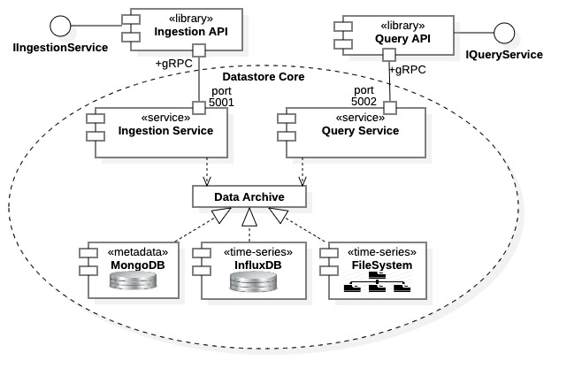

Figure 1: Datastore architecture, components, and relationships

### Implementation

The Datastore core is implemented almost exclusively in the Java programming language. The only exception being the Protocol Buffers meta-language for defining Remote Procedure Call (RPC) interfaces. Specifically, remote procedure calls and exchanged messages are defined in the proto meta-language. These definitions are then used to generate Java source code using the Protocol Buffers protoc compiler within the *datastore-grpc* project. More details are described below in Section 2.4.

Several third-party technologies and off-the-shelf components are used in the current Datastore implementation. The core implementation utilizes the Spring and Spring Boot Java application frameworks [7]. The core also requires two database services, MongoDB [8] and InfluxDB [9], both must be installed and available on the host platform network. All communications to the Datastore core are realized through the gRPC framework [3] and data serialization is managed through the Protocol Buffers technology [4]. Internal Datastore communications between the core services and the MongoDB and InfluxDB databases are via network sockets supported by the respective database APIs.

### 3rd Party Databases

A Datastore host platform must have the InfluxDB and MongoDB database services pre-installed. These databases may be hosted on separate servers, but they must be accessible within the host network. Moreover, the databases must be properly administered to provide access to the Datastore through user credentials. Specifically, the Datastore Ingestion and Query Services must have user credentials allowing read/write access to the InfluxDB and MongoDB databases. The Datastore administration library must have administrative access to both databases. Typically, the credentialling process is facilitated through the *application.yml* project properties file at build time, or host platform environment variables during service launch (see Subsection 2.4.5 below).

### Core Services

The Ingestion Service and Query Service run independently, although both have simultaneous access to the Data Archive. The services are typically built as self-contained shaded Java Archives (i.e., “fat jars”) that are launched with the Java Virtual Machine (VM). Each service is implemented separately with distinct Maven projects [10] within the Datastore code repository (see Subsection 2.4.2 below). Communications with these services may be performed directly through the gRPC interface or using one of the available API libraries. The gRPC communications framework contained within the *datastore-grpc* project must be installed on any server platform, see Subsection 2.4.1 below. Additionally, the core services must have network access to the InfluxDB and MongoDB database installations.

### Synchronous and Asynchronous Communications

The Datastore core can communicate either synchronously or asynchronously through the gRPC connections, for both ingestion and query operations. Synchronous communications are blocking communications; remote procedure calls are invoked and not released until all data is exchanged. Asynchronous communications are non-blocking, streaming operations, data exchange occurs through a data stream. Remote procedure calls establish the data stream then return before data exchange completes, or potentially even begins. Within the Java gRPC implementation all asynchronous communication is realized through data streaming, a specific mechanism within gRPC. Data streams between the client and service must be properly managed to maintain stream integrity, there are gRPC procedures and individual protocols of the core services that must be respected. The Datastore services support asynchronous data streaming, clients must implement proper threading for full asynchronous communication.

The advantage of synchronous communication is that it is straightforward and simple. It also avoids state and connection errors. However, it is slower, and size limited in data exchange over a single remote procedure call (default 4 Mbytes). Streaming operations are faster and essentially unlimited in size but runs the risk of overloading and data corruption through protocol or network errors. Asynchronous streaming is potentially the fastest communication method, depending upon context and concurrency.

### API Libraries

Again, as shown in Figure 1, external client communications to the Datastore core can be facilitated with high-level API libraries. Each available client library supports both synchronous and asynchronous communication. The API libraries isolate clients from the low-level gRPC communication used by the core. The platform hosting an API library must have the Datastore gRPC communications framework contained in project *datastore-grpc* installed locally, see Subsection 2.4.1 below for details on that project.

## Data Archive

Figure 2 provides a conceptual diagram of the Datastore Data Archive. From there we see that the Datastore maintains an archive of both time-series data and associated metadata. Internally, time-series data is generally archived by data type, however it is referenced by timestamp and data source (e.g., EPICS process variable). Thus, time-series data may be queried by time ranges and by data source (process variable) name. Additionally, it may be queried by any associated metadata properties, for example attributes provided by data providers or data sources. Metadata are archived as record sets with each record type being specific to the metadata type (see Figure 2). Thus, one must be familiar with all metadata types to formulate metadata query requests. Moreover, since time-series data may be queried by associated metadata, familiarity with supported metadata types and their corresponding record fields is further stressed.

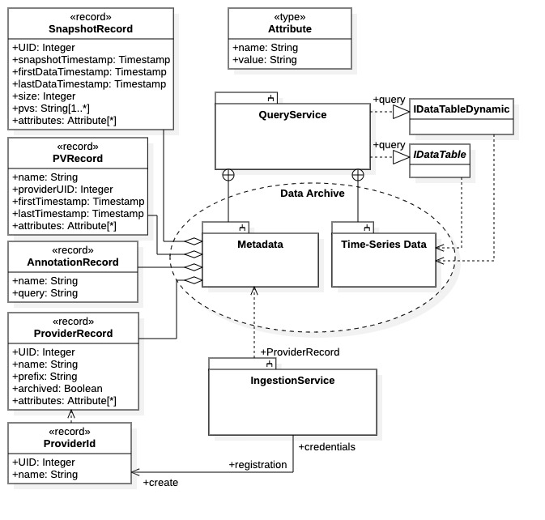

Figure 2: Datastore Data Archive including time-series data and metadata

Figure 2 provides a particular emphasis on the metadata archive. However, the figure also depicts two types of time-series data requests, both offered by the data-science query API library. There, request results are returned data tables; the IDataTable object being the response from a synchronous request and the IDataTableDynamic object being the response from an asynchronous, streaming request. Each query API library provides a different query mechanism producing different query results. However, all time-series data requests may be executed uniformly using the Datastore Query Language (DQL) described in APPENDIX A. This is the only query mechanism available when directly communicating with the Query Service through gRPC.

Figure 2 lists all metadata records available in the Data Archive. Additionally, all metadata record fields are also listed in the diagram. As discussed below, only the top three metadata records are available from the Query Service. Note from the figure that the Ingestion Service creates one type of metadata record, ProviderId. The ProviderId record contains a unique identifier (UID) for data providers and is only available from the Ingestion Service. The Ingestion Service requires data providers to register with the Datastore before any data can be transmitted to the archive.

### Time-Series Data

Time-series data is stored within the InfluxDB time-series database system and the server host file system. Time-series data is stored as time-correlated data sets. Data within correlated data sets can be heterogeneous, that is, of differing types. Currently the Datastore supports the scalar types of Boolean, integer, long integer, double floating point, and character string. It also supports complex types including raw byte arrays, images, one-dimensional arrays (of arbitrary type, including other arrays), and data structures. Scalar types are stored within the InfluxDB database. Complex types may be stored completely within the InfluxDB database, as raw data within the host file system, or partially between the two locations.

Time-series data requests are available directly from the Query Service using the Datastore Query Language. However, the data-science query API library supports time-series data requests using query builder objects.

### Metadata

There are currently 4 categories of metadata within the Datastore archive: 1) snapshot, 2) data source, or process variable (PV), 3) annotation, and 4) data provider. The available metadata records and their relationship to the Data Archive, the Query Service, and the Ingestion Service are all shown in Figure 2. All the metadata record types are shown in the left-hand side of the diagram; they are listed by category, in order, top to bottom. Metadata is stored exclusively in the MongoDB database system.

Metadata query requests are returned as record sets containing all the requested parameters and associations. These records can, in turn, be parsed to create more sophisticated metadata queries identifying desired data correlations and associations. Relationships between snapshots, data providers, data sources (process variables), user attributes, and timestamps are all available. All records shown in Figure 2 are available through the Query Service, except the ProviderRecord and ProviderId types. The ProviderRecord type currently remains internal to the Datastore. The ProviderId record type is generated by the Ingestion Service during provider registration and is available only through the Ingestion Service. Its attributes are populated from appropriate ProviderRecord instances that are managed by the Ingestion Service

## Ingestion and Query Operations

### Snapshots

Data ingestion for the Datastore is based upon the notation of a “snapshot.” A snapshot is a collection of time-correlated, time-series data, and any associated metadata, acquired over a finite time interval. Snapshots generally contain the signal outputs of a related set of data sources (process variables) over a finite time interval. The signals data is aggregated as a snapshot, then sent to the Datastore Ingestion Service where it is archived. Note that the Datastore is capable of archiving heterogeneous, time-series data *and* associated metadata, and both forms of data are available for search and query operations. Thus, queries are available across all snapshots, including associated data providers and metadata. Figure 3 attempts to capture this idea.

The notation of a snapshot is essentially abstract in that concrete snapshot instances are not stored within the archive. However, all data collected for a given snapshot is assigned a unique identifier (UID) and is available for query as such. Figure 3 is provided to clarify the general Datastore ingestion and query process. The figure illustrates an example where two data providers supply data contained in two snapshots using separate, and potentially concurrent, data streams. However, as implied in the diagram, the snapshot data is queried across all snapshots.

### Data Ingestion

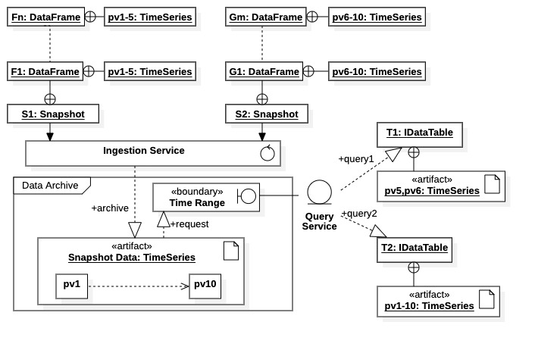

Figure 3: snapshots, time-series data, and queries

In the figure we see that multiple data frames are ingested into single snapshots. (Data frames are a unit of ingestion analogous to EPICS NTTable types and are directly supported by the high-level ingestion API library.) Each data frame contains time-series data from multiple data sources (process variables). In the left-hand side we see that snapshot S1 is composed of the sequence of data frames F1 through Fn. Each of the data frames contain a portion of the time-series data acquired from data sources named pv1 through pv5. Likewise, snapshot S2 is composed of the sequence of data frames G1 through Gm, each containing a portion of the time-series data from data sources named pv6 through pv10. Within the Datastore archive both snapshots are simply stored as time-series data, although all the relationships between snapshots S1 and S2, and data sources pv1 through pv10, are maintained within the metadata archive (not shown).

### Data Query

The query service has access to the full archive, facilitating data requests using a spectrum of query parameters. The example shown in Figure 3 demonstrates query operations over time ranges and data sources. The results of 2 query requests are shown: 1) query1 produces a data table T1 containing time-series data for data sources pv5 and pv6 over some unspecified (but bounded) time duration, while 2) query2 produces a data table T2 containing time-series data for data sources pv1 through pv10 over some unspecified (but bounded) time duration. In each case the snapshot data is originally sourced from both snapshots S1 and S2. The point is to illustrate that data requests are general, and results are available across the entire archive. That is, regardless of the ingestion configuration and process, data is available across data providers, snapshots, data sources, time intervals, and other attributes (including metadata).

## Code Repositories

The Datastore code base is composed of multiple projects contained in multiple code repositories, all hosted on GitHub [10]. The structure of the Datastore project within the repository system is shown in Figure 4. The central location is the Osprey DCS organization common branch <https://github.com/org/osprey-dcs>, as shown in the figure. Seven principal projects are identified in the figure along with their hierarchical relationships and the services and/or functions they provide. Repository projects are identified with the <<project>> stereotype. Currently all projects within the Datastore repository are managed, built, and installed using the Maven utility [10].

The diagram identifies two high-level systems using the <<system>> stereotypes, *Datastore* and *Datastore Administration*. The *Datastore* system contains all internal operations of the Datastore core service and is composed of three projects, *datastore-grpc*, *datastore*, and *datastore-service*. These projects realize the gRPC communications framework, the Ingestion Service, and the Query Service, respectively. The other high-level system, *Datastore Administration*, is composed of a single project, *datastore-admin*, and realizes many administrative requirements for Datastore operations, including connections services and testing, data integrity testing, performance testing, and some data management. The project also contains the high-level API libraries for both the Ingestion Service and the Query Service; these libraries are required for the management and testing services within the project.

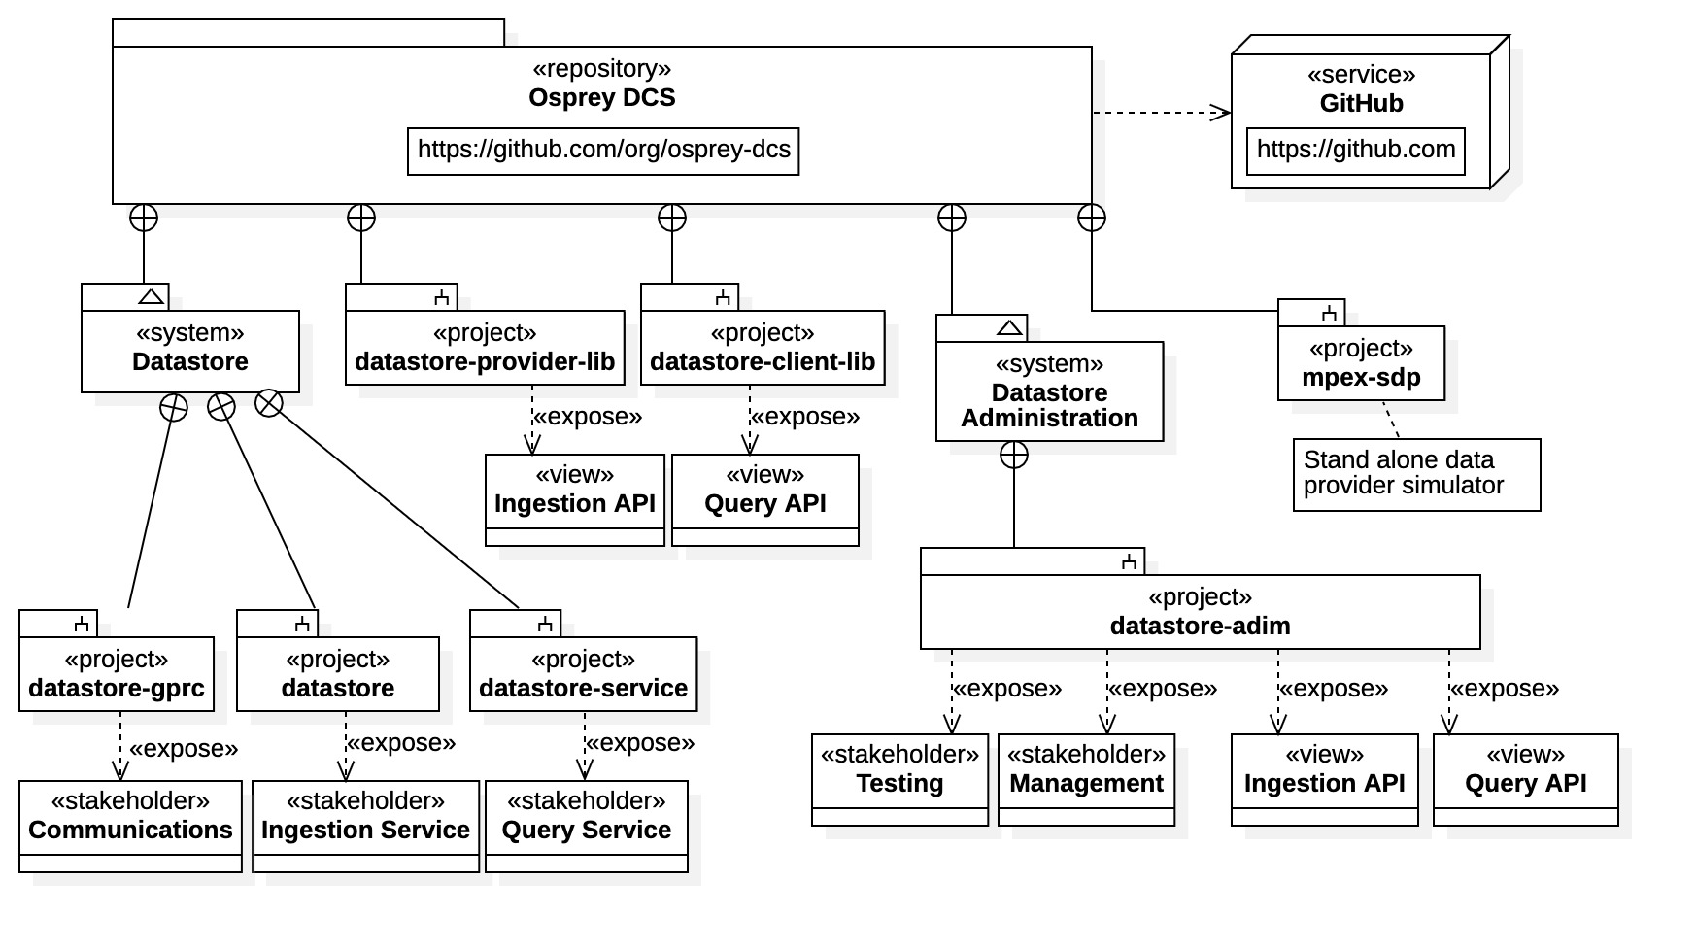

Figure 4: Datastore code repositories and project structure

### gRPC Communications Framework

The *datastore-grpc* project contains the definition and (once built) the implementation of the Datastore gRPC communications framework. It is the topic of Chapter 3 and is fundamental to all other Datastore projects. It must be installed on any platform hosting a Datastore service, an API library, or any client of the Datastore core services. The project generates all gRPC communications resources required by the Datastore system. The communications framework is defined with Protocol Buffers proto meta programming language and compiled into standard programming language source code using the Protocol Buffers protoc compiler [4].

The default *datastore-grpc* project settings instruct the protoc compiler to generate Java source code, which is subsequently built into executable Java bytecode by the Maven utility. Once built, the project should be installed as a Maven library on any platform requiring communications with the Datastore. *Because this project is a dependency of all other Datastore projects, it should be built first, then installed on any host or support platform.*

Note that proto source code defining the RPC interfaces and data structures can be compiled into a variety of programming languages, such as C/C++, JavaScript, or Python. Thus, clients wishing to communicate with the Datastore directly through gRPC may choose a variety of languages to do so.

### Datastore Core Services

The two projects, *datastore* and *datastore-service*, implement the Ingestion Service and the Query Service, respectively. They are currently configured to build into executable shaded Java archives (i.e., “fat jars”) to be launched using the Java virtual machine. Once launched, the services monitor pre-defined host ports for connection requests. These two services maintain and manage the Data Archive and comprise the core operations of the Datastore. These core services require network access to the InfluxDB and MongoDB database systems. Database credentials and service configurations can be managed through project properties files, through Java virtual machine arguments, or through host environment variables. See the project-specific documentation on Github for details.

### API Libraries

The projects *datastore-provider-lib* and *datastore-client-lib* are two standalone API libraries for client interaction with the Datastore Ingestion Service and the Datastore Query Service, respectively. They provide wide interfaces supporting general ingestion and query operations. Specifically, the API within *datastore-provider-lib* provides ingestion operations based upon Java native types; it offers data providers a wide, general (but somewhat complex) interface. The API within *datastore-client-lib* provides a low-level interface where requests are made in the Datastore Query Language (DQL) and results are returned as collections of metadata records or time-series data sets; it is essentially a wrapper for the Query Service gRPC interface. Both API libraries can be considered “expert friendly” interfaces.

Two accompanying projects, not shown in the diagram but also belonging to the Datastore repository collection, are *datastore-provider-spring-boot-starter* and *datastore-client-spring-boot-starter*. These are two standalone applications supporting the API libraries within *datastore-provider-lib* and *datastore-client-lib*, respectively. They provide interfaces to the API libraries based upon the Spring Boot [7] framework.

Two additional API libraries are contained in the *datatstore-admin* project, one supporting the Ingestion Service and one supporting the Query Service. These provide narrow APIs offering high-level support for both ingestion and query communications. Specifically, the ingestion API uses the *data frame* as a unit of ingestion, which is directly analogous to the EPICS NTTable normative type. It is provided for the Aggregator service of the Machine Learning Data Platform, or any other data provider supplying NTTable instances for ingestion. The query API within project *datastore-admin* offers a high-level perspective of the Query Service and is oriented towards high-level data science applications. It provides request builders for formulating data queries, rather than relying on the Datastore Query Language. Time-series data query results are provided as high-level data tables rather than collections of data sets.

### Data Simulators

The project *mpex-spd* is a standalone application that simulates data produced by the MPEX facility at Oak Ridge National Laboratory (ORNL) [12]. This application creates simulated data which can be ingested by the Datastore through the API library within the *datastore-provider* project. The data simulator offers configuration parameters which are available through the project properties file.

The *datastore-admin* project contains a scenarios-based data simulator that facilitates a wide variety of general ingestion scenarios. In particular, the data simulator can be configured to emulate the Aggregator service of the Machine Learning Data Platform. The scenarios simulator utilizes the ingestion API library within the same project, *datastore-admin*. A wide variety of data types, shapes, and sizes are available for building scenarios-based testing frameworks. Additionally, testing configurations, data rates, and loading conditions can also be specified with scenarios definition files available within the project resources.

### Project Configurations

All projects contain the properties file *application.yml* in their *src/main/resources* directory. These are configuration files required by their respective project for configuring site-specific builds, installations, and deployments. The files contain general properties values for building, deployment, and service connections within the host environment. Default values are available for most properties but, typically, some user-specific and/or site-specific modifications are required for proper installation and deployment (e.g., user credentials for databases, path locations for archive files, URLs and port addresses for service connections, etc.). All projects also support property value assignment through host environment variables or Java virtual machine command-line options.

# Datastore Communications Framework

The Datastore has a distinct communications framework. Communications are managed through remote procedure calls requiring protocols specific to the Datastore operations. The remote procedure call interfaces, the data messages, and the protocols required by the interfaces, are described in this chapter.

Direct client communications with Datastore core services, both the Ingestion Service and the Query Service, is based upon Remote Procedure Call (RPC). Datastore RPC operations are defined using the Protocol Buffers meta language and implemented with the gRPC remote procedure call technology [3] [4]. The Datastore communications framework is defined entirely within the *datastore-grpc* project. The project contains the complete set of data structures and data types that may be exchanged (i.e., protobuf messages), and the interfaces by which they are exchanged (i.e., the gRPC interfaces). All are covered in detail, along with the operation and use of each interface.

Clients employing the API libraries exclusively are generally isolated from the details of low-level Datastore communications and the project *datastore-grpc*. However, application developers wishing to communicate with the Datastore core services directly through gRPC must be familiar with the paradigm. Additionally, the lower-level API libraries in the *datastore-provider-lib* and *datastore-client-lib* projects expose some Datastore gRPC communications resources and protocols.

## Remote Procedure Call and gRPC

The remote procedure call mechanism is defined using Protocol Buffers and realized with the gRPC communications framework. Protocol Buffers, or “*protobuf*” in the shorthand, is generally used in conjunction with the gRPC framework, both technologies support one another. The data structures, data types, and operations used in RPC communication are defined in the “proto” meta language of Protocol Buffers. These definitions are then compiled into common programming-language specific implementations by the protobuf “protoc” compiler. The source code generated by the protobuf compiler performs data serialization of the RPC messages and utilizes the gRPC framework for underlying data transport. The gRPC framework also provides direct support for Protocol Buffers, in fact, the protoc compiler is available within the gRPC installation.

The *datastore-grpc* project contains the proto source files defining the RPC interfaces and messages for each of the core services. This chapter describes the Datastore communications protocol using the protobuf messages and interfaces for each service, as contained in the project. Because the Datastore core services are implemented in Java, the *datastore-grpc* project generates Java gRPC resources in the default configuration. Thus, most language-specific descriptions within this chapter are for Java.

Note that other language options are available. Because Protocol Buffers and gRPC are language and platform independent, the *datastore-grpc* project can be built for any supported programming language. This fact allows direct Datastore gRPC communications in any supported programming languages. APPENDIX C provides additional information on Protocol Buffers and gRPC, containing details for the Python, Java, and C++ languages.

## Framework Overview

Before proceeding with specific message and interface descriptions of the Datastore core services, we provide an overview of the Datastore communications framework. The overview is by way of an example, where the framework supports communications between an API library and a Datastore core service. The example identifies basic gRPC resources required by clients for direct communications with a Datastore service. It also demonstrates the basic structure and operation of the Datastore communications framework.

The graphic in Figure 5 demonstrates the basic communication framework realized by the project *datastore-grpc*. The diagram captures the basic mechanism for both client and service in Java gRPC. It is intended to provide a high-level understanding of the function and role of the Datastore communications framework in the context of gRPC.

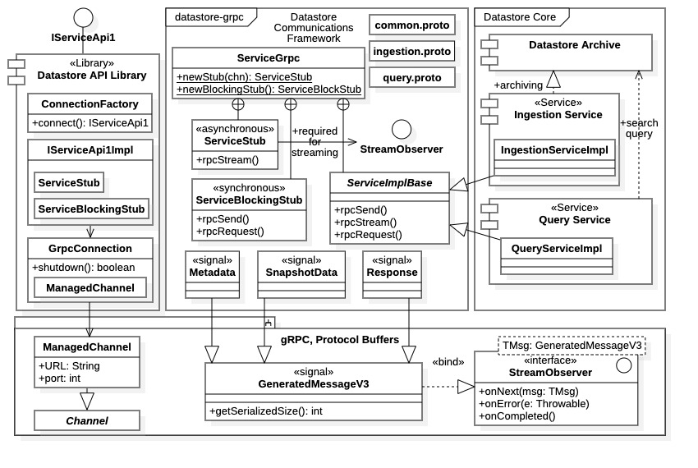

Figure 5: Datastore communications framework implementation overview

The Datastore Communications Framework is represented by the top-center frame within Figure 5. Before building, the project contains only three source files: common.proto, ingestion.proto, and query.proto. These files are the proto source files that entirely define the Datastore communications framework. Invoking the protobuf compiler generates the remaining entities within the center box. Note however, that the identifiers used there are simply generalizations used for demonstration. Actual gRPC resources generated for each proto source file are covered precisely in the sequel.

Seen in the diagram is class ServiceGrpc, this is the gRPC implementation for a service interface defined in the proto source (i.e., using the service keyword). This class provides the communications endpoints for both client and service. Typically, endpoints are implemented within enclosed classes of ServiceGrpc. Protobuf maintains a naming convention where communications resources are always prefixed with the interface name. (The actual interfaces defined in *datastore-grpc* are IngestionService and QueryService.)

Within Figure 5 client communications are supported by the two enclosed classes, ServiceBlockingStub and ServiceStub. These are gRPC “communication stubs” that contain the remote procedure calls defined in a gRPC interface and used by clients. There is an additional communications stub, ServiceFuturesStub, not shown in the diagram.

The third enclosed class, ServiceImplBase, is provided for service implementations. This is the gRPC “implementation base” that contains the remote procedure call endpoints for services. Services respond to remote procedure calls by overriding endpoint methods. The mechanism is shown in the right-hand side of Figure 5 where the Ingestion Service and Query Service implement the child classes IngestionServiceImpl and QueryServiceImpl, respectively. Again, the diagram is illustrative, the actual gRPC resources within *datastore-grpc* are the separate implementation bases IngestionServiceImplBase and QueryServiceImplBase.

Three protobuf message implementations are highlighted in Figure 5: Metadata, SnapshotData, and Response. These messages are generalizations intended to represent the transport of metadata, time-series data, and service responses, respectively. Actual message types within the *datastore-grpc* framework are detailed in the sequel. The diagram indicates that, in Java gRPC, all protobuf messages inherit from the base GeneratedMessageV3. Subtypes of GeneratedMessageV3 are then recognized by the communications stubs and the service implementation base class. Other languages have similar mechanism.

The left-hand side of Figure 5 depicts a typical client of the Datastore core service, in this case an API library. The API library exposes a single interface, IServiceApi1, providing high-level communications with the Datastore service. The library has 3 highlighted components, 1) a connection factory ConnectionFactory, 2) the interface implementation IServiceApi1Impl, and 3) a communication channel GrpcConnection. The “connection factory” is a general mechanism for obtaining API interfaces used by Datastore API libraries and outlined in APPENDIX B. The interface implementation IServiceApi1Impl maintains the communication stubs containing the RPC operations. It also maintains an association with the gRPC channel object used by the stubs, a MannagedChannel instance in this case. The gRPC channel object represents the client network connections. The GrpcChannel class within Figure 5 is simply a convenience wrapper for gRPC ManagedChannel objects. Note the shutdown() operation, used to release gRPC resources before discarding.

Clearly, arbitrary clients of the Datastore would not necessarily expose interfaces or require connection factories. However, all clients would be required to create communications channels and acquire communications stubs, these are the common gRPC resources required for client communication. The gRPC framework also offers clients multiple communications models.

### Streaming and Non-Streaming Operations

The gRPC framework provides support for both standard RPC operations and streaming RPC operations. For standard RPC operations a procedure is invoked and blocks until completed, after which the response is returned. For a streaming gRPC operation, the remote procedure call establishes a data stream between client and service, it does not block. A dynamic data stream remains open allowing client and service to exchange messages until explicitly terminated. The Datastore core services contain both streaming and non-streaming operations, streaming operations are typically used to transmit large data sets.

Non-streaming RPC operations are those defined *without* the protobuf “stream” modifier. Non-streaming operations are standard RPC message passing, remote procedure calls are made directly on the communication stub. The client passes in a protobuf message instance and receives a protobuf message instance in response; the operation blocks until completed.

Streaming operations are explicitly identified with the protobuf “stream” modifier on a remote procedure call definition. Either the argument, the response, or both can be marked with the stream keyword. If both are marked, the remote procedure call establishes a fully bidirectional data stream between client and service, otherwise a unidirectional stream is created.

In gRPC, streaming operations are generally implemented with an exchange of programming interfaces, or iterators. No data is exchanged, and the operation does not block. This idea is shown explicitly for Java in Figure 5. There, a dependency is shown between ServiceStub and the interface StreamObserver<>. Java streaming operations require the StreamObserver<> interfaces to maintain the data stream. The client must always pass in an implementation of StreamObserver<> to receive responses from the service. The client will receive a StreamObserver<> interface from the service (i.e., when the RPC operation is defined with a stream argument). This interface allows clients to stream messages to the service. Note that the StreamObserver<> implementation can be executed on an independent thread enabling asynchronous operation. The gRPC framework facilitates multi-threading for streaming operations.

In the Java gRPC implementation, *data streaming is implemented asynchronously*, discussed more below. Thus, in Java gRPC, asynchronous operations imply streaming operations, although the converse is not required (i.e., streams may be single threaded). The Datastore core services support asynchronous streaming.

### Clients

Clients can communicate directly with the Datastore core services using gRPC communication stubs. Figure 5 demonstrates the Java case for the example protobuf interface Service. There, three communications stubs are generated, two of which are shown in the diagram, ServiceBlockingStub and ServiceStub.

The static methods newStub() and newBlockingStub() within the enclosing class ServiceGrpc create the communications stubs ServiceStub and ServiceBlockingStub, respectively. Both methods require Channel objects as arguments. As seen in the diagram, the Channel class is a generalization of the ManagedChannel class used for Java implementations. Not shown in the diagram is the method newFutureStub() which creates a ServiceFutureStub instance.

The ServiceBlockingStub stub offers *only* standard RPC operations (i.e., remote procedure calls defined *without* the stream modifier). Any remote procedure call defined with the protobuf stream modifier are not available within this stub. All operations are blocking. Note that operations within ServiceBlockingStub are supported with synchronous communication in the Java implementation.

Alternatively, the ServiceStub communication stub exposes *all* RPC operations with the service (i.e., including non-streaming operations). Consequently, any RPC operations defined with the stream modifier are only available within the ServiceStub stub. All operations are non-blocking and involve the exchange of at least one StreamObserver<> interface.

The communications stub ServiceFutureStub (not shown in the diagram) supports a hybrid communications mechanism; RPC operations are technically synchronous, but operations do not block. Instead, a callback notification is established with the client. The notification can be configured to execute as a separate thread. Only non-streaming operations are contained within ServiceFutureStub.

### Datastore Services

In the Java gRPC implementation, used by the Datastore core services, the ServiceImplBase class is the only base class for service implementation. The Java gRPC implements service endpoints as streaming operations supporting asynchronous communications.

The Datastore core services use multi-threading in the streaming RPC operations. Thus, asynchronous communication is supported when data streaming. Ultimately, it is the choice of the client as to which communication model is used, by selection of the communications stub.

### Streaming and Asynchronous Communications

The interface StreamObserver<> identified in Figure 5 is required by gRPC for streaming operations. The interface is used by both clients and services to send and receive messages through a data stream. It is a generic interface where the template parameters are protobuf message types. For example, the interface StreamObserver<SnapshotData> would be transmit messages of type SnapshotData.

To clarify the process of streaming and asynchronous client communications, we provide an example using the resources of Figure 5 (which are accurate for this case). Consider the ingestion scenario where a client offers a large data set to the Ingestion Service as a data stream of SnapshotData objects, the Ingestion Service responds using the Response message. In contrast with a blocking remote procedure call where a concrete SnapshotData instance is offered as an argument, a streaming operation results in the exchange of interfaces. In this case, the client offers a StreamObserver<Response> interface (or a subtype of this interface) and receives a StreamObserver<SnapshotData> interface. The StreamObserver<Response> argument allows the Ingestion Service to send acknowledgments and instructions to the client. It is the client’s responsibility to implement a StreamObserver<Response> interface that properly manages the ingestion protocol with the Ingestion Service. In turn, the client is provided with an interface StreamObserver<SnapshotData>. This interface contains an operation onNext(SnapshotData) used by the client to transmit data to the Ingestion Service.

The client initiates the ingestion data stream by invoking the ingestion operation, say streamSnapshotData(StreamObserver<Response>). The operation accepts a StreamObserver<Response> request and returns a StreamObserver<SnapshotData> response. To initiate the data stream, the client sends the first SnapshotData messages to Ingestion Service. A received Response messages would typically acknowledgement the SnapshotData message and/or signal a ready condition.

In full asynchronous communication, the client invokes streamSnapshotData(StreamObserver<Response>) with the StreamObserver<Response> implementation running on a separate thread. The acknowledgments received by the client would then spawn ingestion threads attached to the StreamObserver<SnapshotData> interface. Multiple execution threads can be spawned on multiple data streams by repeated invocation of the streamSnapshotData() operation.

## The datastore-grpc Project

To reiterate and clarify: all remote procedure calls and data messages used by both the Datastore Ingestion Service and Query Service are defined within the *datastore-grpc* project. The interfaces and messages are defined in the proto meta-programming language of Protocol Buffers. The Maven project utility is used to run the protobuf compiler generating the gRPC framework programming language source code. The Maven utility then builds the source into an executable library. Note that after the Maven build, all source code is available for inspection. For Java builds, source code is located within Java package directories specified in the proto source.

The *datastore-grpc* project settings are stipulated in the Maven Project Object Model (POM) file pom.xml. In the default configuration, Maven creates the gRPC framework in Java then bundles executable bytecode into a Java archive (“jar”). Once fully built, the Java archive contains the Datastore communications framework as a library. It can be installed on the host platform using the Maven install command.

Note that the Datastore core services are implemented in Java and the *datastore-grpc* project must be built and installed using the Java language on the hosting platform.

### Source Files

Three protobuf source files define the entire communications framework and protocol: 1) common.proto, 2) ingestion.proto, and 3) query.proto. They contain 1) the common message used by core services, 2) the Ingestion Service interface and messages, and 3) the Query Service interface and messages. These are the only source files within the *datastore-grpc* project before building. Instructions for the protobuf compiler are found in the Maven project file *pom.xml*. When building the project, Maven first creates Java source code using the protobuf compiler. The Java source code is then, in turn, compiled into Java bytecode and bundled into a Java archive file (i.e., a “jar” file). The jar file contains the entire Datastore gRPC communications library and should be installed any client platform as well as the Datastore host platform. Note that once built, the *datastore-grpc* project will contain all the Java source files for inspection.

### Generated Files

After a build, the *datastore-grpc* project contains all Java gRPC resources within the Datastore communications framework. For the default configuration, all source files are located in the project directory target. The following lists protobuf compiler output by source file:

* common.proto: Defines protobuf messages common to both Ingestion and Query Service.
  + Package: com.ospreydcs.datastore.grpc.v1.common.
  + Parent directory: target/generated-sources/protobuf/java
* ingestion.proto: Defines Ingestion Service gRPC interface and service-specific protobuf messages.
  + Package: Package com.ospreydcs.datastore.grpc.v1.ingestion.
  + Class Ingestion: Protobuf messages specific to Ingestion Service (enclosed classes).
    - Parent directory: target/generated-sources/protobuf/java
  + Class IngestionServiceGrpc: Ingestion Service interface gRPC resources (enclosed classes).
    - Parent directory: target/generated-sources/protobuf/grpc-java
* query.proto: Defines Query Service gRPC interface and service-specific protobuf messages.
  + Package: com.ospreydcs.datastore.grpc.v1.query
  + Query Service messages: All implemented in separate Java source files.
    - Parent directory: target/generated-sources/protobuf/java
  + Class QueryServiceGrpc: Query Service interface gRPC resources (enclosed classes).
    - Parent directory: target/generated-sources/protobuf/grpc-java

The final directory locations for source files follows the Java package naming convention from the parent directory. Note that protobuf messages and gRPC interface resources have different parent locations. Note also that all Ingestion Service specific protobuf messages are all enclosed by the class Ingestion due to lack of protoc compiler option java_multiple_files. They can be accessed using the class namespace com.ospreydcs.datastore.grpc.v1.ingestion.Ingestion.

### Language Options

In its default configuration, the *datastore-grpc* project generates a Java-based implementation of the Datastore communications framework (i.e., as dictated by the Maven project utility). However, one can generate the Datastore communications framework in other languages, such as the C++ language used for low-level systems access, the Python language popular in machine learning applications, and JavaScript which was used for the Web Application augmenting the Machine Learning Data Platform.

Clients desiring alternate programming language support can build the project in the language of their choice on a client platform. One selects the desired language by using the appropriate protobuf compiler. Note, however, that Maven only supports Java builds. The command-line protobuf compiler or other project management utilities are necessary for languages other than Java (e.g., Gradle [13], Make [14], etc.). See Subsection C.3.1 of APPENDIX C for instructions on the command-line protobuf compiler.

## Common MessageS Definitions

Here we begin explicit descriptions of the Datastore gRPC communications framework defined in the Protocol Buffers source files. This section covers the common message used by both the Ingestion Service and the Query Service. The next section covers the Java implementation for the common messages, the protobuf generated source files found in project *datastore-grpc* post build. The chapter sections following continue in similar form, first for the Ingestion Service gRPC interface and messages, then for the Query Service gRPC interface and messages.

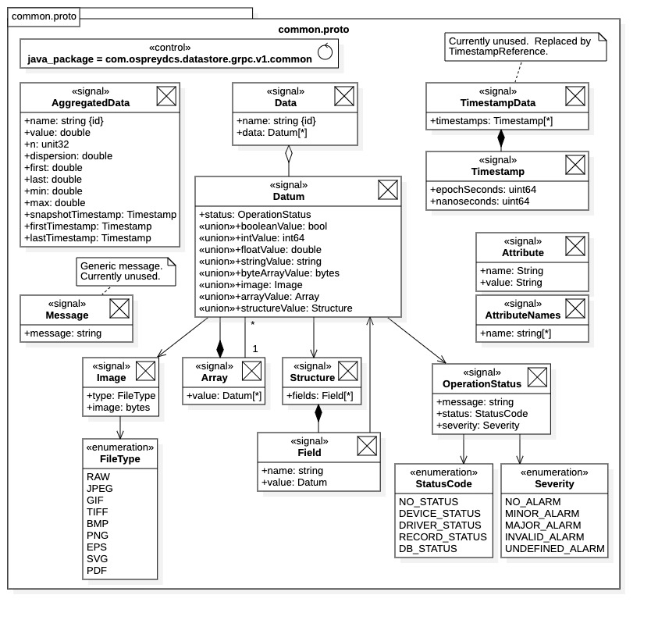

Figure 6: common.proto - shared Datastore gRPC communications messages

### Protobuf Messages

The Datastore communications framework common messages are listed in Figure 6. The protobuf messages in the figure are contained in file common.proto and used for both the Ingestion Service and the Query Service. Consequently, file common.proto is included within both the ingestion.proto and query.proto source files.

Upon inspection of the diagram, the common messages essentially describe the data structures and data types needed to define time-series data and properties. To help clarify roles, the relationships and associations between common messages are also shown in the diagram.

All protobuf messages are defined with the message keyword in the proto meta-language. Within the diagram of Figure 6, protobuf messages are represented as signals, identified with the <<signal>> stereotype. This convention is used throughout the chapter and main body. Although a slight notational abuse, it captures the basic nature of a protobuf message in that signals have only data (attributes) which are intended for transmission (usually asynchronously). Protobuf enumerations are defined with the enum keyword and identified with the <<enumeration>> stereotype.

### Time-Series Data

##### Datum

The basic value within a time-series data set is the Datum message. This message provides the heterogenous data support for the communications framework. A Datum message contains a value field and a status field. The status field, status, represents the value condition at acquisition time. The value field is the single data value contained in the Datum message; it can be of the various typed fields modified by the <<union>> stereotype. The field union supports multiple data types for heterogeneous data in the single value. Referring to Figure 6, the Datum value supports both native types and data structures described by other protobuf messages, and message groups, listed within Figure 6.

When directly inspecting the common.proto source file, the Datum message actually contains only two fields: “status”, and “value_oneof”. However, the value_oneof field is defined as a union using the protobuf “oneof” modifier. Thus, the value_oneof field is a union of all the possible data types for the Datum value. The Datum representation of Figure 6 is an abbreviation, it shows only the named fields of the value_oneof union.

The Datum value field supports the scalar types Boolean, long integer, double, and character string; all of these being protobuf primitive types. Protobuf also has the native type “bytes”, also supported by the Datum value and representing a byte array containing raw data. Additionally, images, one-dimensional data arrays (vectors), and data structures are supported by the Datum message. These complex types are defined by the protobuf messages Image, Array, Structure, respectively, which are listed in Figure 6.

As mentioned above, each Datum message contains a status condition, represented by the status field of type OperationStatus. This is an optional status indicator for the message value, its status at acquisition time. From inspection of the protobuf message OperationStatus, we see the status field contains a string message, a status code, and a severity code, the latter two being enumerations of type StatusCode and Severity, respectively.

##### Data

Time-series data sets acquired from a data source (process variable) are represented as Data messages. From Figure 6, we see that Data messages are named aggregations of Datum instances. (The proto language uses the repeated keyword to define aggregation fields within messages.) Each Datum instance represents a data value within the time-series data set. Typically, time-series data are named by the data source producing them (e.g., process variables).

The Data message contains the following 2 fields:

1. name: Name of the time-series data set, typically the name of its data source.
2. data: Ordered aggregation of Datum message instances, the time-series data values.

For proper Datastore archiving, *the data source names must all be unique* (e.g., all EPICS PV names are unique). The Datum instances should be ordered by acquisition timestamp. The values within multiple Data messages of a snapshot should be correlated (i.e., have the same timestamps). Additionally, once the data type of a data source is established, it cannot be changed. Attempting to archive differing data types from the same data source will create an exception during the ingestion process.

##### Timestamp

Timestamps are represented by the protobuf message Timestamp contained in common.proto. Timestamp messages are used in conjunction with Data messages to represent the correlated, time-series data set within snapshots. A Timestamp message contains the following 2 fields (the general fields of a time instant):

1. epochSeconds: The number of epoch seconds (i.e., number of seconds since January 1, 1970).
2. nanoseconds: The number of nanoseconds past the epoch second.

Timestamps for time-series data are provided as a separate field with a snapshot data message. Snapshots themselves are represented by protobuf message SnapshotData within ingestion.proto, to be covered in Section 3.6.

##### AggregatedData

The protobuf message AggregatedData contains an “aggregated data set.” It represents an aggregate description of a time-series data set, or an “aggregation process” applied to a Data message. For example, either situation could result from a statistical process performed on a set of numeric values.

Continuing with the statistical example, consider a time-series process with samples $\left(x_{1},x_{2},…,x_{n}\right)$ and ordered timestamps $\left(t_{1},t_{2},…,t_{n}\right)$. The AggregatedData message might contain the following statistical properties:

1. n: The sample size *n*.

2. value: The statical average ,

3. dispersion: The standard deviation .

4. min: The minimum value .

5. max: The maximum value .

6. snapshotTimestamp: The trigger time of the acquisition process.

7. firstTimestamp: The earliest timestamp .

8. lastTimestamp: The latest timestamp $t_{n}$.

Note that the above description is interpretive. Actual interpretations would be at the discretion of the data provider.

### Datastore Supported Types

In addition to scalar types, from Figure 6 we see that the Datastore currently supports complex data types of image, one-dimensional array, and data structure, each respectively represented by the messages Image, Array, and Structure. Raw data is also supported in the form of byte arrays. Both the Array and Structure messages can contain repeated instances of Datum messages (the latter through the Field message). These latter types may be nested since Datum messages can, in turn, contain Array and Structure messages.

##### Images

Images are messages containing 2 fields.

1. image: The raw data for the image (as a byte array).

2. type: The image format type as an enumeration.

The Image message type is realized as a raw byte array with an image type identifier. The type field is the protobuf enumeration FileType, which contains all the Datastore supported image file formats.

##### Arrays

One-dimensional arrays are represented by the Array protobuf message. They are vectors of Datum messages. As such, array elements may contain values of any supported type. For example, arrays can contain subarrays and substructures. In this manner multi-dimension arrays can be constructed, as well as other more complex data types.

##### Data Structures

Data structures are represented by the Structure protobuf message. As shown in Figure 6, a data structure is an aggregation of the Field protobuf messages. The Field message is simply a named Datum message, that is, a (name, value) pair. Thus, data structures are implemented as collections of (name, value) pairs, where the value can be any supported type. Accordingly, data structures may be complex, their field values may contain other data structures (or any other supported type). Complex data structures can be formed to arbitrary width and depth.

### Data Attributes

The protobuf message Attribute defines a general attribute that may be associated with any data set, metadata, data source, data provider, etc. within the Data Archive. Referring to Figure 6, an attribute consists simply of a (name, value) pair of character strings. Within the Datastore communications framework, attributes typically appear as aggregations of Attribute messages (i.e., as a protobuf message field “repeated Attribute”).

The AttributeNames protobuf message is provided as a utility when querying the Datastore archive for all attribute names associated with an entity. The message contains the field name, which is an aggregation of character strings, each representing an attribute name. The AttributeNames message is typically the response for metadata queries requesting all attributes within a metadata record collection.

## Common Messages Realization

All the protobuf messages defined within the common.proto, and listed in Figure 6, are realized with programming language source code generated by the protobuf compiler. The Datastore core services are implemented in the Java language and, accordingly, the protobuf realization of the common messages is presented for the Java language. Readers familiar with Java protobuf implementations may skip this section as no exceptional situations are encountered.

### Java gRPC Implementation

Figure 7 depicts the Java implementation for the three protobuf messages Timestamp, Datum, and Data. All other protobuf messages defined within common.proto have an analogous implementation. The diagram is not exhaustive, it only highlights the protobuf implementation features commonly utilized in Datastore communications.

For each protobuf message, 3 resources are always generated in Java: 1) an interface exposing attribute “getter” methods, 2) the message class itself, and 3) a builder class enclosed by the message class. In the Java protobuf implementation, all message classes are immutable, they cannot be modified after creation (i.e., there are no attribute “setter” methods). Thus, builder classes are required for each Java protobuf message as demonstrated in the diagram.

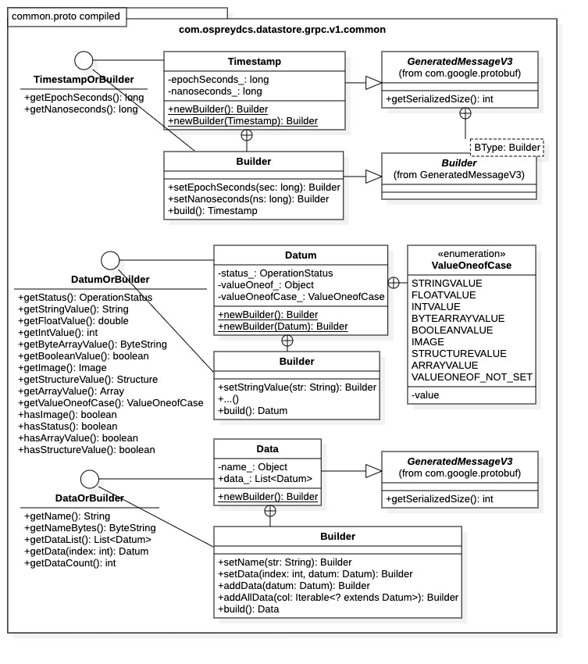

Figure 7: common.proto – common messages protobuf implementation in Java

The diagram indicates that each message class inherits from abstract base class GeneratedMessageV3, contained within the Protocol Buffers library. Likewise, each builder class inherits from the enclosed class GeneratedMessageV3.Builder. Both base classes reside in the com.google.protobuf package within the Protocol Buffers library. Note that the base class GeneratedMessageV3 contains a public method getSerializedSize() which is overridden by the protobuf message subclasses. This method calculates the size of the populated message (in bytes) after serialization. This is a useful feature in data transport and performance testing.

### Message Classes

The three messages depicted in Figure 7 are selected purposefully; they each demonstrate specific features of the Java protobuf implementation. The Timestamp message was chosen because it demonstrates implementation of a simple protobuf message containing only primitive attribute types. Attributes of a protobuf message class are always private and their names are suffixed with an underscore (_). Attribute values must be retrieved through “getter” methods specified in the TimestampOrBuilder interface. Attribute values are assigned before message creation using the builder class Timestamp:Builder discussed below. Briefly, a message class object is always instantiated in is final, immutable configuration by the builder class. (Messages may also be instantiated using Java input streams, not shown.)

The Datum message illustrates the case when a message field is a union. Here the protobuf message implementation represents the union as a single attribute valueOneof_ (generated from message field name value_oneof). The attribute value is realized as a Java Object type (i.e., it has no defined type). The attribute type is specified using protobuf generated enumeration ValueOneofCase enclosed by the Datum class. An additional Datum attribute, valueOneofCase_, contains the enumeration constant identifying the attribute type. The enumeration is used to parse the valueOneof_ attribute for type conversion.

To illustrate the protobuf implementation for messages containing aggregations of other messages, consider the Data message. The Data message contains a named collection of Datum messages. Within the Java implementation, internal message collections are realized as an ordered list of type java.util.List<>. In this case, the Data message contains the attribute data_ with type List<Datum>. Populating a Data instance is done through the builder class Data.Builder. There are several approaches for populating message classes containing collections of sub-messages, described below.

### Message Interfaces

In the Java protobuf implementation, a Java getter interface is generated for each protobuf message, as shown in Figure 6. The interface exposes all “getter” methods required to access the message class attributes. The interface is also exposed by the message builder class. Accordingly, the appearance of suffix “OrBuilder” seen in the protobuf naming convention for message class interfaces. Thus, the message instance configuration can be determined before building.

For messages containing attributes with Java native types, the interface operations are the common getter methods conforming to the JavaBean standard. This is seen in the TimestampOrBuilder interface for the Timestamp message class in Figure 6.

For messages containing attribute unions, a separate getter method is provided for every union field. This is the situation for the Datum message. Note also that the operation getValueOneofCase() is available, which returns the enumeration constant identifying the attribute type (it has value VALUEONE_NOT_SET if the attribute value was not assigned). Additionally, operations prefixed with “has” return Boolean flags indicating if the attribute value contains a message instance; in this case, the supported Datastore types.

To retrieve values from messages containing aggregations, consider the Data message. Referring to the interface DataOrBuilder, individual Datum message may be retrieved by index through the getData(int) operation, or the entire collection of Datum instances may be retrieved using the getDataList() operation. The interface also specifies the getDataCount() operation returning the number of Datum instances within the message class instance.

### Message Builders

Attribute assignment for all Java protobuf message requires the use of builder classes. The protobuf message classes shown in Figure 7 explicitly identify builder classes, all other message classes follow in an analogous fashion. Builders for message instances are available through the static methods newBuilder() within the message class. Named attributes within the protobuf message are assigned via the builder “setter” methods according to the JavaBean standard. Once the builder is configured with the desired attribute values, its build() method is invoked returning the populated message instance.

For protobuf messages containing aggregations of other messages, the building process requires the use of “setter” and “adder” methods within the builder class. The process is demonstrated for the Data message implementation within Figure 7. The Data message class contains the attribute data_ which is implemented as a list of Datum instances. The Data message builder class Data.Builder contains methods setData(int, Datum), addData(Datum), and addAllData(Iterable<? extends Datum>). These methods are required to assign the values for attribute data_. The setData(int, Datum) method sets the Datum instance at the given list index. The addData(Datum) method adds a Datum instance to the list tail. Finally, the addAllData(Iterable<? extends Data>) method accepts the entire collection of Datum instances as a Java iterator, thus, populating the entire data_ attribute.

## Ingestion Service Definition

The communications interface for the Datastore Ingestion Service is defined in source file ingestion.proto. A description of the ingestion service gRPC interface, along with the protobuf messages required by the Ingestion Service, is shown in Figure 8. The diagram also includes the Java implementation for the Ingestion Service gRPC communications interface, IngestionServiceGrpc. The full implementation is covered in the next section.

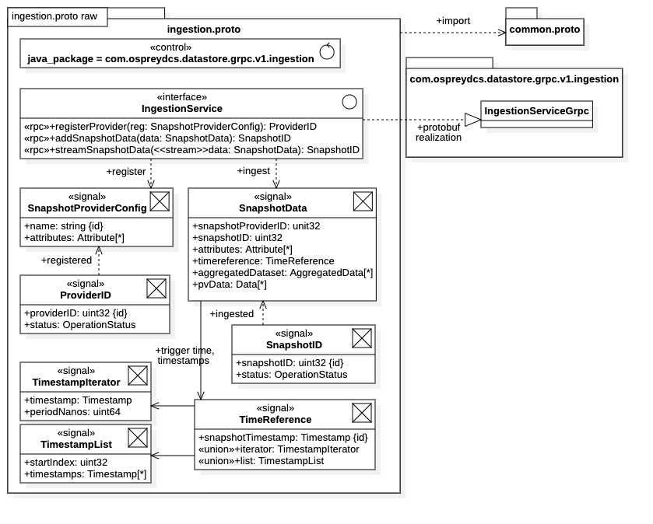

Figure 8: ingestion.proto - Datastore Ingestion Service gRPC communications framework

### Ingestion Service Interface

All remote procedure calls available for the Datastore Ingestion Service are defined by the IngestionService interface within ingestion.proto (i.e., within the service IngestionService statement). Note there are only 3 remote procedure call operations available.

1. registerProvider(): Register client as a data provider with Ingestion Service (prior to ingestion).

2. addSnapshotData(): Ingestion single snapshot synchronously (non-streaming).

3. streamSnapshotData(): Ingestion stream of snapshots (potentially asynchronously).

These operations manifest all interactions with the Datastore Ingestion Service. Note the use of the <<stream>> stereotype within remote procedure call definitions used to indicate streaming operation.

##### Provider Registration

Data providers must first register themselves with the Ingestion Service prior to any data ingestion. Providers register themselves by supplying their *unique name*, for which they will be returned their provider UID. The data provider populates a SnapshotProviderConfig protobuf message with its unique name and any optional attributes. It then transmits the message using the registerProvider() operation. The optional provider attributes can be used in query operations to locate provider data and metadata.

Through registration the data provider receives ProviderID response message containing an integer-valued unique identifier (UID) within the field providerID. This UID maintains persistent association with the data provider name throughout the lifetime of the data archive. Thus, if the provider has previously registered with the Ingestion Service, the same UID is always returned.

Once registered, a client data provider “signs” supplied data by setting the snapshotProviderID field of any SnapshotData message sent to the Ingestion Service. The field value must be set to the provider UID. Any snapshot data sent to the Ingestion Service without a valid provider UID is rejected.

##### Non-Streaming Ingestion

Referring to Figure 8, the addSnapshotData() operation ingests a single snapshot (i.e., as a SnapshotData message). The addSnapshotData() operation is a straightforward RPC invocation, the client passes in a SnapshotData message and receives a SnapshotID message response. The operation blocks until the Ingestion Service receives the data message and releases the operation.

The returned SnapshotID message contains the unique identifier (UID) of the ingested snapshot, along with an operation status code. Any errors in ingestion or archiving will be indicated within the status code. The snapshot UID can be used in query operations to identify individual snapshots.

##### Streaming Ingestion

Snapshot data can be streamed to the Ingestion Service using the streamSnapshotData() operation. Note that the argument is modified the stream protobuf keyword (indicated by the <<stream>> stereotype) which creates a unidirectional stream from client to Ingestion Service. The streamSnapshotData() operation establishes the data stream, no data is exchanged and the operation does not block. Multiple snapshots can be transmitted over a single data stream. However, there are restrictions on data contained with ingestion stream (covered below).

The Ingestion Service supports concurrent multiple data streams established with multiple streamSnapshotData() invocations. Thus, the operation can be used to implement asynchronous, multi-threaded ingestion. The data streams may be implemented as independent execution threads and multiple invocations of streamSnapshotData() create multiple execution threads. Additionally, execution threads can be assigned to individual ingestion operations within a stream.

Once a data stream is established, the client thread can send multiple SnapshotData messages; the stream blocks only if the Ingestion Service becomes overwhelmed. Once finished, the client thread terminates the data stream by sending a “completed” signal to the Ingestion Service.

Referring to Figure 8, the streamSnapshotData() operation returns a single (non-streamed) SnapshotID message. Thus, the Ingestion Service assigns a single snapshot UID to an entire data stream of messages. In asynchronous ingestion, each execution thread receives a snapshot UID upon termination of the data stream.

##### Sustained Ingestion

Note that the streamSnapshotData() operation can be used for sustained ingestion over a data stream. Specifically, the case where time-series data is generated from continuous data acquisition. However, this application is currently only possible when using timestamp iterators for the time reference. See the description of time references below for further information. Also see the warning of Subsection 3.6.4.

### Ingestion Service Messages

Referring to Figure 8, the ingestion.proto file contains protobuf message definitions used exclusively by the Ingestion Service. The messages are required to perform all the operations within the Ingestion Service interface. The ingestion messages listed below, along with concise descriptions. Further descriptions of critical messages follow.

1. SnapshotProviderConfig: Record containing provider unique name and optional attributes.

2. ProviderID: Record containing provider UID w/ registration status from provider registration.

3. SnapshotID: Record containing snapshot UID and ingestion status.

4. SnapshotData: Collection of all snapshot data, the unit of ingestion. Represents a “snapshot.”

5. TimeReference: Supplies all timestamps a snapshot, i.e., the snapshot itself, and the time-series data.

6. TimestampIterator: Timestamps defined by start time and sampling period.

7. TimestampList: Timestamps given explicitly as ordered aggregation.

The SnapshotData message is the unit of ingestion, it contains all snapshot data. Time-series data sets are contained as aggregations of Data messages. Optionally, or additionally, aggregated data can be contained as AggregatedData messages. Thus, all time-series data is contained in messages defined within the common.proto source file and covered in Subsection 3.4.2.

The time-series data timestamps within a snapshot are identified with a *time reference*, discussed below. Briefly, a time reference is identified with a TimeReference message. The TimestampIterator and TimestampList messages are needed to configure a TimeReference message.

The protobuf messages SnapshotProviderConfig, ProviderID, and SnapshotID all represent metadata; they are stored within metadata records in the Datastore metadata repository. The ProvideID metadata is only available from the Ingestion Service through data provider registration.

##### Snapshot Data

The SnapshotData protobuf message contains one snapshot of time-series, heterogeneous data, and any associated metadata. The SnapshotData message contains 6 fields with the following brief descriptions:

1. snapshotProviderID: The data provider UID producing the snapshot data (required).

2. snapshotID: The UID of the snapshot data (optional, identifies multiple snapshots within a stream).

3. attributes: A collection of snapshot attributes assigned by the provider (optional, metadata).

4. timereference: The timestamps assigned to the time-series data values (one required per stream).

5. aggregatedDataset: The properties and values for an aggregated snapshot (optional).

6. pvData: A collection of correlated, time-series data sets (optional).

Note that the snapshotProviderID field is required. The timereference field is also a requirement. However, with the streamSnapshotData() operation only one time reference is permitted per data stream; use of this field is covered in depth below. The aggregatedDataset and pvData fields are typically treated as “either or”; however, possibly neither are set when sending only a time reference, or both are set if assigning aggregation properties to a time-series data collection.

**NOTES:**

1. The snapshotProviderID field within a SnapshotData message *must always be set to the provider UID*, otherwise ingestion will fail. The provider UID is obtained from provider registration with registerProvider() operation; the value is in the providerID field of the returned ProviderID message.
2. The snapshotID field can be set to the UID of a previously ingested snapshot. This action instructs the Ingestion Service to assign the current snapshot data to the previous snapshot. Can be used in the streaming streamSnapshot() operation.
3. Optional attributes may be assigned to the snapshot within the attributes field. Snapshot attributes will be stored as metadata within the Datastore archive.
4. The timestamps for a snapshot are assigned using the TimeReference message described below.
5. In addition to, or in lieu of, the time-series data contained in the pvData field, a SnapshotData message may contain an aggregation of AggregratedData messages in the field aggregatedDataset. The AggregatedData messages may contain aggregate descriptions of snapshot time-series data sets, or they can be the only data contained within the SnapshotData message. In the latter case, this would be a choice of the data provider when fine-grained data inspection is not required, aggregated data sets would minimize transport and archive resources.
6. The time-series data values within a SnapshotData instance are represented as an aggregation of Data message instances within the pvData field. Each Data instance within the aggregation contains signal data from a single data source (process variable), the name of the data source provided in the Data message name field. *All time-series data must be correlated*. Specifically, each Data instance should contain the same number of Datum instances. Additionally, each Data instance should have its Datum values ordered by timestamp. All Datum instances are assigned timestamps according to their index within their containing Data message.

##### Time References

All timestamps for a snapshot are supplied using a *time reference*, including the snapshot timestamp and the timestamps for the time-series data within the snapshot. There are 2 methods for assigning time-series data timestamps: 1) using a *timestamp iterator* or 2) using a *timestamp list*. Note that a time reference contains either a timestamp iterator or a timestamp list, but not both.

A time reference is represented by the TimeReference protobuf message. Referring to Figure 8 we see that TimeReference contains 3 fields, where the latter two are a field union.

1. snapshotTimestamp: The timestamp of the snapshot (e.g., the acquisition “trigger time”).
2. iterator: Assign timestamps through uniform sampling (as a TimestampIterator message).
3. list: Timestamps are explicitly assigned from an ordered list (as a TimestampList message).

Since fields 2 and 3 comprise a value union, only one may be assigned within the time reference.

**NOTES:**

1. The time reference directly assigns the snapshot timestamp with the field snapshotTimestamp. This value is typically the acquisition “trigger time” for the snapshot time-series data. It is often the first timestamp within the time-series data set; however, this is not a requirement.

S*napshot timestamps must be unique* within the Data Archive. The snapshot UID is generated from the unique snapshot timestamp.

1. If the iterator field is set, the timestamps for the snapshot time-series data are assumed to be acquired from a uniform sampling process. The iterator value contains the uniform sampling parameters as a TimestampIterator message.
2. If the list field is set, the timestamps for the snapshot time-series data are directly assigned from an ordered list of timestamp values. The list value contains the ordered aggregation of timestamps as a TimestampList message.

Thus, the snapshot time-series data timestamps are assigned either by assuming uniform sampling during acquisition using a TimestampIterator message, or by directly assignment timestamps using a TimestampList message.

The use of the timestamp iterator is convenient for uniform sampling and sustained ingestion. Specifically, when sampling rates are known a priori, and do not vary, we can establish a continuous, sustained data stream to the Ingestion Service. On the other hand, the timestamp list is necessary when data acquisition rates vary, or when acquisition is subject to interruptions.

##### Timestamp Iterators

Timestamp iterators within a time references are represented with the TimestampIterator protobuf message. It has the following fields:

1. timestamp: The starting timestamp for the uniform sampling process.
2. periodNanos: The uniform sampling period in nanoseconds.

The two parameters completely defined a uniform sampling process. The first row of time-series data is assigned the value timestamp. All subsequent timestamps are separated in duration by periodNanos.

##### Timestamp Lists

Timestamp lists within a time reference are represented with the TimestampList protobuf message. It has the following fields:

1. startIndex: Optional index (1-based). An offset within the timestamp list.
2. timestamps: Ordered aggregation of timestamp values.

When set, the startIndex specifies the start index within the timestamp list. Timestamp assignment for the time-series data will begin at this value, rather than at the head of the timestamp list. This feature can be used for streaming, where time-series data values are sent in separate snapshots.

### Warnings: General Ingestion

##### Snapshot Provider UIDs

The SnapshotData message requires the data provider UID, which is contained in the snapshotProviderID field. The snapshot data provider UID *must be assigned,* or the ingestion operation will fail.

##### Snapshot Timestamps

Recall each snapshot is assigned a UID. This UID is taken from the snapshot timestamp contained in the time reference. Thus, *snapshot timestamps must be unique*. Additionally, it is standard practice to send only one time reference per snapshot. For data streaming where each stream represents a single snapshot, a single time reference is transmitted through the stream.

##### Data Sources and Data Providers

Different data providers attempting to archive data from the same data source (process variable) will create a conflict within the Datastore archive. Generally this action results in an ingestion exception. Data sources are identified by the name field within a in Data messages. The data source names within all SnapshotData messages are assigned to the associated data provider, they must not change during the archive lifetime.

### Warning: Ingestion Streaming and Time References

In the current Datastore release *only one time reference may be sent to the Ingestion Service* *through an open data stream*. Specifically, only one TimeReference message may be included in the stream of SnapshotData messages when using the streamSnapshotData() operation. The TimeReference message may be sent individually in a SnapshotData message containing no snapshot data, or it may be included within a SnapshotData message containing time-series data. The preferred practice is to send the time reference *exclusively within the first* SnapshotData message to the Ingestion Service. This practice improves performance as it allows the Ingestion Service to immediately assign timestamps to incoming data.

When using timestamp iterators as the time reference this condition presents no difficulties; timestamps are assigned to incoming data according to the uniform sampling rate and initial timestamp. However, when using timestamps lists, data streams are limited. Specifically, the timestamp list *must contain all timestamps* for the entire data stream. Although time-series data may be distributed between multiple SnapshotData messages within the same data stream, the entire set of timestamps must be known *a priori*. The data stream must be terminated once the timestamp list for the stream has been exhausted.

In future Datastore releases, the intension is to provide the option of including both time-series data and individual timestamps within a single SnapshotData message. This would allow a single streaming ingestion operation (i.e., a single streamSnapshotData() operation) to support sustained data acquisition using both timestamp iterators and timestamp lists.

## Ingestion Service Realization

The Protocol Buffers Java realization of the Datastore Ingestion Service gRPC interface is depicted in Figure 9. The protobuf messages defined in Figure 8 are not shown, their implementations follow the general convention presented in Section 3.5. Once again, the diagram is not exhaustive. It contains the gRPC features required for most common Java communications with the Ingestion Service. There are additional implementation operations and resources, including gRPC resources, not shown in the diagram but useful for advanced ingestion operations. In particular, the resources needed to create secure connections between clients and the Ingestion Service are not included. For additional information on gRPC communications see the online [documentation](https://grpc.io/) [3], the gRPC quick start [guide](https://grpc.io/docs/languages/cpp/quickstart/#install-grpc) [13] (C++ guide, includes gRPC installation), the Java gRPC quick start [guide](https://grpc.io/docs/languages/java/quickstart/) [16], or APPENDIX C. (Section C.5 in APPENDIX C describes the resources required for secure Java communications.). Readers familiar with Java gRPC can skip this section without consequence, although resource names and locations are specified in the follow subsection.

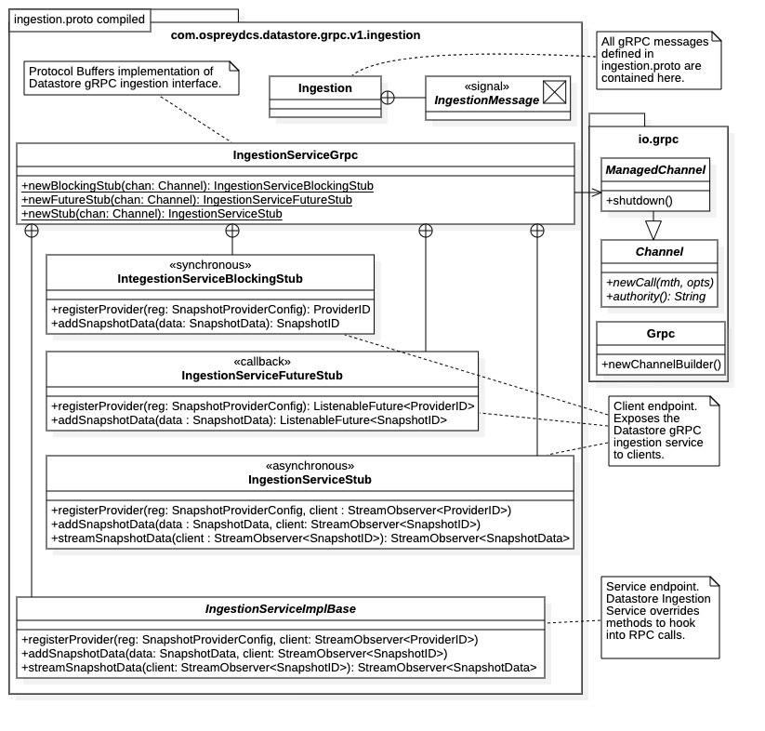

Figure 9: ingestion.proto - gRPC Ingestion Service interface realization in Java

### Java Implementation

All protobuf generated Java classes originating from the ingestion.proto source file are contained in package com.ospreydcs.datastore.grpc.v1.ingestion, as instructed by the compiler directive within the file. As indicated in the diagram, all protobuf messages defined in the ingestion.proto are generated as enclosed classes within the Ingestion class. Specifically, they are implemented as independent static classes within the Ingestion class and, consequently, are all contained within the single Java class file Ingestion.java. This condition results from the lack of a compiler directive (option java_multiple_files) instructing the protobuf compiler to generation separate files for each message.

Once built, all Java resources will be contained in the parent directory target/generated-sources/protobuf within the *datastore-grpc* project top directory. Although all Java resources will be contained within the single package com.ospreydcs.datastore.grpc.v1.ingestion, the Ingestion Service gRPC interface and protobuf messages will be contained within different directories. The interface realization IngestionServiceGrpc is contained in target/generated-sources/protobuf/grpc-java and the messages are located under target/generated-sources/protobuf/java. The subdirectories and names follow according to the Java standard for package locations. See Subsection 3.3.2 for a complete listing of generated files.

### Ingestion Service Interface

As implied in Figure 8 and shown in Figure 9, the entire Ingestion Service gRPC communications interface, for both client and service, is realized within one class, IngestionServiceGrpc. That is, protobuf compiles the IngestionService service interface defined in Figure 8 into the single class IngestionServiceGrpc seen in Figure 9. The communications stubs and implementation base are realized as independent static classes within the IngestionServiceGrpc class. Thus, the class functions as a namespace for the available client communications stubs. It also functions as the builder class for creating client communications stubs. Additionally, the IngestionServiceGrpc class encloses the base class for implementing service endpoints.

### Client Communications

The communications stubs IngestionServiceBlockingStub, IngestionServiceFutureStub, and IngestionServiceStub all contain client endpoints for the remote procedure calls defined in ingestion.proto. There are 3 available communications models for clients in Java gRPC. The stub class type determines the communications model it supports.

1. IngestionServiceBlockingStub: Non-streaming, blocking (synchronous) communication.
2. IngestionServiceFutureStub: Callback communication (non-blocking “synchronous”).
3. IngestionServiceStub: Streaming communications (facilitate asynchronous communication).

Each communication model is described below.

The class IngestionServiceGrpc provides static methods for creating each of the respective communications stubs. As seen in Figure 9, each method requires a io.grpc.Channel argument for stub creation, discussed below.

##### Channel Creation

Clients require a Channel instance to create a communications stub. The Channel object maintains the network connection with a gRPC service. Here it specifies the location of the Ingestion Service, and any security credentials. In Java, instances of the io.grpc.ManagedChannel class are used, which is a Channel subclass. ManagedChannel objects support various configuration options, including timeout limits, message size limits, and the security credentials.

To create a ManagedChannel object, clients must first obtain an io.grpc.ManagedChannelBuilder instance. There are multiple techniques for obtaining ManagedChannelBuilder objects, including static methods within the builder class. The static methods ManagedChannelBuilder.forAddress() and ManagedChannelBuilder.forTarget() create ManagedChannelBuilder instances producing insecure ManagedChannel instances. ManagedChannelBuilder instances producing secure network channels must be obtained from the io.grpc.Grpc utility class within the Java gRPC library.

More explicitly, the process is as follows:

* If network security is required, create the appropriate credentials object. These are derived from the ChannelCredentials class (see Section C.5 of APPENDIX C).
* Create a ManagedChannelBuilder instance. Created according to channel security requirement.
  + Insecure channels: Builders creating only insecure channels are available through the following static methods:
    - ManagedChannelBuilder.forAddress(String URL, int port): Host URL and port.
    - ManagedChannelBuilder.forTarget(String URI): Host URI or authority string.
  + Secure channels: Builders creating secure network channels are available from the following io.grpc.Grpc static methods:
    - Grpc.newChannelBuilder(String URI, ChannelCredentials creds)
    - Grpc.newChannelBuilderForAddress(String URL, int port, ChannelCredentials creds)
* Configure and create a ManagedChannel object.
  + The ManagedChannel class provides numerous methods for channel configuration.
  + Once configured, channels are created with method ManagedChannel.build().
* Offer the new ManagedChannel instance to the desired IngestionServiceGrpc static stub creation method:
  + newBlockingStub(Channel): Creates an IngestionServiceBlockingStub instance.
  + newFutureStub(Channel): Create an IngestionServiceFutureStub instance.
  + newStub(Channel): Create an IngestionServiceStub instance.
* Invoke the shutdown() method on the ManagedChannel instance before discarding.

Note that the last step is a housekeeping measure to ensure gRPC resources are released when no longer needed. For additional information on creating ManagedChannel objects, including security credentials, see Section C.5 within APPENDIX C. The same general process is used in most other programming languages.

##### Non-Streaming Communication

The communications stub IngestionServiceBlockingStub is used by clients for non-streaming communications with the Ingestion Service. It implements only non-streaming remote procedure calls defined in the IngestionService interface (operations defined *without* the stream modifier). Accordingly, from Figure 9 we see that the streamSnapshotData() operation is not available within the stub. In Java gRPC non-streaming operations are implemented with synchronous communications and, consequently, they block until the operation is completed.

Recall from Subsection 3.6.1 that, prior to any data ingestion, clients must first register with the Ingestion Service to obtain its data provider UID. The registerProvider() method within the stub is available for this process. The provider UID must be assigned to the snapshotProviderID attribute of any SnapshotData instance transmitted using the stub addSnapshotData() method.

Also recall that non-streaming ingestion is a straightforward RPC invocation of addSnapshotData(). The client passes in a SnapshotData class instance and receives a SnapshotID instance as a response. The operation blocks until the message is fully received and the Ingestion Service releases the procedure. The client may send multiple SnapshotData instance to the Ingestion Service using addSnapshotData(), however, each invocation blocks until complete.

##### Callback Communication

The callback communications offered by IngestionServiceFutureStub is a hybrid between synchronous client communications and asynchronous, streaming client communications. Referring to Figure 9 we see that, again, only the non-streaming addSnapshotData() operation is available within the stub. However, instead of returning a SnapshotID message response, the operation returns a ListenableFuture<> interface. The interface is part of the Google concurrency library in the com.google.common.util.concurrent package. The interface allows clients to either block on the interface get() operation, which provides the SnapshotID response, or provide an execution thread spawning whenever the addSnapshotData() operation is complete. Thus, rather than blocking until finished, here the addSnapshotData() method allows clients to continue execution with the option of a response reaction. Although not strictly asynchronous communication, clients may send all data serially without blocking, or send all data while acquiring responses via independent execution threads.

As with the blocking stub, the registerProvider() operation is available for data provider registration. In this case, however, the operation returns a ListenableFuture<ProviderID> interface. The client must wait for a response to retrieve the ProviderID message containing the provider UID, required for ingestion. Use of the addSnapshotData() method is not possible until the UID is available. The provider UID must be assigned to the snapshotProviderID attribute of any SnapshotData instance transmitted with the addSnapshotData() method.

##### Streaming Communication

The enclosed class IngestionService.IngestionServiceStub is the streaming communications stub for Ingestion Service clients. It contains *all* remote procedure call operations defined in the ingestion interface Ingestion, both streaming and non-streaming. From Figure 9, note that both ingestion operations addSnapshotData() and streamSnapshotData() require clients to provide a StreamObserver<SnapshotID> interface for receipt of Ingestion Service responses. Neither operation blocks.

The IngestionServiceStub facilitates asynchronous communication between the client and the Ingestion Service. Since the ingestion operations do not block, the client is free to implements independent execution threads for each ingestion operation. Asynchronous communication always involves a data stream, a condition particular to the Java gRPC implementation.

For the “non-streaming” addSnapshotData() operation, the client supplies a single SnapshotData instance *and* an implementation of the StreamObserver<SnapshotID> interface. The latter argument is used to recover the SnapshotID message for the snapshot data. From the Ingestion Service, the client receives an StreamObserver.onNext(SnapshotID) invocation on the interface implementation. The client then receive an additional completed notification with an onCompleted() invocation.

The streaming operation streamSnapshotData() involves an exchange of StreamObserver<> interfaces to establish the forward data stream between client and Ingestion Service, the operation does not block or exchange any data. Instead, the client provides a StreamObserver<SnapshotID> interface implementation as the argument and receives a StreamObserver<SnapshotData> interface implementation in return. The returned interface is used to transmit SnapshotData messages to the Ingestion Service without blocking, using the onNext(SnapshotData) operation. The data stream between the client and Ingestion Service is initiated when the client first invokes the onNext(SnapshotData) operation. The client can continue to stream additional SnapshotData messages with repeated method invocations. The operation will not block unless the Ingestion Service becomes overwhelmed. In that case the onNext(SnapshotData) operation will release once the data processing has caught up to the ingestion stream.

Once all snapshot data is transmitted, the client invokes the onCompleted() operation signaling completion of the data stream. Assuming that all ingestion was successful, the client will receive the snapshot UID from an onNext(SnapshotID) invocation on its interface implementation, followed by an onCompleted() call signaling termination of the data stream. If any errors occur during ingestion, the client will receive an onError() call on its interface, upon which the data stream immediately terminates.

The Ingestion Service supports multiple, concurrent data streams. Thus, a single client may open multiple data streams and transmit snapshot data currently to the Ingestion Service. The multi-stream support also allows multiple data providers to simultaneously transmit data to the Ingestion Service. Each active data provider may also utilize multiple concurrent data streams.

The streaming ingestion operation streamSnapshotData() can be used to implement asynchronous communications between client and the Ingestion Service. For example, the client can implement an independent thread for the StreamObserver<SnapshotData> interface offered to streamSnapshotData(). Multiple non-blocking calls to streamSnapshotData() would then create simultaneous ingestion threads, one for each data stream. It is the responsibility of the client to explicitly synchronous ingestion within the established thread pool.

Again, the registerProvider() operation is available within the stub for data provider registration. Here the operation returns a StreamObserver<ProviderID> interface. The client must wait until the interface onNext(ProviderID) operation supplies the ProviderID message containing the provider UID. The provider UID must be assigned to the snapshotProviderID attribute of any SnapshotData instance transmitted through a data stream. Note that clients can use an IngestionServiceBlockingStub for provider registration and an IngestionServiceStub for data streaming.

##### Warning

The warning of Subsection 3.6.4 directly applies to the streaming client communications described here.

### Service Communications

The Datastore Ingestion Service utilizes the base class IngestionServiceImplBase to implement the service endpoints. In the Java gRPC implementation, this is the only base class provided for gRPC services. It provide all endpoints for the remote procedure calls contained in the IngestionService interface defined the ingestion.proto source file.

All remote procedure calls contained within IngestionServiceImplBase require the StreamObserver<> interface. Thus, Java gRPC treats all remote procedure calls as streaming operations on the service side. The service chooses how to implement the response, that is, either synchronous or asynchronously. The Ingestion Service implements the addSnapshotData() synchronously, on the main execution thread. The streamSnapshotData() operation is multi-threaded within the Ingestion Service implementation. Thus, clients may utilize the streamSnapshotData() operation to implement full asynchronous ingestion. Ultimately, the client determines the communications method, through its choice of communications stub and implementation strategy.

Note that for the streaming operation streamSnapshotData(), the roles of StreamObserver<SnapshotData> and StreamObserver<SnapshotID> are reversed at the service side. The Ingestion Service implements the StreamObserver<SnapshotData> interface to receive SnapshotData instances from the client. The service accepts an implementation of StreamObserver<SnapshotID> interface to transmit responses.

## Query Service Definition

The gRPC communications framework for the Datastore Query Service is defined in the source file query.proto. A description of the query service gRPC interface, along with the protobuf messages specific to the Query Service, is shown in Figure 10. The diagram also includes associations and relationships between protobuf messages, along with the Java package assignment for the gRPC resources. As seen from the figure, the Query Service communications framework is significantly more complicated than the Ingestion Service.

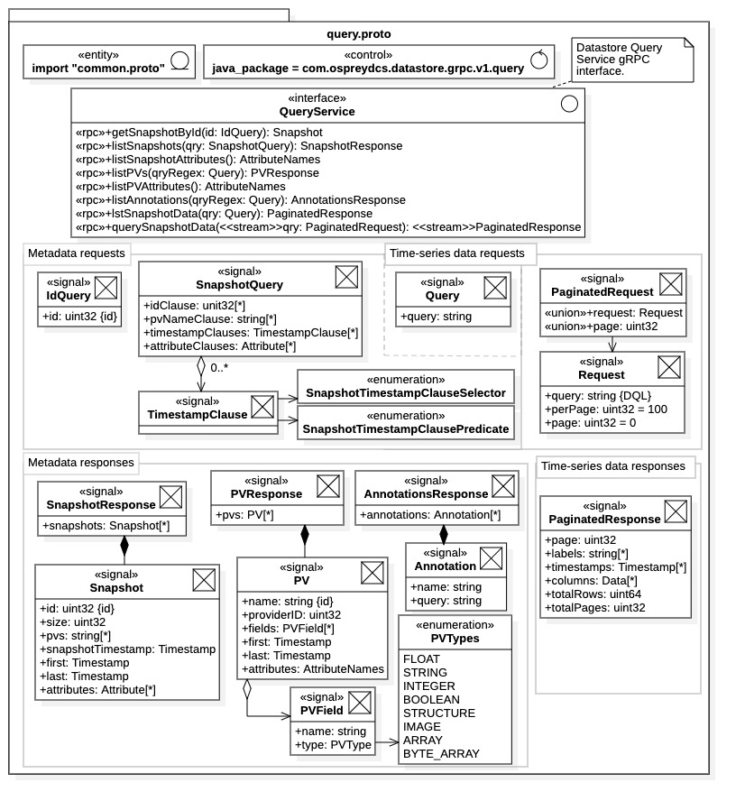

Figure 10: query.proto - Datastore Query Service gRPC communications framework

Within Figure 10, the Query Service request messages are in the center of the diagram while the response messages are at the bottom. To clarify the roles of the Query Service communications framework, Figure 10 explicitly separates the protobuf messages into 4 categories: 1) metadata requests, 2) time-series data requests, 3) metadata responses, and 4) time-series data responses. These categories help to associate the operations within the QueryService interface. Additionally, message relationships and associations are included in the diagram to refine their roles.

As seen in the diagram, most of the Query Service communications resources are dedicated to metadata requests. There is one protobuf message, Query, which is common to both metadata requests and time-series data requests. It contains a single field whose value depends upon the request context. It contains a regular expression for name matching when used as a metadata request (e.g., for a PV request). It contains a Datastore Query Language (DQL) statement when used for time-series data requests.

### Query Service Interface

Referring to Figure 10, the remote procedure calls available for the Query Service are all defined within the QueryService interface. All, but one, are non-streaming remote procedure calls. The single exception, querySnapshotData(), provides bi-directional streaming of large time-series data requests.

The interface is much wider than that for the Ingestion Service. The Query Service must support the broad search and query capabilities of the Datastore. Additionally, it supports both metadata and time-series data queries. Note that all non-streaming query operations are prefixed with “get” or “list” and the single streaming operation is prefixed with “query.”

Metadata requests return record sets specific to the metadata requested. There, metadata records are realized as protobuf messages defined in query.proto. All Time-series data requests return PaginatedResponse messages, either singularly in the case of listSnapshotData(), or as a data stream when using querySnapshotData(). Note the difference between *snapshot metadata* contained in the SnapshotResponse message, and *time-series data* contained in the PaginatedResponse message; this distinction is categorized within Figure 10.

##### Metadata Requests

The first 6 operations listed in the QueryService interface all support metadata queries. The following is a list of these operations, along with brief descriptions:

1. getSnapshotById(): Return the single snapshot record for the snapshot with given UID.
2. listSnapshots(): Return only snapshot records matching the given snapshot query (see below).
3. listSnapshotAttributes(): Return all attribute names within all archived snapshot records.
4. listPVs(): Return all PV records with name fields matching the given regular expression.
5. listPVAttributes(): Return all attribute names within all archived PV records.
6. listAnnotations(): Return all annotation records with name field matching a regular expression.

The remaining operations, listSnapshotData() and querySnapshotData(), support time-series data requests. Note that there is a unique operation, getSnapshotById(), which requires the singular request message IdRequest and returns a single Snapshot record.

Metadata query operations all return metadata records specific to the metadata type. Each metadata record has a protobuf message representation. Currently there are 3 types of metadata available from the Query Service, they are described in Section 2.2.2. Accordingly, there are 3 protobuf message types, 1) Snapshot, 2) PV, and 3) Annotation. Additionally, there are 3 protobuf message response types associated with metadata requests, 1) SnapshotResponse, 2) PVResponse, and 3) AnnotationsResponse. These response messages are simply aggregations of the respective metadata records.

The following is a list of metadata types along with their record type, request operations, arguments, and responses:

1. Snapshot metadata:
   1. Metadata record: Snapshot message.
   2. Query operation: getSnapshotById(IdQuery):
      1. Request message: IdQuery, containssnapshot UID.
      2. Response message: SnapshotResponse, aggregation of Snapshot messages.
   3. Query operation: listSnapshots(SnapshotQuery):
      1. Request messages: SnapshotQuery described below.
      2. Response message: SnapshotResponse, aggregation of Snapshot messages.
2. Data source (or “PV”) metadata:
   1. Metadata record: PV message.
   2. Query operation: listPvs(Query).
      1. Request message: Query, contains data source name-matching regular expression.
      2. Response message: PVResponse, aggregation of PV messages.
3. Annotation metadata:
   1. Metadata record: Annotation message.
   2. Query operation: listAnnotations(Query).
      1. Request message: Query, contains name-matching regular expression.
      2. Response message: AnnotationsResponse, aggregation of Annotation messages.

Each metadata response is simply a collection of metadata records. The snapshot metadata request requires a unique query argument of type SnapshotQuery. The remaining metadata requests require the general Query message argument. Snapshot metadata queries can be complex, use of the SnapshotQuery message is described in Subsection 3.8.3 below.

##### Attribute Names Requests

The additional operations listSnapshotAttributes() and listPVAttributes() are available for snapshot and PV metadata cases, respectively. These operations return all attribute names within their respective metadata records collection.

1. listSnapshotAttributes(): returns all attribute names within the snapshot records archive.
2. listPVAttributes(): returns all attribute names within the PV records archive.

Both operations return an AttributeNames message (defined in common.proto) which is simply an aggregation of strings, the attribute names. This a convenience feature allowing clients to search the Data Archive by formulating attribute-based queries from the response.

##### Time-Series Data Requests

Time-series query operations require the use of the Datastore Query Language (DQL) to formulate query statements. DQL is an SQL-like query language particular to the Datastore and is described in APPENDIX A. Use of DQL greatly simplifies the Query Service interface but requires familiarity with DQL.

**NOTE**: As an alternative to direct Query Service communications, the query API library described in Section 5.2 offers a high-level perspective of the Query Service. It contains query builder classes that isolate clients from DQL (and snapshot queries).

There are 2 time-series data query operations.

1. listSnapshotData(): Non-streaming, synchronous implementation of a time-series data request.
   1. Request: A single Query message containing the DQL query statement.
   2. Response: A single PaginagedResponse message containing time-series and related data.
2. querySnapshotData(): Streaming, asynchronous implementation of a time-series data request.
   1. Request: PaginatedRequest forward stream with initial Request message or data page index.
   2. Response: PaginatedResponse backward stream containing time-series data pages.

**NOTES:**

1. The non-streaming listSnapshotData() operation is a standard RPC invocation. It requires a single argument containing the DQL statement and returns a single response, blocking until completed. Since only one message is returned, this operation is gRPC message size limited. If request results are larger than the message size limit, the response is truncated to the request head. The fields within the PaginatedResponse message allow the client to determine if a truncation has occurred (see Subsection 3.8.6).
2. The streaming operation querySnapshotData() creates a bidirectional data stream between client and Query Service. There, PaginatedQuery messages flow to the Query Service and PaginatedResponse messages flow back to the client. This operation requires a refined use of the PaginatedQuery message. Specifically, the first PaginatedQuery message must contain a Request message to initiate the data stream. The Request message contains the DQL query statement and parameters for the resulting data stream. The procedure is described more fully in Subsection 3.8.6 below.

When using the streaming request, results are divided into data pages which are then transmitted within the PaginatedResponse response stream. The paging process mitigates any gRPC message size limitation and, consequently, the size of the response is essentially unlimited. All large time-series data requests should be made with the querySnapshotData() operation.

### Query Service Messages

Rather than individually describe each protobuf message within query.proto, the messages are described by category. Specifically, we consider the request type then described the messages used to perform the request. This format is better suited to the complexity of the Query Service gRPC interface.

Each individual query operation described above is further covered below by category. Each operation category is contained in a separate subsection presented in the following order: 1) 3.8.3 Snapshot Metadata, 2) 3.8.4 PV Metadata, 3) 3.8.5 Annotations Metadata, and 4) 3.8.6 Time-Series Data.

### Snapshot Metadata

Snapshot metadata is defined in the Snapshot protobuf message. The Snapshot message is a record containing all metadata associated with a single snapshot ingestion operation. A general snapshot metadata query is performed with the listSnapshots() operation in the QueryService interface. As seen in Figure 10 the results are returned as a SnapshotResponse message; this message is simply an aggregation of snapshot metadata records satisfying the request. A general snapshot metadata request is made using the argument SnapshotQuery message covered below. As to be seen, snapshot requests can be complex.

Alternately, a specific snapshot record may be requested directly by UID using the getSnapshotById() operation. An argument of type IdQuery must be used to identify the snapshot UID, it contains a single field, id, containing the UID for the requested snapshot. The operation returns a single Snapshot message containing the requested snapshot record.

##### Snapshot Metadata Results

Snapshot metadata request results are returned as aggregations of snapshot records, represented by the Snapshot message. As shown in Figure 10, it contains the following 7 fields:

1. id: The UID for the snapshot and the metadata record.
2. size: The size of the snapshot, the number of rows of correlated, time-series data.
3. pvs: The data source (process variable) names supplying time-series data. Equivalently, the column names of the time-series data.
4. snapshotTimestamp: The (unique) timestamp of the snapshot itself. Typically, this is the “trigger time” starting the acquisition process.
5. first: The earliest timestamp appearing within the snapshot time-series data set.
6. last: The latest timestamp appearing within the snapshot time-series data set.
7. attributes: A list of (name, value) attribute pairs associated with the snapshot.

A general snapshot metadata query can be formulated using any of the above fields, as described below.

##### Snapshot Metadata Requests

General snapshot metadata requests are made using the SnapshotQuery message as an argument to the listSnapshots() operation. Shown in Figure 10, the SnapshotQuery message contains 4 fields describing the request. The response returned by listSnapshots() will be a collection of snapshot records matching *all request fields* (i.e., the intersection of request fields).

Snapshot requests contain 4 “clauses”. The fields within SnapshotQuery form these “clauses” within the snapshot query. They are identified as follows:

1. idClause: Collection of snapshot UIDs. Results are exclusive, only snapshot records with the given snapshot UIDs are selected.
2. pvNameClause: Collection of data sources (process variable) names. These are the data sources contributing to a snapshot. Regular expressions can be used. The results are inclusive, the records for all snapshots matching any data source name are selected.
3. timestampClauses: Collection of TimestampClause messages identifying *target timestamp* and the comparison *time range* (see below). Results are exclusive, only snapshot records satisfying each supplied timestamp clause will be selected (i.e., the intersection of timestamp clauses).
4. attributeClauses: Collection of Attribute messages (defined in common.proto) identifying attribute (name, value) pairs for the snapshot. The results are inclusive; if a single attribute matches, the snapshot record is selected.

Again, the ultimate result set is determined by the intersection of each clause, that is, only snapshot records satisfying every clause are returned.

If a request field is not set, then it is inactive. Specifically, an unset field selects for the open query regarding that clause. Consequently, a SnapshotQuery instance containing no set fields *is the open query*; it will return *all* snapshot records currently in the Datastore archive.

Note that in preparation for a snapshot request by attribute clause, the operation listSnapshotAttributes() returns an AttributeNames message (defined in common.proto) containing all attribute names for all snapshot records within the Datastore archive. This operation can be invoked prior to the snapshot metadata request to obtain the collection of valid attribute names.

##### Timestamp Clauses

Timestamp clauses within a snapshot request are somewhat sophisticated. They require the configuration of at least one TimestampClause message. The process is highlighted in Figure 11, which includes detailed representations of the SnapshotQuery message. Along with the TimestampClause message, there are two required enumerations, SnapshotTimestampClauseSelector and SnapshotTimestampClausePredicate. The first enumeration selects the target timestamp within the snapshot record, either snapshotTimestamp, first, or last. The second enumeration selects for the type of time range used in timestamp comparisons, to be described below. Thus, each TimestampClause message identifies the target timestamp within snapshot records and a corresponding time range used for comparison.

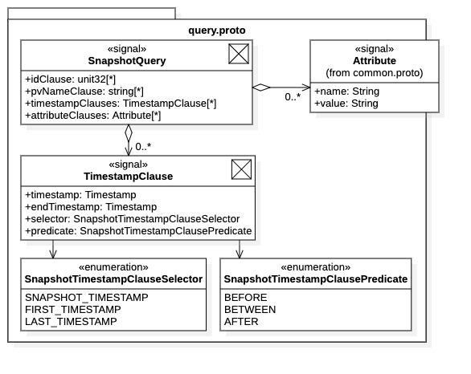

Figure 11: snapshot metadata request timestamp clauses

Referring to Figure 11, the TimestampClause message contains 4 fields described as follows:

1. timestamp: This is the timestamp *value* used for comparisons. The targeted timestamp within each snapshot record is compared against this value. See the selector field for identifying the target timestamp within snapshot records. See the predicate field for defining the comparison time range.
2. endTimestamp: An additional timestamp *value* used in BETWEEN comparisons (see predicate field below). It specifies the right endpoint for a time interval. Specifically, the time range used for BETWEEN comparison is the closed interval [timestamp, endTimestamp].
3. selector: Enumeration identifying the *target* timestamp within snapshot records for timestamp range comparisons. Enumeration values are as follows:
   1. SNAPSHOT_TIMESTAMP: Selects Snapshot.snapshotTimestamp as target timestamp.
   2. FIRST_TIMESTAMP: Selects Snapshot.first as target timestamp.
   3. LAST_TIMESTAMP: Selects Snapshot.last as target timestamp.
4. predicate: Enumeration defining the comparison *time range*. Let t be the target timestamp identified with the above selector field. Enumeration values create the following time ranges:
   1. BEFORE: selects all snapshot records with t ≤ timestamp.
   2. BETWEEN: selects all snapshot records with t ∈ [timestamp, endTimestamp].
   3. AFTER: selects all snapshot records with t ≥ timestamp.

Note that BETWEEN comparisons can also be formulated with two timestamp clauses, an AFTER clause and a BEFORE clause. Specifically, let timestamp = timestamp1 be the timestamp value in the AFTER clause and timestamp = timestamp2 be the value in the BEFORE clause. Then application of both clauses will be the result t ∈ {t : t ≥ timestamp1, t ≤ timestamp2 }, which is the intersection of time intervals t ∈ [timestamp1, ∞) ∩ (∞, timestamp2] = [timestamp1, timestamp2].

Complex time range selections can be created using collections of timestamp clauses. Subsets of timestamp clauses within the collection may target different timestamps within snapshot records. For example, one subset may target the Snapshot.first field while another subset targets the Snapshot.last field. Generalizing the concept, let $C_{i}$ be a timestamp clause, t*i* be the snapshot record timestamp targeted by $C_{i}$, and $T_{i}$ be the time interval described by timestamp clause. Now let $S≜\left\{S_{j}\right\}$ be the entire collection of snapshot metadata records $S_{j}$ within the Datastore archive. The result set $R_{C}$ of snapshot records selected by the entire timestamp clause collection $C≜\left\{C_{i}\right\}$ is then identified as $R_{C}=\left\{S_{j}∈S :{ S}_{j}.t_{i}∈T_{i} ∀C_{i}∈C\right\}$.

### PV Metadata

Metadata records for data sources (process variables), also called PV records, are represented by the protobuf message PV. PV metadata queries are made using the listPVs() operation using the general Query message as an argument. The query field within Query contains a regular expression string for matching the data source (process variable) name. The query result is returned as a PVResponse protobuf message, which is an aggregation of PV messages. They are the PV records with name fields matching the request.

##### PV Metadata Results

The results of a process variable (PV) metadata request are returned as PV records. A PV record, as realized by the PV message, consists of 6 fields. These fields are listed in Figure 10 and described as follows:

1. name: The unique string name of the data source (e.g., the PV name). This value is used as the unique identifier for the data source (process variable) throughout the archive lifetime.
2. providerID: The UID of the data provider associated with the data source (process variable). Note that a data source can be associated with only one data provider.
3. fields: A collection of data fields (properties) maintained by the data source. These fields are defined with the PVField message, described below. Data sources can have multiple data fields.
4. first: The earliest timestamp within archived data produced by the data source (process variable).
5. last: The latest timestamp within archived data produced by the data source (process variable).
6. attributes: A collection of (name, value) attributes pairs associated with the data source (PV).

The name field is used as the unique identifier for both the data source (process variable) and the PV record, names must be unique. Data fields (properties) of a data source are typically alarm conditions or other parameters associated with its data value. The PVField protobuf message is described below.

**WARNING**: Different data providers attempting to archive data produced by the same data source will create a conflict within the Datastore archive. Generally, this results in an ingestion exception. Thus, only a single providerID field is available in each PV record, which is assigned and/or verified during ingestion.

##### PV Metadata Requests

PV metadata requests are performed with the listPVs() operation using a Query message argument. The query field within the Query message contains the request query, a regular expression for matching the PV records name field. Thus, only the name field may be referenced in PV metadata queries. All PV records with matching name fields are returned in the PVResponse message.

**NOTES:**

* The listPVAttributes() operation within the QueryService interface is available to obtain the set of attribute names used within the collection of currently archived PV records. However, attribute names cannot be used in PV metadata requests. Nonetheless, they may be used to filter time-series data requests using DQL statements.
* The Query message is used as an argument for both for PV metadata queries and for non-streaming time-series data queries. It consists of a single character string formulating the query request. In the case of a PV metadata request the query string is *a regular expression* matching the PV name, while in the time-series request the query string is *a DQL statement*.

##### PV Fields

As inferred by the PV message field “fields”, a data source (process variable) may contain multiple data fields, or process variable fields. These fields are described with the PVField protobuf message. As seen in Figure 10, this message requires the enumeration PVType, which enumerates the supported data types for the data field.

To expand on the function of data fields we offer some examples.

* Consider the situation for a typical EPICS process variable. A process variable supplies a scalar numeric value along with limiting lower and upper bounds. It may then also contain an alarm status used to trigger alarm events whenever the value crosses a limit boundary.
* A data source produces images as its value, where an additional scalar field is used to characterize the overall image intensity. To maintain image integrity, the intensity field may also have limiting boundaries (e.g., to maximize resolution and minimize compression). An alarm status may be associated with the intensity parameter.

In both cases the alarm status may be archived along with the data source value. In the latter case the intensity parameter may be archived along with the image (or as a separate process variable). Both these situations can be captured with collections of process variable fields as defined by the PVField message.

A PVField message consists of a (name, type) pair which are identified as follows:

1. name: The name of the process variable field. PV fields are generally referenced by name.
2. type: The data type for the process variable field. Any of data types enumerated in PVType.

PV field values may be obtained as time-series data when performing time-series data requests. They are referenced within DQL using the naming convention described below. Thus, although PV fields cannot be utilized in PV metadata requests, they can be used when formulating DQL statements for time-series data requests.

**NOTES**:

1. Process variable fields are generally referenced by their name, with respect to their associated data source name. To clarify, consider the case of a scalar process variable data source with name PV01. Let process variable PV01 have data field alarmStatus. Then within DQL the process variable field is referenced as PV01.alarmStatus. The process variable value is typically referenced as PV01.value, or simply PV01 if the context is clear.
2. Data types for process variable fields, as seen in the PVType enumeration, are those supported by the Datastore. This includes complex types Image, Array, and Structure.

Within DQL, the value of the data source itself (i.e., the “value field”) is identified as name.value where name is the name of the data source. Alternately, when using DQL the value field can be referenced simply as name when the context is clear, this then expands to name.value.

### Annotations Metadata

In the current release, annotations metadata consists solely of “named queries.” These are DQL statements of particular interest that users wish archived. Annotations metadata are archived as annotation records, which are realized with the Annotation protobuf message.

Annotation records consist of the following two fields:

1. name: The unique name identifier for the annotation (a character string).
2. query: The named DQL query statement.

Annotation requests are performed using the listAnnotations() operation. The argument for the request is a Query message containing a regular expression for matching annotation records name field. Request results are returned in an AnnotationsResponse message, which is a collection of Annotation messages matching the request.

**NOTE**: The intent is to support more general archive annotations with future Datastore releases, including user notes, data associations, and user calculations.

### Time-Series Data

Time-series data requests were covered briefly in Subsection 3.8.1 when describing the QueryService interface. Here we cover the process in greater detail, including the data messages, data streaming, and asynchronous implementation.

In general, time-series data is represented by common messages defined within common.proto. All common messages are described in Section 3.4 and the time-series data messages covered in detail within Subsections 3.4.2 and 3.4.3. Time-series data resulting from a time-series data request are contained within one-or-more PaginatedResponse messages produced by the Query Service. Time-series data requests are made using the listSnapshotData() and querySnapshotData() operations, both operations return results as PaginatedResponse messages.

The non-streaming listSnapshotData() request requires the general-purpose Query message as an argument; it contains a DQL statement formulating the request query. A single PaginatedResponse message is returned and the operation blocks until complete.

The bidirectional streaming querySnapshotData() request requires a PaginatedRequest message as an argument; it must contain a Request message comprised of the DQL query statement and additional parameters for data stream configuration. The operation does not block, it establishes the data stream then returns. Henceforth, the client and Query Service exchange PaginatedRequest and PaginatedResponse messages through the data stream. Thus, large time-series data sets can be transmitted to the client through the streamed PaginatedResponse messages.

**NOTES**:

* Because only one response message is returned for a non-streaming time-series request, the listSnapshotData() operation works correctly only for small data requests. It accommodates only data requests whose result can be contained within a single gRPC message. Consequently, listSnapshotData() is constrained by the current gRPC message size limit (default 4 Mbytes). If a request is too large the response is truncated to the result head. It is possible for the client to determine if a truncation occurred by inspecting the fields of the returned PaginatedResponse message (see below).
* The streaming request operation querySnapshotData() can accommodate all time-series data requests; it will continue to stream PaginatedResponse messages until the entire data request is fulfilled. Consequently, large time-series data requests should always use this operation.

##### Data Paging

In streaming requests, results appear as indexed data pages, each page containing a portion of the full time-series data request. Here we briefly describe paging process since some familiarity with the data paging is needed to appreciate all data fields within the PaginatedResponse message. After invoking the querySnapshotData() operation a stream of PaginagedResponse messages flows back to the client. Each message contains one data page of the full result, the page index is contained within the message. Data pages typically arrive in order of index; however, this condition is *not* guaranteed. Additionally, the client is expected to either request all data pages (without acknowledgment) or request each page individually. More details on streaming requests are covered below.

##### Time-Series Data Results

Results of a time-series data request are always returned in PaginatedResponse messages, regardless of the specific request operation (i.e., streaming, or non-streaming). The message contains 6 fields. Some fields contain requested time-series data while other fields identify the current response relative to the overall request. Referring to Figure 10, the fields of PaginatedResponse are listed below, along with a description.

1. page: The current data page index. Page indices are 1-based. The full request consists of pages {1, …, totalPages}, where totalPages is field 6 below.
2. labels: The column names for the time-series data contained in field 4, columns. These are identically the names within the Data messages forming the columns field. Column names are typically the names of the data sources producing the data (e.g., process variable names).
3. timestamps: The ordered list of timestamps for the time-series data. All data columns within field 4 should have the same length as this field. Timestamps are assigned by row index.
4. columns: The correlated, time-series data. This field is an unordered aggregation of Data messages, each containing a time-series data set produced from the named data source (process variable). (Recall that a Data message is named data set containing an ordered aggregation of heterogeneous Datum values.)
5. totalRows: The total number of time-series data rows needed to satisfy the full data request. Includes all data columns.
6. totalPages: The total number of data pages needed to satisfy the full data request.

Note that clients can determine the allocation required to store the full result from a received PaginatedResponse message. The message contains the total number of data rows for the full request in the totalRows field. The number of columns can be determined from the size of the columns field. The column type can be determined from a contained Datum instance (data columns are typically a single type since they are produced by the same data source).

##### Non-Streaming Requests

Non-streaming (blocking) time-series data requests are performed with the listSnapshotData(Query) operation. A DQL statement specifying the request is first used to populate a Query protobuf message, it is then offered to the listSnapshotData() operation. The results are returned as a single PaginatedResponse message containing the time-series data described above.

Again, it is important to emphasize that if the result set is larger than the current gRPC message size limit (4 Mbytes default) the full request will not be returned*; the result is truncated to the request head*. It is possible to check for truncation by inspecting the returned PaginatedResponsed message. If the totalPages field is greater than 1, then the results are truncated. For a quantitative determination of the truncation, one compares the totalRows field against the timestamps field. If the totalRows field is larger than the length of the timestamps field, the result has been truncated and the size of the missing data (in rows) is given by the difference. *For large data requests always use streaming operations*.

##### Streaming Requests

Streaming time-series data requests are performed with the querySnapshotData(PaginatedRequest) operation. A PaginatedRequest message is required for a streaming time-series data request. Messages of this type are also required to maintain the data stream once the request has been initiated.

Referring to Figure 10 we see the PaginatedRequest message contains a union of two fields.

1. request: A Request protobuf message. Used to initiate a data stream.
2. page: A data page index. Used to request a data page within an established stream.

Being defined as a union, the PaginatedRequest message contains only one of the two fields, and the field assignment determines the message function within the data stream.

To initiate a streaming time-series data request the PaginatedRequest must contain a Request message. That is, the PaginatedRequest argument in the querySnapshotData(PaginatedRequest) operation must contain a Request message. Again, referring to Figure 10 we see that the Request message contains the following 3 fields:

1. query: A string containing a DQL statement, formulating the time-series data request.
2. perPage: The size of each data page, in rows. If left unsigned this value defaults to 100. Note that this value can be used as a performance tuning parameter, where larger pages reduce network traffic. However, if the value is too large page allocation can exceed gRPC message limits; in that case pages will be truncated. Be especially weary with wide requests (i.e., requests containing thousands of data columns).
3. page: The page index of the first data page sent to the client. Page indices are 1-based. Setting this value to 0 requests the full result set; no further PaginatedRequest messages are required. Zero is the default value. Setting the value greater than 0 initiates a managed data stream (see below).

From the above field descriptions, we see that the Request message is used to formulate the time-series data request and configure the resulting data stream supporting the request. Additionally, by setting the page field to a positive value, a managed data stream is established. The Query Service responds to a nonzero page value by first sending back the requested data page. Clients can then inspect the page, requesting additional pages by index (e.g., in order of interest), terminating the data stream when satisfied.

##### Managed and Unmanaged Data Streams

From the above discussion we see that streaming time-series data requests can be either *managed* or *unmanaged*. A managed data stream implies that the client directly controls the data flow, here the client requests specific data pages by index. An unmanaged data stream implies that the data flow is dictated by the service, here the Query Service transmits data without interaction from the client.

Both managed and unmanaged streams are established with the Request message within the PaginatedRequest argument of querySnapshotData(). The Request message contains the DQL query statement in the query field, and data stream management is determined by the page field. We have the following:

* Unmanaged data stream (page = 0): The Query Service streams back all pages of the request without client interaction.
* Managed data stream (page = *n* > 0): The Query Service returns the data page with index *n*. The client then requests the next data page by sending a PaginatedRequest message containing the next page index (i.e., by setting the page field). The Query Service responds by transmitting the desired data page within a PaginatedResponse message. The process continues until the client terminates the stream or the full time-series data request is recovered.

Note that since the data stream is bidirectional, for managed streams clients can request batches of data pages. A client sends multiple PaginatedRequest messages containing the desired page indices, the client is not required to wait.

For both managed and unmanaged streams, the Query Service notifies the client when the full request has been transmitted with a “completed” stream notification.

##### Asynchronous Communication

Because the querySnapshotData() operation does not block, streaming time-series data requests can be implemented asynchronously. The Query Service supports asynchronous streaming. However, unlike ingestion processing, a time-series data request supports only one data stream.

For example, data processing can be implemented with independent execution threads. For unmanaged streams, threads can be attached to incoming data pages, clients coordinate the processing. For managed streams thread pools could be assigned to batches of data pages. Although only one data stream is available, multi-threading may improve performance if data processing is not strictly serial.

## Query Service Realization

Figure 12 is a diagram depicting the Query Service gRPC interface defined in query.proto as realized in the Java programming language. The diagram is not exhaustive, it captures the essential features required for client communications in Java. It contains the gRPC features required for most common Java communications with the Query Service. However, the resources needed to create secure connections between clients and the Query Service are not included. For additional information on gRPC communications see the online [documentation](https://grpc.io/) [3], the gRPC quick start [guide](https://grpc.io/docs/languages/cpp/quickstart/#install-grpc) [13] (C++ guide, includes gRPC installation), the Java gRPC quick start [guide](https://grpc.io/docs/languages/java/quickstart/) [16], or APPENDIX C. (Section C.5 in APPENDIX C describes the resources required for secure Java communications.). Readers familiar with Java protobuf can skip this section without consequence, although resource names and locations are specified in the following subsection.

### Java Implementation

The QueryService interface and all supporting protobuf messages defined in query.proto (and depicted in Figure 10) are contained in the Java package com.ospreydcs.datastore.grpc.v1.query. However, the messages have different directory locations than the QueryServiceGrpc class. Exact directory locations depend upon the Maven project build settings, however in the default configuration the protobuf messages have the start directory target/generated-sources/protobuf/java, while the QueryServiceGrpc class has the start directory target/generated-sources/protobuf/grpc-java. The subdirectories and names follow according to the Java standard for package locations.

Unlike the case for the Ingestion Service, the protobuf messages defined within query.proto are implemented in separate files. Specifically, each message class is independent of any enclosing class and, therefore, contained in a separate file according to the Java standard. This condition is a consequence of the protobuf compiler directive java_multiple_files = true within the query.proto file. See Subsection 3.3.2 for a complete listing of generated files.

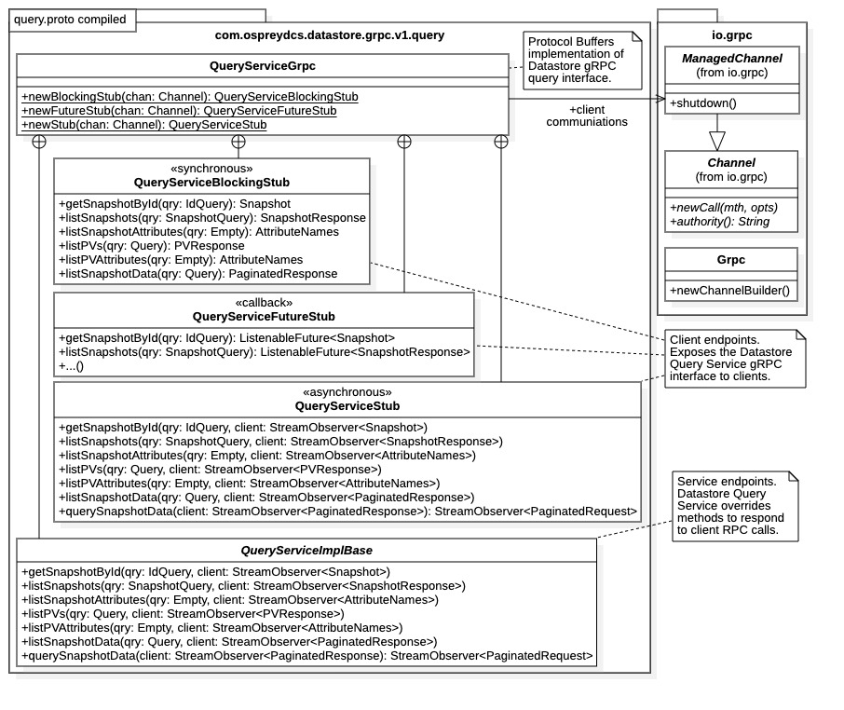

Figure 12: query.proto - gRPC Query Service interface realization in Java

### Query Service Interface

One can see from Figure 12 that the Query Service interface Java realization is exactly analogous to the Ingestion Service interface Java realization. The protobuf compiler generates the entire Query Service interface within the single class QueryServiceGrpc. Analogous to the Ingestion Service interface implementation IngestionServiceGrpc, this class functions as a namespace for the appropriate communications stubs and the base implementation for service endpoints. Specifically, the communications stubs and implementation base are realized as independent static classes enclosed within the QueryServiceGrpc class.

In accordance with Java gRPC, all client communications stubs are suffixed with the identifier “Stub.” The communications stubs expose the remote procedure calls defined in QueryServce of query.proto. The enclosed class QueryServiceImplBase contains the service endpoints for the remote procedure call operations. As such, the Datastore Query Service implements a service class inheriting from the QueryServiceImplBase to respond to the operations defined QueryService. Figure 12 identifies the methods and their corresponding signatures that must be overridden to respond to clients through gRPC.

### Client Communications

Client communications are supported by the gRPC communications stubs shown in Figure 12. The communications model is determined by the class type of the stub.

1. QueryServiceBlockingStub: Non-streaming, blocking (synchronous) communication.
2. QueryServiceFutureStub: Callback communication (non-blocking “synchronous”).
3. QueryServiceStub: Streaming communications (facilitate asynchronous communication).

The non-blocking stub QueryServiceStub is the only client stub offering the streaming time-series data request operation querySnapshotData(). The other two stubs support only the non-streaming time-series data request listSnapshotData(). However, all metadata requests are available in every communication stub, as these operations are all non-streaming.

The QueryServiceGrpc class provides static methods for generating the communications stubs of the desired type.

1. newBlockingStub(): Creates a QueryServiceBlockingStub for non-streaming communication.
2. newFutureStub(): Creates a QueryServiceFutureStub for callback communication.
3. newStub(): Creates a QueryServiceStub for streaming communications.

All stub creation methods require a Channel object argument used to establish network connections to the Query Service (see below).

Note the use of the com.google.protobuf.Empty message which inherits from message base class com.google.protobuf.GeneratedMessageV3. This message type is used in Java gRPC implementations whenever a remote procedure call has no arguments. This is the case for operations listSnapshotAttributes() and listPVAttributes(). Referring to Figure 12 we see that clients are required to provide Empty messages when invoking these operations. Note that the class static method Empty.getDefaultInstance() returns the default instance for the message type; it can be used whenever an Empty message is required. Creation of new Empty instances is not necessary.

##### Channel Creation

To obtain a communications stub for client communications, a communications Channel object must first be constructed. The Channel object contains the network address of the Query Service and any credentials required for connection. The process is exactly analogous to that for client communications with the Ingestion Service, which is fully described in Subsection 3.7.3.

A brief outline of the process is presented here.

* Obtain a ManagedChannel object, which is derived from the Channel class.
  + Insecure ManagedChannel objects are available through ManagedChannelBuilder instances obtained from static class methods ManagedChannelBuilder.forAddress() and ManagedChannelBuilder.forTarget().
  + Secure ManageChannel objects must be created with a ManagedChannelBuilder instance obtained from the utility class io.grpc.Grpc within the Java gRPC library. A credentials object derived io.grpc.ChannelCredentials must first be configured.
* Obtain a communication stub:
  + Offer the ManagedChannel instance to a QueryServiceGrpc stub creation static method.
* Invoke the shutdown() method on the ManagedChannel instance before discarding.

Note that the last step is a housekeeping measure to ensure gRPC resources are released when no longer needed. For additional information on creating Channel objects and communications stubs, including security credentials, see Section C.5 of APPENDIX C.

##### Non-Streaming Communications

The enclosed class QueryServiceBlockingStub implements all non-streaming operations within the QueryService interface using synchronous, blocking communications. The querySnapshotData() operation is not available within this communications stub. Here, remote procedure call invocations are straightforward; message instances are offered as arguments (when required) and message instances are returned as results. Metadata queries and the non-streaming time-series data request operate as described in Section 3.8. Note that the Java gRPC implementation of protobuf messages requires the use of message builders to configure remote procedure call arguments. Results are unpacked using the message class getter methods as per the JavaBean standard.

Non-streaming communications are blocking communications. Once a method within the QueryServiceBlockingStub is called, it does not return until the operation has completed. These operations are implemented synchronously within the Query Service, that is, on the main execution thread. The returned result message will be fully populated and available for inspection.

The above conditions generally present no limitations for metadata requests, as results are typically small. However, one must be weary when using the listSnapshotData() time-series data request. Time-series data requests producing results larger than the gRPC message size limits will be truncated. The non-streaming listSnapshotData() operation is not acceptable for large time-series data requests.

##### Callback Communications

The communications stub QueryServiceFutureStub provides callback communications for a Query Service client. Again, the streaming time-series data request querySnapshotData() is not supported by this communications stub. Referring to Figure 12, this communications stub is almost identical to the QueryServiceBlockStub implementation. The exception is that all operations return a ListenableFuture<> interface. The generic parameter for the interface is the response type, the protobuf message type of the result. The ListenableFuture<> interface is part of the Google concurrency library in the com.google.common.util.concurrent package. The interface allows clients to block on the ListenableFuture.get() operation, or register an execution thread to spawn when the operation is completed.

Note that callback communications can be considered a hybrid between synchronous communications and full asynchronous communications. Here operations do not block but, instead, return a ListenableFuture<> interface. This condition allows clients to wait for completion, set up a completion notification thread, or set up a result processing thread. To do so the ListenableFuture<> interface provides the following operations:

* get(): Blocks until completed, returning the result message class instance.
* addListener(Runnable, Executor>: Spawns a thread with the given executor when complete.

Note that remote procedure call results can be recovered by waiting on the ListenableFuture<>.get() blocking operation. Alternatively, the client can implement independent response threads using the addListener() operation. Thus, the callback communications stub offers a limited form of asynchronous communication.

##### Streaming Communications

Streaming client communication with the Query Service is provided by the QueryServiceStub class. Referring to Figure 12, the client is required to provide a StreamObserver<> interface implementation for every operation. The interface generic parameter is bound by result type returned by the operation. Thus, clients must implement a StreamObserver<> interface to receive all request results (through the onNext() operation).

To ease implementation, clients typically maintain instances of both QueryServiceBlockingStub and QueryServiceStub to perform query requests. The former is used for non-streaming metadata requests while the latter for large time-series data requests. Consequently we focus here on the bidirectional streaming operation querySnapshotData() which is available only in QueryServiceStub.

The querySnapshotData(StreamObserver<PaginatedResponse>) operation is non-blocking, no data is transmitted, only interfaces are exchanged. Comparing the QueryService definition in Figure 10 with its Java gRPC implementation in Figure 12, we see that the argument and result are reversed. The client is required to provide an implementation of StreamObserver<PaginatedResponse> as the argument for the operation (i.e., rather than a PaginatedRequest as defined in the proto file). This implementation must be capable of correctly receiving and processing the requested time-series data through a stream of PaginatedResponse messages supplied by the Query Service.

In response to the querySnapshotData() operation, an interface of type StreamObserver<PaginatedRequest> is returned to the client. This interface, implemented by the Query Service, allows clients to send PaginatedRequest messages used to manage a data stream. The process for stream management of time-series data requests is covered in Subsection 3.8.6.

We outline the querySnapshotData() operation for the Java implementation.

1. Invoke the querySnapshotData() operation:
   1. The client supplies an implementation of the StreamObserver<PaginatedResponse> interface which receives data pages containing time-series data.
   2. A StreamObserver<PaginatedRequest> interface is received. It is used to configure and initiate the data stream using a Request message, then managed the resulting data stream.
2. Configure the data stream:
   1. The first PaginatedRequest message sent to the Query Service configures the data stream.
      1. It *must contain* a Request message.
   2. The Request message specifies the time-series data request and the data stream parameters. It contains the following attributes:
      1. query_: The DQL request statement.
      2. perPage_: The number of time-series data rows per data page.
      3. page_: The index of the first page to be returned. Page indices are 1-based.
   3. The Request.page_ attribute determines whether the stream is managed or unmanaged.
      1. Unmanaged: Set the page index to 0 (the default value). Instructs the Query Service to transmit all data pages without acknowledgement.
      2. Managed: A positive index value is provided. The data page with the given index is returned. All following data pages must be explicitly requested by page index within a PaginatedRequest message.
3. Initiate the data stream:
   1. Once the Request message is configured and built, it is used to populate the first PaginatedRequest message.
   2. The client transmits the first message to the Query Service using the onNext(PaginatedRequest) operation on the StreamObserver<PaginatedRequest> interface returned by the Query Service.
4. Manage the data stream:

NOTES:

The client receives PaginatedResponse messages from the onNext(PaginatedResponse) method of the StreamObserver<PaginatedResponse> interface given to the Query Service.

The client sends PaginatedRequest messages to the Query Service using the onNex(PaginatedRequest) method of the StreamObserver<PaginatedRequest> interface supplied by the Query Service.

* 1. The Request.page_ attribute was set to 0:
     1. All data pages of the request are sent to the client as PaginatedResponse instances within repeated onNext(PaginatedResponse) invocations.
     2. An onCompleted() operation is invoked by the Query Service when the request is completed.
  2. The Request.page_ attribute was set to a positive index value:
     1. The client receives a single PaginatedResponse instance containing the requested data page.
     2. The client requests the next data page by specifying its index within a PaginateRequest message and invoking the onNext(PaginatedRequest) operation.
     3. The process continues until onCompleted() is invoked by either client or service.

1. Terminate the data stream:
   1. Once the full data request is complete the client will receive an onCompleted() operation call on its interface implementation. The client responds in kind with an onCompleted() acknowledgment terminating the data stream.
   2. The client may interrupt the data stream by invoking onCompleted() on the received interface. The Query Service responds in kind with an onCompleted() acknowledgment terminating the data stream.

Note, if any errors occur during data transmission the client will receive an onError() method call on its StreamObserver<PaginatedResponse> interface implementation, and the data stream will be terminated.

### Service Communications

The enclosed class QueryServiceGrpc.QueryServiceImplBase provides service endpoints for the remote procedure call operations defined in QueryService of query.proto. In the Java gRPC implementation there is only one base class for implementing service endpoints, and it supports the streaming communications model. In Figure 12 we see the StreamObserver<> interface is provided as method arguments to communicate with clients. Thus, in Java gRPC service communications are essentially always streaming communications. The service may choose to implement the communications synchronously on the main execution thread or asynchronously on independent execution threads.

The Query Service executes responses on separate execution threads. The query request itself is dependent upon the underlying InfluxDB and MongoDB databases. Nevertheless, request results are transmitted on separate threads as available. Thus, the Query Service does support asynchronous communications for the querySnapshotData() streaming request. Note, however, that only one data stream is available per request.

The Datastore Query Service implements a child of QueryServiceImplBase overriding the remote procedure call methods to receive client calls. Referring to Figure 12, all the non-streaming remote procedure call operations receive both a message instance argument and a StreamObserver<> argument, the latter is used to transmit the response to the client. The listSnapshotAttributes() and listPVAttributes() methods are somewhat exceptional in that they do not require arguments; the Java gRPC implementation substitutes the Empty message in these cases, which is ignored. For the streaming operation querySnapshotData() the class provides a method with the same signature as the non-blocking communications stub. The method accepts a StreamObserver<PaginatedResponse> interface, which is used to transmit time-series data to the client. The Query Service returns an implementation of the StreamObserver<PaginatedRequest> interface which is used to process data requests from clients and manage the subsequent data stream. The data stream management for this operation is described in the previous subsection.

# Ingestion Service API Libraries

There are currently two Ingestion Service API libraries available, both implemented in the Java programming language. One is contained in the *datastore-provider-lib* project within the Datastore repository, the other is contained within the *datastore-admin* project. The first library provides a wide, low-level API supporting ingestion through Java native types. It also supports ingestion of EPICS PVStructure normative types available in the org.epics.pvdata.pv Java library. The NTTable normative type is of special interest and is essentially a subclass of the PVStructure type. The second API library provides a narrow, high-level API supporting ingestion with DataFrame objects, which are defined within the library. The DataFrame type is essentially equivalent to the EPICS NTTable type, and instances of DataFrame can be constructed from NTTable instances. The DataFrame is the singular unit of ingestion for the latter API library, which is used as the interface to the Aggregator system of the Machine Learning Data Platform.

Both API libraries utilize connection factories to create user interfaces, although the details are different (connection factories are described in APPENDIX B). The library connection factory establishes connection with the Datastore Ingestion Service and creates an API implementation using the connection. Thus, users select for both the desired API and the desired Ingestion Service host server.

## Native Java API

The *datastore-provider-lib* project contains a single API library, which is described by Figure 13. The library provides an API supporting data ingestion using Java native types, and EPICS PVStructure instances. This API library is typically used by data providers requiring added flexibility, those requiring data ingestion other than by EPICS NTTable instances. As seen in Figure 13, it has a single, wide interface, DatastoreClient, which provides all communications between the data provider client and the Datastore Ingestion Service. The interface DatastoreClient is contained in the com.ospreydcs.datastore.provider.lib Java package.

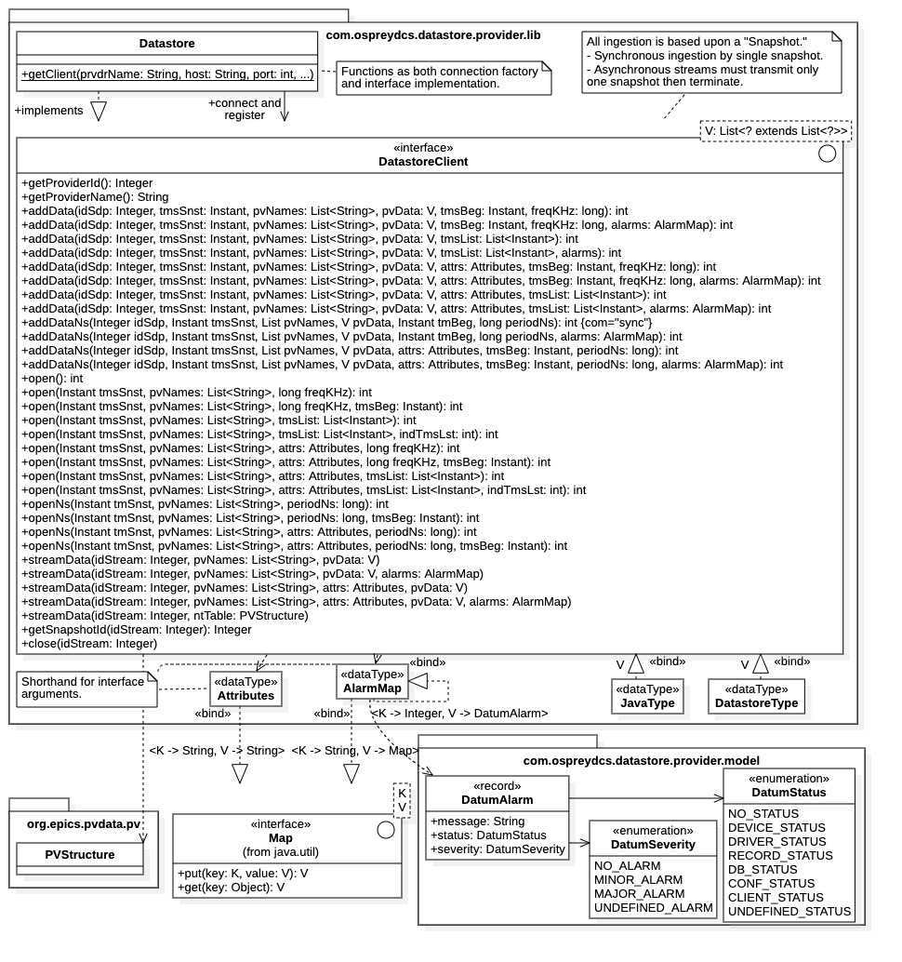

Figure 13: Ingestion Service API library supporting Java native types

The added flexibility comes at the cost of additional complexity, as seen with the abundance of interface operations in Figure 13. The ingestion process here is more complicated, requiring several steps for streaming ingestion. The DatastoreClient interface is extremely wide requiring numerous interface operations to support all ingestion options.

### Diagram Shorthand

The diagram of Figure 13 uses several shorthand notations that are not part of the library implementation. Note that the data type for ingestion is specified by an interface generic parameter V; however, this condition is overly constraining. In implementation, generic parameters are provided for each ingestion operation; thus, one interface is capable of ingesting multiple data types. However, only one data type can be specified for each ingestion operation.

Additionally, the data types Attributes and AlarmMap do not appear in the library, they are simply shorthand for template bindings of the java.util.Map<> generic interface. Specifically, Attribute represents binding Map<String, String> and AlarmMap represents binding Map<String, Map<Integer, DatumAlarm>.

Figure 13 contains the fictitious types JavaType and DatastoreType. These types are bound to the generic parameter V. The appearance of these fictitious types is meant to indicate that the DatastoreClient interface can support ingestion of both Java native types and any complex data type supported by the Datastore, such as images, one-dimensional arrays, and data structures. Native Java types are represented by JavaType and Datastore supported types are represented by DatastoreType.

To summarize the shorthand notation, in implementation the shorthand notations expand to the following:

* V = java.util.List<? extends List<?>>: the snapshot time-series data type.
* Attributes = java.util.Map<String, String>: optional snapshot (name, value) attributes.
* AlarmMap = java.util.Map<String, Map<Integer, DatumAlarm>: time-series value alarm conditions.
* JavaType: refers to types within the Java language.
* DatastoreType: refers to Datastore supported types of Image, Array, and Structure.

### Connection Factory

Note that the class Datastore functions both as an implementation class for interface DatastoreClient and its connection factory. The Datastore class has multiple static methods getClient(…) with various argument signatures for connecting with the Ingestion Service and returning a DatastoreClient interface. Data provider clients register with the Ingestion Service through the getClient() methods, the provider name is a required argument. The data provider may optionally supply attributes. As seen in Figure 13, both implementation class Datastore and interface DatastoreClient are contained in the Java package com.ospreydcs.datastore.provider.lib.

Note that the getProviderId() and getProviderName() operations are available within the DatastoreClient interface to recover the data provider UID and unique name, respectively. These properties are part of the provider registration process for the Ingestion Service.

### Ingestion Operations

Ingestion with the DatastoreClient interface is performed with the addData(), addDataNs(), open(), openNs(), and streamData() operations. The addData() and addDataNs() support non-streaming ingestion while the open(), openNs(), and streamData() support streaming data ingestion. The details of these operations are covered more fully in subsections below.

The ingestion operations have multiple argument signatures to accommodate the variety of ingestion options. However, the argument names and functions are common among operations. All arguments are considered below.

##### Arguments

The list below contains all possible ingestion operation arguments. Note that arguments names are particular to the diagram in Figure 13, implementation details may differ.

* idSdp: The UID of the snapshot data provider. This value is available through getProviderId().
* idStream: The ID of a data stream. This value is returned from open() and openNs().
* tmsSnst: The snapshot timestamp, e.g., the acquisition “trigger time.” This value must be unique.
* pvNames: An ordered list of data sources (process variables) producing snapshot time-series data.
* pvData: Snapshot time-series data as generic type V (a list of lists). This is the general case.
* ntTable: Snapshot time-series data as an EPICS PVStructure, must be NTTable compatible.
* tmsBeg: The timestamp of the first time-series data value, i.e., acquisition start time.
* freqKHz: The acquisition sampling frequency for all time-series data (in kHz).
* periodNs: The acquisition sampling period for all times-series data (in nanoseconds).
* tmsList: The ordered list of timestamps for all (correlated) time-series data.
* indTmsLst: Index within the timestamp list specifying the first timestamp to be assigned.
* attrs: A collection of (name, value) attribute pairs for the snapshot (as metadata).
* alarms: A collection of alarm conditions for each snapshot time-series data value.

All arguments except idSdp and idStream are associated with a “snapshot” data set. We describe each argument in further detail below, by category, starting with the snapshot data.

### Snapshot Data

The general unit of ingestion supported by the DatastoreClient interface is the “snapshot.” A snapshot consists of columns of correlated time-series data sets and the shared collection of timestamps associated with each data column (i.e., there is one timestamp for every column row). Each data column must be labeled with the data source (process variable) name supplying the data column. Additionally, optional data for a snapshot may include a list of (name, value) attribute pairs and/or a collection of alarm conditions for each time-series data value.

Alternatively, the time-series data may be supplied as an NTTable-compatible PVStructure when using streaming ingestion (see below). In this case the named data columns must match the list of data source (process variable) names.

##### Timestamps

Timestamps are represented as java.time.Instant objects within the DatastoreClient interface. The timestamps for each correlated time-series data column may be specified in one of 4 ways:

1. Arguments tmsBeg and freqKHz: Starting acquisition time and sampling frequency (in kHz).
2. Arguments tmsBeg and periodNs: Starting acquisition time and sampling period (in ns).
3. Argument tmsList: The full, ordered list of timestamps for each row of the data columns.
4. Arguments tmsList and indTmsLst: A timestamp list and initial offset within the list.

Ingestion operations supporting case 2) always have the suffix “Ns” attached to their name, specifically addDataNs() and openNs(). Whenever the argument tmsBeg is not included, its value defaults to the snapshot timestamp.

Within each ingestion operation an additional timestamp is always provided with the argument tmsSnst. This is the timestamp of the snapshot itself. This timestamp typically represents the “trigger time” for the acquisition process. Snapshot timestamps must be unique, otherwise an ingestion exception occurs.

The following conditions apply to all timestamps with a snapshot data set:

* Snapshot timestamps must be unique.
* If no initial timestamp is offered in cases 1) or 2) then the snapshot timestamp tmsSnst is used as the start time for acquisition.
* In case 3) and 4) only one timestamp list tmsList can be supplied per snapshot. This is true even for streaming ingestion.
* In case 4) there is an offset for timestamp assignment for the correlated time-series data. The first timestamp assigned is given by index indTmsLst, the rest follow in order.

##### Time-Series Data

Within the DatastoreClient interface, snapshot time-series data is represented as the generic parameter type V, or the EPICS normative type PVStructure. Ingestion operations contain the time-series data within the arguments pvData or ntTable, respectively. Note that the PVStructure normative type is defined in the EPICS library org.epics.pvdata.pv. When this case is used, the supplied argument must be NTTable compatible. Only one ingestion operation supports this type, streamData(Integer, PVStructure). This is a streaming operation accepting the data stream identifier and the time-series data set, respectively.

For general ingestion operations time-series data pvData has the expanded generic type V = java.util.List<? extends List<?>>. This generic type may be interpreted as an ordered list of data column of arbitrary type. The internal column vectors must all be of the same length. The length of the outer list must match the length of the data source name list provided as a co-argument to any ingestion operation.

Note that the pvData argument may also be interpreted as an array of time-series data values where the rows are all time-correlated (i.e., data having the same timestamp) and the columns represent data sets produced by a single data source. This is in direct analogy to the case for an ntTable argument. To summarize,

* pvData: The Java type List<? extends List<?>>, a list of lists forming a value array. The internal lists are columns of time-series data supplied by a single data source. Each row of each column is time-correlated.
* ntTable: An NTTable-compatible PVStructure instance. The columns are labeled by data source names and contain data supplied by that source. The rows must be time correlated.

##### Snapshot Attributes

Attribute for each snapshot may be optionally assigned. Within Figure 13, ingestion operations contain the argument attrs offer snapshot attributes assignment. This argument is of fictitious type Attributes which expands to Map<String, String>. The map contains a collection of (name, value) pairs, each pair representing a named snapshot attribute value. Snapshot attributes are stored as metadata within the Datastore archive. Query Service clients can query snapshots and their contents by attribute values.

##### Alarm Conditions

Snapshot data sets may include optional alarm conditions for each time-series data value. An alarm condition is represented by the data type DatumAlarm within the com.ospreydcs.datastore.provider.model package, as shown in Figure 13. As seen in the figure, an alarm condition consists of a message string, a status enumeration, and a severity enumeration. Alarm conditions are stored in the time-series data archive within the Datastore, in correspondence with their time-series values.

Within the figure, ingestion operations providing alarm condition assignment contain the argument alarms (this may differ than the actual implementation). The alarms argument is of fictitious type AlarmMap and contains the entire set of alarm conditions for the time-series data set. As described above, AlarmMap expands to the Java generic type Map<String, Map<Integer, DatumAlarm>. Alarm conditions within the alarms argument are retrieved as alarm.get(pvName).get(indRow), where pvName is the data source (process variable) name and indRow is the row index of the time-series data value within the data column.

### Non-Streaming Ingestion

Non-streaming ingestion is performed through the addData() and addDataNs() ingestion operations. Both operations require the snapshot data provider UID, argument idSdp, which is available from the interface operation getProviderId(). Both operations block until the snapshot data is transmitted and the Ingestion Service completes the archiving process. In all non-streaming ingestion operations, the entire set of snapshot data is sent with one method call.

The addData() operations support timestamp ingestion either by sampling frequency and start time, or by explicit timestamp lists. For the former case, note that some addData() operations contain the freqKHz and tmsBeg arguments, thus specifying the sampling frequency and start time. If the tmsBeg argument is missing, the snapshot timestamp tmsSnst is used for the start time. The other addData() operations contain the argument tmsList, these support data ingestion via timestamp lists. There, the entire set of timestamps for the snapshot is sent along with the time-series data.

The addDataNs() operations only support timestamp ingestion through sampling period and start time. These methods always contain the argument periodNs and optionally contain the argument tmsBeg, used to specify a start time different from the snapshot timestamp tmsSnst.

Additional method signatures for the addData() and addDataNs() operations allow the data provider to supply optional parameters, such as attribute lists attrs for the snapshot, or alarm conditions alarms for the time-series data.

### Streaming Ingestion

Streaming data ingestion is performed using the open(), openNs(), streamData(), and close() operations. (Note that in the Java gRPC implementation, asynchronous communication involves a data stream.) The open() and openNs() operations are needed to initiate a data stream; they also specify the timestamps of the time-series data to be transmitted, and the data source names assigned to the data stream. The operations return the integer-valued stream identifier for the new data stream. This value is required to identify the stream when using the subsequent streamData() operations to transmit time-series data. It is also required in the close() operation used to terminate the data stream.

The Ingestion Service supports asynchronous ingestion using multiple concurrent data streams. The client can implement independent execution threads for each data stream. However, *only one snapshot is transmitted per data stream*. Each snapshot transmission requires the opening of a data stream, transmitting the snapshot data, then closure of the data stream; a single snapshot UID is assigned.

The general process for streaming snapshot data ingestion is as follows:

1. open(), openNs(): Open the ingestion stream and recover its integer identifier.
   * tmsSnst: The unique snapshot timestamp. Typically, the “trigger time” for acquisition.
   * pvNames: List of all data source names providing time-series data in streamData().
   * Timestamps for the time-series data are specified using one of the following techniques:
     + tmsBeg, freqHz: Timestamps are iterated according to start time and frequency.
     + tmsBeg, periodNs: Timestamps are iterated according to start time and period.
     + tmsList: List of all timestamps for incoming time-series data.
     + tmsList, indTmsLst: Timestamp list includes an offset for first assignment.
   * attrs: Optional collection of (name, value) attribute pairs for snapshot.
2. streamData(): Transmit time-series data and optional alarm condition through data stream.
   * idStream: Identifier for data stream, supplied by open(), openNs().
   * pvNames: Data source names for time-series data contained in this method call.
     + The order coincides with the order within the pvData or ntTable argument.
     + Note, this may be a subset of the pvNames given to open(), openNs().
     + Multiple calls to streamData() may contain data sets for different data sources.
   * pvData: Time-series data as Java/Datastore types, a V = List<? extends List<?>> instance.
   * ntTable: Time-series data as an NTTable-compatible PVStructure.
   * alarms: Optional collection of alarm conditions for time-series data.
     + Note, alarms structure must be compatible with the pvData or ntTable argument.
   * attrs: Optional collection of (name, value) attribute pairs for snapshot.
3. close(): Terminate the data stream.
   * Argument: idStream, identifier of the stream to be terminated.
     + Note, stream identifiers are re-used after termination.
   * Response: returns the UID of the of the ingested snapshot.

**NOTES:**

1. The open() operations specify the snapshot’s timestamps either 1) by sampling frequency and start time, with arguments freqHz and tmsBeg, or 2) by sending a timestamp list with argument tmsList. The openNs() operations specify the snapshot’s timestamps by sampling period periodNs and start time instant tmsBeg only. Whenever the tmsBeg argument is not included the start time is assigned to the snapshot timestamp tmsSnst. The data source names for the data stream are also assigned by the open() and openNs() operations; these names cannot change for the lifetime of the stream.
2. Once the data stream has been opened, the snapshot time-series data is transmitted using a streamData() operation. The data source names for the contained time-series data are specified in the pvNames argument. Partial data sets may be transmitted using multiple streamData() calls. Note that again multiple method signatures are available for the general streamData() operation allowing data providers to specify additional parameters for the snapshot, such as attributes and time-series data alarm conditions. The streamData(PVStructure) operation is available allowing data providers to transmit time-series data as an EPICS NTTable compatible PVStruture instance; in this case the column names specify the data sources.
3. After all snapshot data is streamed to the Ingestion Service, the data stream is terminated with the close() operation. The operation requires the integer identifier idStream for the data stream. Note that the UID for the snapshot created by the data stream is available with the getSnapshotId(idStream) operation, which must be called before stream closure. Note also that this ingestion API library reuses stream identifiers. When employing multiple concurrent data streams, users must manage open streams with these identifiers.

### Warning: Ingestion Streaming and Timestamp Lists

When using streaming ingestion with timestamp lists, all timestamps must be specified *a priori*. Specifically, the timestamps must all be provided in the argument tmsList for open() operation. This implies that all time-series data subsequently transmitted to the Ingestion Service must be fully staged before invoking the streamData() operations. Consequently, it is not possible to support sustained, continuous ingestion using timestamp lists and a single data stream.

## Data Frame API

The ingestion API library within the *datastore-admin* project is based upon the *data frame* as the sole unit of data ingestion. The library provides multiple narrow API interfaces for data ingestion based upon the data frame. Data frames are realized with the DataFrame type, which is implemented within the project. A DataFrame is analogous to an EPICS NTTable normative type, being a collection of named, correlated, time-series data columns sharing a common timestamp vector. Correspondingly, DataFrame objects can be constructed directly from NTTable objects. As such, this is the intended ingestion API library for the aggregator service of the Machine Learning Data Platform.

### Ingestion Operations

The ingestion process for the data frame API library is described with the help of Figure 14. The left-hand side of Figure 14 contains a generic data provider, while the right-hand side contains the ingestion API library and the Ingestion Service. The library exposes the two interfaces, IIngestionService and IIngestionStream, both providing ingestion operations using data frames. The IIngestionService interface supports synchronous, blocking ingestion while the IIngestionStream interface supports streaming ingestion.

As indicated in the diagram, the data provider is assumed to acquire data (i.e., from hardware data sources) then collect it into data frames for ingestion by the Ingestion Service. All that is required of data providers using this API library is that they produce data frames. Data providers are simply sources of data frames, and all ingestion operations use the DataFrame as the single unit of ingestion. Data providers can create DataFrame objects directly from EPICS NTTable objects; DataFrames and NTTables are essentially equivalent classes.

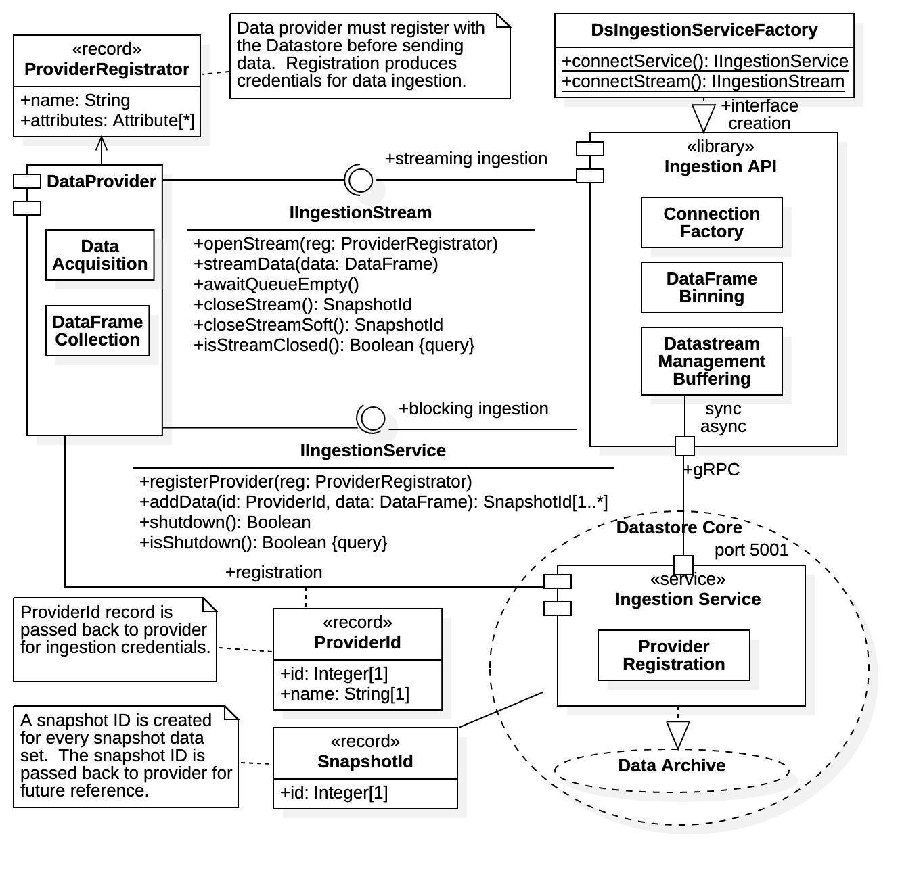

Figure 14: Ingestion Service API library supporting data frames

### Connection Factory

As seen in the right-hand side of Figure 14, the ingestion API library explicitly provides a connection factory, as well as components for data frame binning, data stream management, buffering services, and gRPC communications with the Ingestion Service. To begin the ingestion process, the data provider client must obtain a library interface via the connection factory. Specifically, connection factory DsIngestionServiceFactory in the com.ospreydcs.datastore.admin.grpc.ingestion package is used. The connection factory makes all network connections to the Ingestion Service and passes back an active interface implementation.

The connection factory providers static class methods for creating interface objects. The interface type is given by the method name.

* connectService(…): Creates an IIngestionService interface for synchronous, blocking ingestion.
* connectStream(…): Creates an IIngestionStream interface for streaming ingestion

The various arguments within each static method allow users to connect to Ingestion Service servers at different network locations and host ports. Additionally, they provide various connection configuration options, such as timeout limits, data binning parameters, and compression. Using the connection factory methods without arguments yields a connection to the default Datastore Ingestion Service using the default connection configuration (as defined in the project properties file).

Henceforth all the operations shown in Figure 14 are available. As seen in the diagram, the ingestion interfaces are extremely narrow, only providing operations for provider registration, data frame ingestion, and shutdown operations. The operations within each interface demonstrate the difference between the two ingestion paradigms.

### Snapshot Data

All snapshot data is contained within data frames. This includes the snapshot timestamp, the correlated time-series data, the time-series data timestamps, the data source (process variable) names, and any attributes associated with the snapshot. Time stamps are included either as timestamp lists, or by sampling frequency and start time.

Figure 17 within Chapter 5 depicts the basic structure of the DataFrame class. The class supplies methods for all snapshot data assignment. Not seen explicitly in the diagram are methods for setting the sampling frequency and start time when uniform sampling is used. The class also provides methods for setting timestamp lists shown in the diagram. For more information on data frames see the Java documentation for the DataFrame class contained in the com.ospreydcs.datastore.admin.grpc.model package.

Time-series data may be contained in a single data frame, or may be distributed between multiple data frames, as with streaming ingestion (described below). Multiple snapshots may even result from a large data when using non-streaming ingestion, specifically when data binning is invoked.

### Provider Registration

Snapshot data provider registration is a requirement of the Ingestion Service. A client must register itself with the Datastore as a unique data provider before any data transmission can begin. Unlike the previous ingestion API library, provider registration is accomplished explicitly within the ingestion interfaces.

Once the desired interface is obtained from the connect factory, the data provider must first perform registration before ingestion can begin. Referring to Figure 14, the client must create a ProviderRegistrator record, populating it with the provider’s unique name and any attributes it wishes to establish (e.g., facility, location, subsystem, equipment type, experiment, etc.). Note that attributes may be assigned to the provider itself through the ProviderRegistrator record, or to the incoming data within a DataFrame object.

The registration record is passed to the Ingestion Service through the ingestion interface, after which the client receives a unique identifier (UID) in the form of a ProviderId record. The registration operation depends upon the interface obtained from the connection factory.

* IIngestionService: Explicitly through registerProvider().
* IIngestionStream: When opening the data stream using the openStream() operation.

If the data provider has previously registered with the Datastore it will be returned the original registration UID (provider names are unique). For any ingestion process to commence, this provider UID record must first be established; all incoming snapshot data will be associated with the provider UID. Henceforth the ingestion process proceeds as dictated through the acquired ingestion interface.

### Non-Streaming Ingestion

As stated above, non-streaming ingestion is performed using the IIngestionService interface. Non-streaming ingestion through an IIngestionService interface proceeds as follows:

1. registerProvider(): Client registers as a data provider to obtain a ProviderId record.
2. addData(): Invoked as many times as required to send a collection of data frames.
3. shutdown(): Called when ingestion is completed. Interface is no longer active.

The shutdown() operation should always be invoked before discarding the interface.

**NOTES:**

1. For non-streaming ingestion the data provider must first explicitly register with the Ingestion Service. A ProviderRegistrator record is created and populated with the data provider’s unique string name, and any optional attributes stored as metadata. The registration record is offered as an argument to the registerProvider(ProviderRegistrator) operation to obtain the data provider’s ProviderId UID record. The returned record is a required argument of all subsequent addData() ingestions operations.
2. The client can then transmit as many data frames as desired using the addData(ProviderId, DataFrame) operation, always identifying itself with its ProviderId record. This is a blocking operation and the addData() operation will not release until the data frame is fully transmitted, processed, and archived.

Referring to Figure 14, note that at least one snapshot ID is returned with every data frame offered. Multiple snapshot UIDs are returned if the data frame requires binning (as a List<SnapshotId>). Data binning is invoked whenever the data frame allocation is larger than the current gRPC message limit (default 4 Mbytes). In that case one snapshot UID is returned for each data bin created.

1. Once the client has finished transmitting all data frames the connection should be shut down using the shutdown() operation. Once shut down, the interface can be discarded. All gRPC resources for the interface are released after a shutdown operation, thus, any further interface operations would result in an exception.

### Streaming Ingestion

Streaming data ingestion is performed using the IIngestionStream interface. This interface currently supports only a single data stream between the provider and the Ingestion Service. Clients may, however, acquire multiple IIngestionStream interfaces for concurrent, multi-stream client communications.

The API library utilizes a buffering queue for data frames. The data queue is used to temper spurious ingestion, and to monitor ingestion rates. With data buffering clients can maximize the ingestion rates by streaming data frames and monitoring queue activity.

In Java gRPC, asynchronous communication always requires the use of a data stream, and the API library utilizes threading for queued data frame ingestion. Within the library, threads are spawned by Ingestion Service ready signals and synchronized on the data frame queue maintain integrity.

An outline of the ingestion process with an IIngestionStream interface is given as follows:

1. openStream(): Open the data stream while simultaneously registering as a provider.
2. streamData(): Invoked multiple times. Supports sustained ingestion (w/ uniform sampling).
3. awaitQueueEmpty(): Optional data stream tuning for sustained ingestion.
4. closeStream(): Terminate the data stream when ingestion is complete. Receive snapshot UID.

The closeStreamSoft() operation is also available for stream termination, it waits for ingestion operations to complete before stream termination. Either the closeStream() or closeStreamSoft() operation should be invoked before discarding the interface.

**NOTES:**

1. Here the registration process is synonymous with data stream initiation. The client first populates a ProviderRegistrator record with its unique provider name and any optional attributes. The client then opens the data stream by passing its registration record to the openStream(ProviderRegistrator) operation. Henceforth the data stream remains open for frame ingestion until explicitly shut down with the closeStream() (or closeStreamSoft()) operation. The provider does not need to overtly identify itself afterwards as long as the data stream to the Ingestion Service remains open.
2. The client may then stream as many data frames as desired to the Ingestion Service through the streamData(DataFrame) operation. The operation blocks only if the data stream becomes backlogged. Normally the operation returns immediately, as data frames are buffered. Specifically, ingested frames are queued for transmission and the ingestion API library attempts to maintain a continuous stream of available data frames. If data is constantly offered at a rate faster than the Ingestion Service can process incoming data, the data queue will eventually fill then block.
3. To optimize transmission from the client side, the ingestion API exposes the awaitQueueEmpty() operation. This operation allows the client to monitor data stream buffering. The operation will block until the data frame queue empties. By transmitting a set amount of data frames and measuring queue wait times, the client can measure data rates. That is, by monitoring the ingestion process, the provider can adjust its data rate to that of the current Ingestion Service ingestion rate. The *datastore-admin* project provides several performance parameters (in the properties file) for tuning of the data buffer size, bin sizes, and queue time limits.
4. Once the client has completed data transmission the data stream should be terminated using the closeStream() operation. The operation also returns the snapshot UID for the entire data stream. After the closeStream() operation, the interface is no longer active and can be discarded.

The closeStream() operation performs a “hard shutdown” operation, immediately releasing all gRPC resources and any queued data. The closeStreamSoft() operation is offered as an alternative; it allows any buffered data to be streamed to the Ingestion Service before terminating the data stream. The isStreamClosed() operation can be used to poll the API library for the closed stream condition.

The Ingestion Service supports multiple, concurrent data streams. Clients may utilize multiple concurrent data stream by creating multiple IIngestionStream interfaces. Note that separate processing can be assigned to each interface for asynchronous ingestion.

Note that within the ingestion API library, data streams are managed using StreamObserver<> interfaces. Clients need not be concerned with the internal library operations using this interface, only the streaming operations exposed by the IIngestionStream interface.

### Warning: Ingestion Streams and Timestamp Lists

Sustained, continuous ingestion using timestamp lists (within data frames) is currently not supported by the Ingestion Service. Only one timestamp list can be sent through an ingestion stream in the current Ingestion Service implementation. Thus, continuous, sustained ingestion is supported only for uniform sampling. When using the IIngestionStream interface for uniform sampling one must specify a sampling frequency and initial timestamp within the data frames. The DataFrame class supplies methods for setting the sampling frequency and start time.

### Warning: Ingestion Interface Shutdowns

The Ingestion Service sometimes continues to process after invoking a closeStream() operation when using streaming ingestion. Thus, the current implementation sometimes throws an exception when attempting to access the Datastore archive using the Query Service immediately after an IIngestionStream interface shutdown.

# Query Service API Libraries

Two Query Service API libraries are currently available for the Datastore, both are implemented in the Java programming language. The *datastore-client-lib* project contains a single query API library as its only resource. The other query API library is contained in the *datastore-admin* project.

The query library within *datastore-client-lib* contains a single interface. It provides a wide, general-purpose interface oriented towards clients having familiarity with the Query Service and, in particular, the Datastore Query Language (DQL). A description of DQL is offered in APPENDIX A.

The *datastore-admin* project contains a query API library providing narrow, data-science based interfaces. These interfaces hide much of the Query Service internal operations. They offer a high-level perspective of the Datastore Query Service suitable for data-science applications. No familiarity with DQL is required.

A third high-level API library is proposed for future development, one in the Python language. The API library is intended to provide explicit support for the Pandas DataFrame object commonly used in data science applications [2].

## General-Purpose Query API

A general-purpose query API library is contained in the *datastore-client-lib* project in the Datastore repository. It provides a wide, low-level programming interface requiring familiarity with the Query Service gRPC interface. It also requires familiarity with the Datastore Query Language (DQL) for making time-series data requests, and some associated metadata requests.

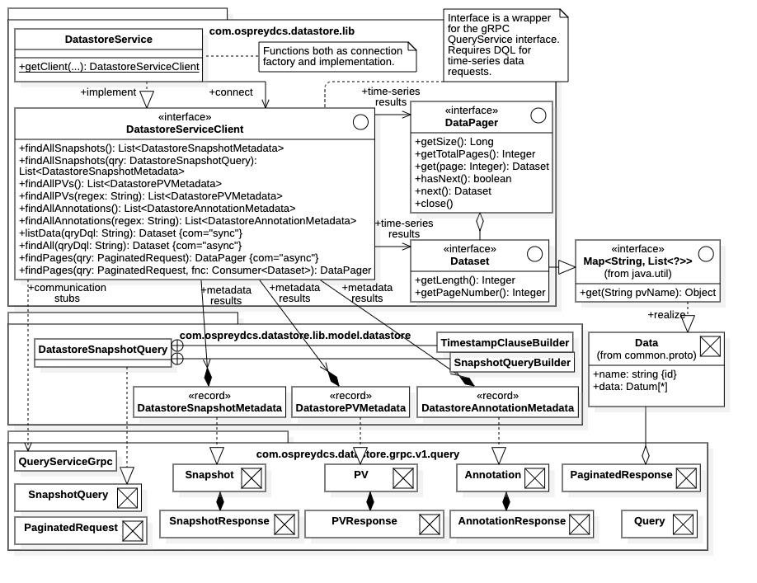

Figure 15: general-purpose Query Service API library

The API interface, associated data types, and relationships to the Datastore Query Service communications framework are shown in Figure 15. Referring to the figure, the entire API is contained in a single interface, DatastoreServiceClient. As indicated in the diagram, the DatastoreServiceClient interface is essential a wrapper for the gRPC query interface described in Figure 10. The figure also explicitly indicates the relationship of interface query results to the resources generated by the QueryService Java gRPC realization (i.e., those contained within the com.ospreydcs.datastore.grpc.v1.query package).

### Connection Factory

The class DatastoreService within package com.ospreydcs.datastore.lib functions as the connection factory for interface DatastoreServiceClient, which is contained within the same package. DatastoreService also functions as the implementation class for the interface. There are several static methods getClient(…) that create and return implementations for the DatastoreServiceClient interface. The network connections to the Query Service are also performed. Thus, various argument signatures are available allowing clients to specify the network address of the desired Query Service server, and optional connection configurations, such as compression algorithms. The zero-argument signature connects to the default Query Service using the default connection parameters as defined in the *datastore-client-lib* project properties file.

### Metadata Requests

There are three types of metadata currently supported: 1) snapshot metadata, 2) data source (process variable) metadata, and 3) annotation metadata (i.e., “named queries”). Archived metadata is stored in records of type 1) snapshot record, 2) PV record, and 3) annotation record, respectively. Requests for metadata are made using the DatastoreClient interface operations 1) findAllSnapshots(), 2) findAllPVs(), and 3) findAllAnnotations().

As seen in Figure 15, all metadata results are returned as lists of Java records, where a different record type is assigned to each metadata category. Java metadata records are contained within package com.ospreydcs.datastore.lib.datastore. From the diagram we see that the Java records are essentially wrappers for their respective protobuf message records defined in query.proto. We discuss each record type below, when covering metadata requests by category.

In general, each metadata request operation is available with two method signatures.

1. Zero argument: Returns all records of given metadata type within the archive.
2. Query argument: Returns only records satisfying the query request.

All metadata requests are made using non-streaming gRPC communications. Thus, metadata requests will block until the operation is complete, and result sets will be complete.

##### Snapshot Metadata

Snapshot metadata requests are made using the findAllSnapshots() operations. Results are returned as lists of DatastoreSnapshotMetadata records, which are wrappers for the protobuf message Snapshot as indicated in Figure 15. The fields of the Snapshot message are described in Subsection 3.8.2.

There are two options for the findAllSnapshots() operation.

1. findAllSnapshots(): Returns all snapshot records currently within the Datastore archive.
2. findAllSnapshots(qry:DatastoreSnapshotQuery): Returns only records matching the query argument.

To use the operation with a query argument, the client must first populate a DatastoreSnapshotQuery object with the desire request. The class DatastoreSnapshotQuery is used internally by the API library to create a SnapshotQuery protobuf message that contains the actual snapshot query. Requests supported by SnapshotQuery can be complex and are covered in Subsection 3.8.2. Currently only the attribute clause and the timestamp clauses within the SnapshotQuery message are supported by the DatastoreSnapshotQuery class.

Referring to Figure 15, the DatastoreSnapshotQuery class contains two enclosed static classes. These are builder classes for the snapshot query itself, and for any timestamp clause within the query.

1. SnapshotQueryBuilder(): Builds a DatastoreSnapshotQuery object once configured.
2. TimestampClauseBuilder(): Builds a timestamp clause within the snapshot query builder.

A SnapshotQueryBuilder instance must first be created with its default constructor. Class methods are available to configure the attribute clause and the timestamp clause. Methods configuring the timestamp clause select the target timestamp within snapshot records (i.e., either snapshotTimestamp, first, or last); a TimeStampClauseBuilder instance is returned identifying the target timestamp. The TimestampClauseBuilder instance is then used to select the timestamp clause predicate identifying the time range.

Note that builder configuration methods often return a Java this pointer, a convenience for method stringing.

##### PV Metadata

Data source metadata requests, also termed PV metadata requests, are made using the findAllPvs() operations. The results are returned as lists of DatastorePVMetadata records. As indicated in Figure 15, DatastorePVMetadata records are wrappers for the PV protobuf messages defined in the query.proto source file and supplied by the Query Service. The fields of the PV message record are described in Subsection 3.8.4.

There are two options for PV metadata requests.

1. findAllPVs(): Returns all PV records currently within the metadata archive.
2. findAllPVs(regex:String): Returns PV records with name fields matching the regular expression.

Clients provide a regular expression string for the findAllPvs(String) argument. There, results will be all PV records whose name field matches the given regular expression. As covered in Subsection 3.8.4, this is the only criterion for searching PV metadata supported by the Query Service.

##### Annotations Metadata

The Datastore supports *named query* archive annotations. Named queries are DQL statements of particular interest that data consumers wish preserved. Currently, named queries are the only archive annotation supported by the Datastore.

Annotation metadata requests (i.e., named query requests) are made with the findAllAnnotations() operations. Results are returned as lists of DatastoreAnnotationMetadata records, which are wrappers for the Annotation protobuf message defined in the query.proto source file. Annotation records are simple (name, query) pairs containing the query name assigned by the data consumer, and the DQL query statement itself.

There are two options for annotation requests.

1. findAllAnnotations(): Returns all annotation records currently within the metadata archive.
2. findAllAnnotations(regex:String): Returns records with name field matching the regular expression.

Name matching is the only search criterion for annotation records supported by the Query Service.

### Time-Series Requests

Time-series data requests are performed with the operations listAll(), findAll(), and findPages(). The first operation is a non-streaming request and the latter two operations support streaming requests (although findAll() blocks). Time-series data requests always require a DQL statement to formulate the request query, either directly as a query string argument, or contained within a PaginatedRequest protobuf message. The latter case is used for explicit data streaming of the request response. The PaginatedRequest message is used to configure and initiate the data stream, then stream management is handled internally by the API library. Use of the PaginatedRequest protobuf message is described in Subsection 3.8.6.

Briefly, a Request protobuf message must be contained within the PaginatedRequest message. The Request message contains the DQL statement and the data stream parameters. Data stream parameters are the size of the streamed data pages (in rows), and the index of the data page returned (0 indicates the full request). If a positive value is assigned to the data pages index, the operation returns only the requested data page. Otherwise the full request is returned.

##### Time-Series Data

Time-series data results are returned in either one of two ways,

1. Dataset object: A collection of named data columns containing correlated, time-series data.
2. DataPager object: A collection of indexed Dataset objects. Used in explicit data stream requests.

Both the Dataset class and the DataPager class are shown in Figure 15, along with their relationship.

**NOTES:**

1. As indicated in Figure 15, the Dataset is a child interface of the java.util.Map<String, List<Object>> interface. Dataset instances contain a collection of named data columns, where each internal List<Object> object represents a time-series data set. The map is indexed by column name, where the name is that of the data source (process variable) producing the data set.
2. A DataPager object is an indexed collection of Dataset instances. DataPager objects are the results of the explicit streaming data request findPages(). Each contained Dataset instance represents an indexed data page from the response data stream. Figure 15 shows a subset of the available methods for a DataPager, including methods for determining the full result size (in rows and in pages) and for recovering the response data pages. The get(Integer) method is used to retrieve data pages by index, it will block until the requested page becomes available. The next() method iterates over the returned pages, it too will block until the next page becomes available. Note that the close() method should be called when finished; it terminates any active data streams and releases all resources.

##### Non-Streaming Requests

Non-streaming requests are made using listData() operation. The listData() operation is supplied with a single argument containing the DQL query statement (as a String object). The operation blocks until the full data request is completed. It then returns a single Dataset object containing the data request.

Since non-streaming operations return a single response message, they are bound by the gRPC message size limit (4 Mbytes default). Only small requests should be made using the listData() operation, otherwise result sets will be truncated to the head of the request. Unfortunately, it is not possible to determine if a request has been truncated (Subsection 3.8.6 describes how to determine truncation from a PaginatedResponse message). Use the equivalent findAll() streaming operation for large data requests (see below).

##### Streaming Requests

Streaming time-series data requests are performed with the findAll() and findPages() operations. All streaming data requests are implemented with streaming communications and the results sets are essentially size unlimited. From Figure 15 note that both findPages() operations require a PaginatedRequest protobuf message as an argument. The PaginatedRequest message was briefly described above, further details are provided in Subsection 3.8.6.

There are three streaming request operation cases, listed as follows:

1. findAll(qryDql:String): Performs the DQL query statement. Results are returned as a single Dataset.
2. findPages(qry:PaginatedRequest): Performs a streaming request. Results are a DataPager instance.
3. findPages(qry:PaginatedRequest, fnc:Consumer<Dataset>): Includes callback notification for page.

The Consumer<> argument within the last method is an interface type within the java.util.function package.

**NOTES:**

1. The findAll() operation functions externally just as the listAll() operation, but without result size limitations. It takes a DQL state query string argument then blocks until the full request is returned within a Dataset object. However, internally the findAll() operation uses asynchronous streaming to collect data pages. Once all data pages are assembled the operation returns. Consequently, the response result is not gRPC message size bound.
2. The findPages(PaginatedQuery) operation returns a dynamic DataPager object as the response. The operation blocks until the first data page is available. The remaining data pages are dynamically loaded to the DataPager as they arrive from the Query Service. Thus, clients may begin accessing the result set immediately, the accessor methods of the DataPager class synchronize page access with respect to page availability.

Note that the PaginatedRequest argument can request a single data page (i.e., if the page index field of the internal Request message is set to a positive value). In this case the response would be the single data page. Although inefficient, clients can retrieve full query requests page by page, blocking for each invocation. (This feature of the PaginatedRequest message is used for internal data stream management within the API library.)

1. The findPages(PaginatedQuery, Consumer<Dataset>) operation offers clients the option of providing a notification callback function. The callback function, an implementation of the java.util.function.Consumer<> interface (often a lambda function), is notified whenever a data page from the request becomes available. When notified, the accept() method of the implementation will produce a Dataset instance containing the new data page; note the page index is available from the getPageNumber() method. The findPages(PaginatedQuery, Consumer<Dataset>) operation also returns a DataPager object that receives the incoming data pages.

## Data Science API

The query API library within the *datastore-admin* project is provided for data science and machine-learning applications development. It exposes narrow API interfaces where query results are returned as metadata records or high-level data tables. Unlike the previous query API library, the interfaces here require no familiarity with DQL (although it supports DQL). Time-series data requests, and complex snapshot metadata requests, can be made using query builders.

Figure 16 depicts the data-science query API library, its basic operations, and its relationship to the Query Service. Note that query operations are the aspect of the Datastore seen by *data consumers*, shown on the right-hand side of the diagram. Here, the client data consumers are data scientists, data science applications, or any other interested party (such as web browser applications for remote archive access). Clients interact with the Datastore archive through the query API library shown in the left-hand side of Figure 16. It explicitly provides a connection factory, data stream management, and data table loading services. Access to the Datastore archive is through the Query Service using both streaming and non-streaming gRPC communications.

The library exposes two separate query interfaces, IQueryServiceMeta for requesting metadata from the Datastore archive, and IQueryServiceData for requesting time-series data from the Datastore archive. Machine learning and other data science operations would likely involve repeated invocation of both metadata requests and time-series data requests to isolate relevant data properties and associations. Thus, clients would generally use both interfaces concurrently.

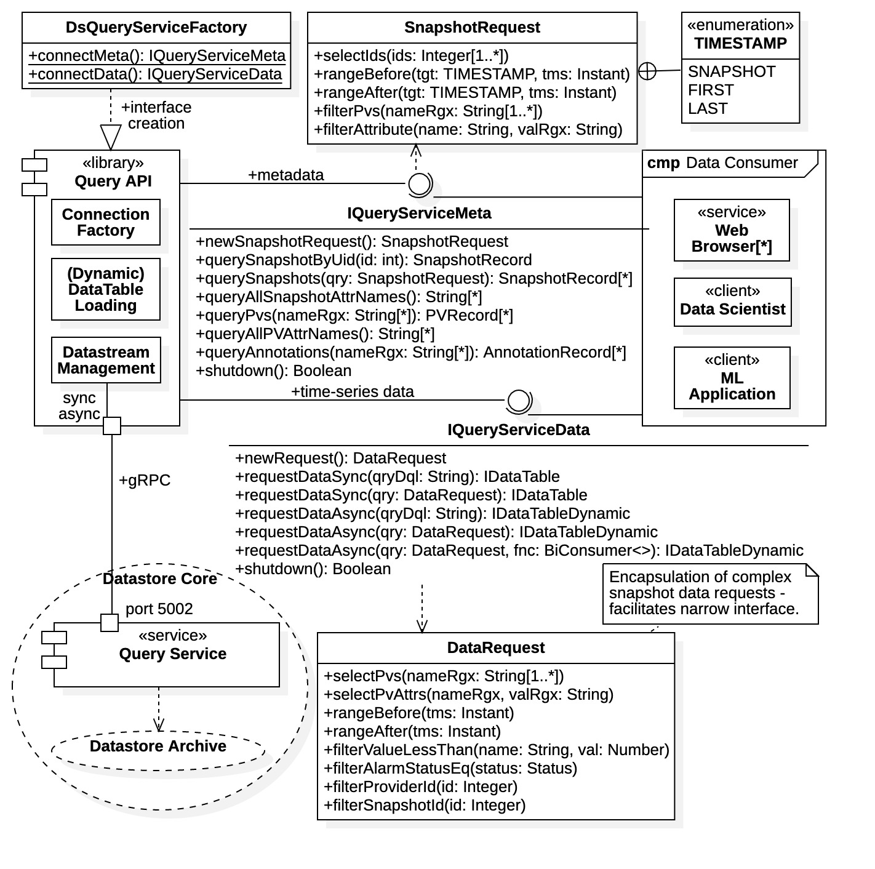

Figure 16: data-science Query Service API library

### Connection Factory

The process of obtaining the library interfaces is analogous to that for obtaining a data-frame ingestion API interface. Clients request an API interface from the connection factory, in this case the DsQueryServiceFactory class contained in the com.datastore.admin.grpc.query package. Again, there are two interfaces in the API library, the IQueryServiceMeta interface for metadata requests and the IQueryServiceData for time-series data requests. Implementations for both interfaces are obtained from connection factory static methods. The connection factory makes the network connection to the Query Service then passes back the appropriate interface implementation. The implementation then maintains all network connections and performs all data stream management with the Query Service. It also interprets all user data requests, formulating them into the appropriate protobuf messages for the query service, then marshalling the Query Service responses into proper responses.

The specific interface supplied to the client depends upon the connection request. Connection requests are made using one of the following connection factory static methods:

* connectMeta(…): Creates an IQueryServiceMeta interface for metadata requests.
* connectData(…): Creates an IQueryServiceData interface for time-series data requests.

The various arguments within each static method allow users to connect to different Query Service servers at different network locations and/or host ports. Additionally, they provide various connection configuration options, such as timeout limits, gRPC message size limits, and compression algorithms. Using the connection factory methods without arguments yields an interface connected to the default Query Service using the default configuration (as defined in the project properties file).

From Figure 16 note also that each query interface has a shutdown() operation. After obtaining a query interface from the connection factory all query operations are active and clients can continue archive inspection for as long as desired. However, once query operations are completed, clients should invoke the shutdown() operation to close the Query Service connection and release all gRPC resources. Afterwards the API interfaces can be safely discarded.

### Metadata Requests

As indicated in the diagram, the interface IQuerySeriviceMeta exposes separate operations for each type of metadata query request. This condition is necessary because each metadata type is represented by a unique record type. All metadata requests are performed using non-streaming, blocking communications.

There are currently three types of metadata within the Datastore archive, snapshot metadata, data source (process variable) metadata, and annotations metadata (i.e., for “named queries”). Metadata request results are returned as lists of records, of type SnapshotRecord, PVRecord, or AnnotationRecord, respectively. All metadata records are located in the com.ospreydcs.datastore.admin.model package within the *datastore-admin* project. These records are simply wrappers for the respective protobuf messages Snapshot, PV, and Annotation described in Section 3.8.

##### Snapshot Metadata

Snapshot metadata requests are performed using the querySnapshot(SnapshotRequest) operation within the IQueryServiceMeta interface. Note that the interface has a special mechanism for handling snapshot metadata requests, as they can be complex. Snapshot requests are encapsulated by special objects, SnapshotRequest objects, which are configured by the client and then passed to the querySnapshot() operation. The SnapshotRequest class is a query builder, described below.

Snapshot metadata is also available from querySnapshotByUid(int) operation. This operation takes a snapshot UID and returns the single metadata record for that snapshot. Additionally, a list of names for all attributes associated with all snapshots within the Datastore archive can be retrieved with the queryAllSnapshotAttrNames() operation. The attribute names can subsequently be used in SnapshotRequest objects for formulate attribute value-matching queries. They can also be used in formulated time-series data requests by filtering on attribute values.

##### Snapshot Request Builder

The querySnapshots(SnapshotRequest) operation is used to make general snapshot metadata requests and requires a SnapshotRequest object as its argument. The SnapshotRequest class is a builder class for creating snapshot metadata requests. SnapshotRequest instances are obtained from the newSnapshotRequest() operation within the IQueryServiceMeta interface.

The SnapshotRequest class contains numerous methods for configurating the snapshot metadata request, which can be complex. However, the methods are grouped into the following 3 categories:

1. select: Select for specific snapshot record field values.
2. range: Select the target timestamp within the snapshot record. Also sets comparison time range.
3. filter: Filter the above result set according to various snapshot record field values.

Select methods begin with the prefix select, range methods are prefixed with range, and filter methods are prefixed with filter. Within Figure 16, note the enclosed enumeration SnapshotRequest.TIMESTAMP which is used in range methods to identify the target timestamp within the snapshot record.

Newly created SnapshotRequest methods contain the “open query.” That is, they request all snapshot records currently within the Datastore archive. The above methods narrow the request by selecting for specific record field values, specifying the allowable time range, and further filtering on other record field values. If a select, range, or filter method is not called, then the query contains all records of that category.

The purpose of the SnapshotRequest builder class is to isolate clients from the internals of the SnapshotQuery protobuf message required for a low-level Query Service snapshot requests. Details on the SnapshotQuery message and the Snapshot message record are provided in Section 3.8.2.

### Time-Series Data Requests

Time-series data requests are made using the interface IQueryServiceData. The interface supports both non-streaming and streaming requests. From Figure 16 we see that the interface is quite narrow, containing only two request operations requestDataSync() and requestDataAsync(), plus a third operation newRequest() for creating request arguments. The requestDataSync() operations are provided for non-streaming, blocking data requests supported by synchronous gRPC communications, and the requestDataAsync() operations are provided for streaming, non-blocking data requests supported by asynchronous gRPC communications. Thus, the single interface supports both gRPC communications models.

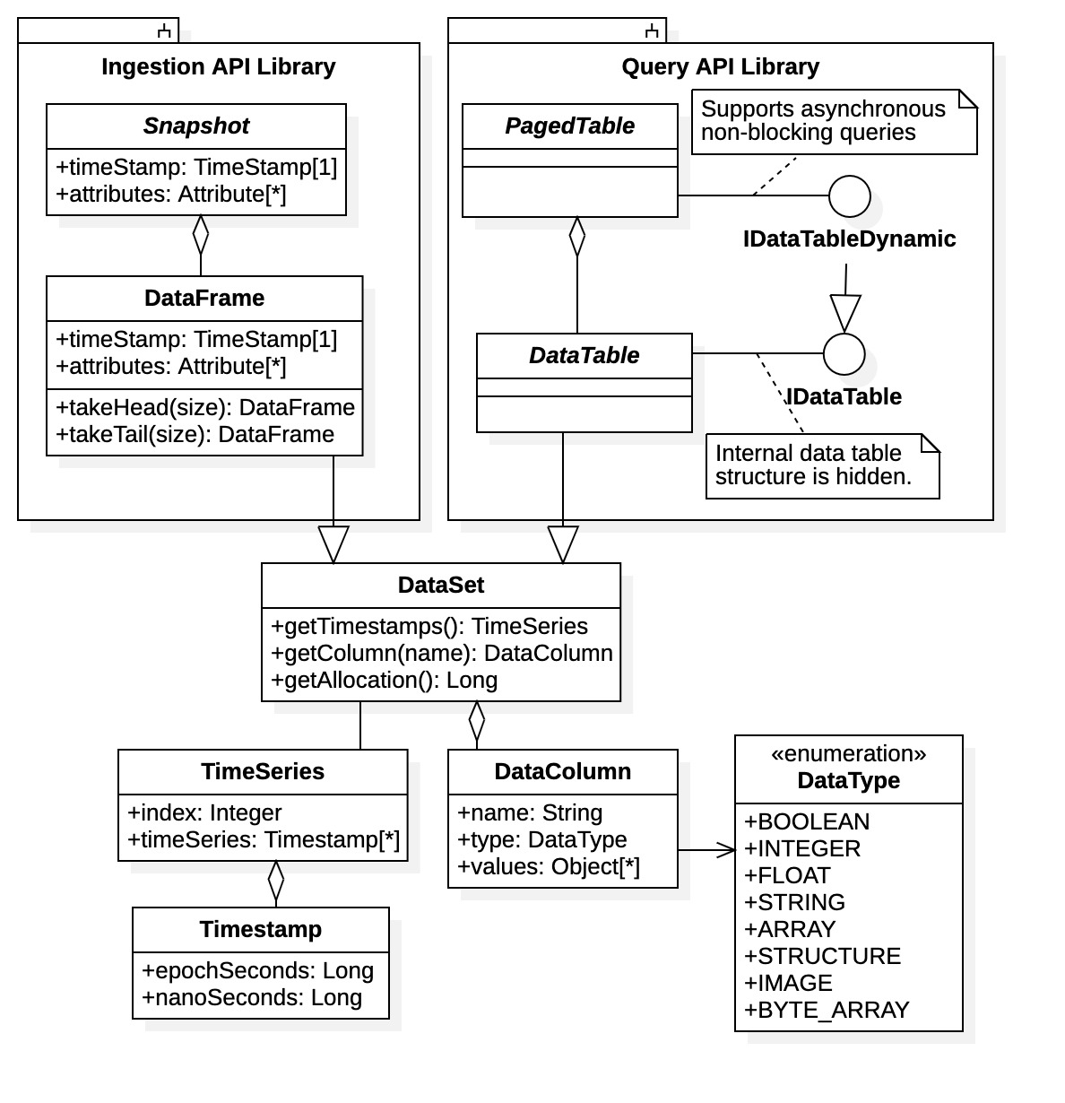

Figure 17: data tables and data frames in datastore-admin project

##### Time-Series Request Results

Both time-series data request operations return results as data tables. The specific type of data table depends upon the request method, IDataTable for non-streaming requests and IDataTableDynamic for streaming requests. The returned objects are really interfaces; the concrete data table implementations are hidden from clients. Some of the implementation details for data tables are shown in Figure 17. As seen in the diagram, data tables and data frames (used in the *datastore-admin* ingestion API) both inherit from the common base class DataSet. Data tables, represented by the DataTable class, are collections of named data columns containing correlated, time-series data, plus the collection of corresponding timestamps. The base class DataSet contains methods for accessing the time-series query results, a subset of which are shown in the diagram. The interface IDataTable exposes those methods.

The differences between the two data table interfaces can be summarized as follows:

* IDataTable: Operations required to access result data size, shape, values, timestamps, and errors.
* IDataTableDynamic: Additional operations required for dynamic table loading from a data stream.

The interface IDataTable essentially appears as a static data table, as would be obtained from a blocking data request. The IDataTableDynamic supports dynamic data tables which continue to load from an open data stream after the request operation returns. From Figure 17 we see that interface IDataTableDynamic inherits from IDataTable, adding the additional operations required for monitoring the dynamic loading process. However, as also seen in the figure, the implementation behind IDataTableDynamic is quite different. Dynamic data tables are implemented as a PagedTable class. PagedTable objects are a collection of data pages, each page being a separate DataTable object. Nevertheless, clients need not be concerned with the implementation details. The IDataTableDynamic interface appears as a standard data table, albeit with additional methods for monitoring the table loading. Both interfaces are located in the com.ospreydcs.datastore.admin.model package.

##### Time-Series Request Builders

Time series data requests can be optionally formulated with DataRequest objects. These are query builders used to isolate clients from details of DQL, which is used for the underlying time-series data requests. New DataRequest instances are available from the newRequest() operation within the interface IQueryServiceData.

Figure 16 identifies some methods within the DataRequest class. Since DQL supports the broad search and query operations of the Query Service, numerous methods are available to create complex query requests. However, as with the SnapshotRequest class, the methods are grouped into the following categories:

1. select: Select for specific data sources (process variables) and attributes for the result set.
2. range: Specifies the allowable time interval for timestamps.
3. filter: Limit the above result set, filtering on various data values, data fields, and properties.

As before, select methods are prefixed with select, range methods are prefixed with range, and filter methods are prefixed with filter.

New DataRequest objects are always created for the “open query”. That is, upon initial creation, the request object always queries for all time-series data within the Datastore archive. The client narrows the search request by invoking the select, range, and filter methods. Once configured, the DataRequest object is then passed to the requestDataSync() operation to perform a non-streaming request, or the requestDataAsync() operation to perform a streaming request.

##### Non-Streaming Requests

Non-streaming time-series data requests are available with the requestDataSync() operations. There are two options available.

1. requestDataSync(DataRequest): The request query is offered as a DataRequest query builder.
2. requestDataSync(String): The request query is offered as a DQL statement.

Note that the second option is available for clients having familiarity with DQL and wanting to forgo a DataRequest configuration.

Non-streaming data requests block until the request is completed, the data table is fully loaded upon return. However, non-streaming requests utilize a synchronous, single message response. Thus, they are size limited by the gRPC maximum message size (4 Mbytes default). Non-streaming requests are only suitable for query results producing small data tables, otherwise the results will be truncated to the request head. There are methods within IDataTable to determine if the result was returned.

##### Streaming Requests

Streaming time-series data requests are available from the requestDataAsync() operations. All operations return an IDataTableDynamic response. Streaming data requests do not block, returning a data table object that is dynamically loaded from the resulting data stream. Clients have access to table data during the loading process, however, not all data may be available at any given instant. There are notification methods within the. IDataTableDynamic interface for table loading completed, and for table loading exceptions (not shown).

There are three options available.

1. requestDataAsync(DataRequest): The request query is offered as a DataRequest query builder.
2. requestDataAsync(DataRequest,BiConsumer<Boolean,IDataTableDynamic>): Callback notification.
3. requestDataAsync(String): The request is offered as a DQL statement.

Note that every operation returns an IDataTableDynamic interface.

**NOTES:**

1. The first option is the general time-series data request. Since this is a streaming operation there are no size limitation on request results.
2. The second option includes the addition of a callback function provided by the client. Call back functions must implement the java.util.function.BiConsumer<Boolean, IDataTableDynamic> interface (generally a lambda function). The accept(Boolean, IDataTableDynamic) operation is called by the API library when the table is fully loaded. The arguments are a Boolean flag indicating success or failure, and a reference to the IDataTableDynamic interface containing the result (the same instance returned by the operation itself).
3. The third option is offered for clients possessing familiarity with DQL and desiring a direct request.

Streaming data requests are essentially unlimited in size. The query API library utilizing uses multiple execution threads to load each data page of the results dynamically, or “asynchronously”. The query API library maintains the active data stream from the Datastore to the data table until the request is completed. The library manages all data connections, table loading threads, and data streams between data tables and the Datastore Query Service.

# References

|  |  |
| --- | --- |
| [1] | "EPICS - Experimental Physics and Industrial Control System," 2023. [Online]. Available: https://epics-controls.org/. |
| [2] | "pandas," NumFOCUS, 2023. [Online]. Available: https://pandas.pydata.org/. |
| [3] | "gRPC," gRPC Authors, 2023. [Online]. Available: https://grpc.io/. |
| [4] | "Protocol Buffers," Google, 2023. [Online]. Available: https://developers.google.com/protocol-buffers/. |
| [5] | "Channel Access Protocol Specification," EPICS Controls, 2019. [Online]. Available: https://docs.epics-controls.org/en/latest/specs/ca_protocol.html. |
| [6] | "pvAccess and pvData," EPICS Controls, [Online]. Available: https://epics-controls.org/resources-and-support/documents/pvaccess/. |
| [7] | "Spring Boot," VMware Tanzu, 2022. [Online]. Available: https://spring.io/projects/spring-boot. |
| [8] | "MongoDB," MongoDB Inc., 2022. [Online]. Available: https://www.mongodb.com/home. |
| [9] | "InfluxDB," InfluxData Inc., 2022. [Online]. Available: https://www.influxdata.com/. |
| [10] | Github, Inc., 2022. [Online]. Available: https://github.com/. |
| [11] | "Apache Maven Project," The Apache Software Foundation, 2023. [Online]. Available: https://maven.apache.org/. |
| [12] | O. R. N. Laboratory, "Material Plasma Exposure eXperiment (MPEX)," 2022. [Online]. Available: https://www.ornl.gov/mpex. |
| [13] | gRPC Authors, "Quick Start," gRPC Authors, 2023. [Online]. Available: https://grpc.io/docs/languages/cpp/quickstart/#install-grpc. |
| [14] | Y. Tibrewal, "grpc/examples," 2023. [Online]. Available: https://github.com/grpc/grpc/tree/v1.54.0/examples. |
| [15] | E. Andersen, "grpc-java/examples," 2023. [Online]. Available: https://github.com/grpc/grpc-java/tree/master/examples. |
| [16] | Google LLC, "Protocol Buffers," Google LLC, 2023. [Online]. Available: https://protobuf.dev/. |
| [17] | Google LLC, "Language Guide," Google LLC, 2023. [Online]. Available: https://protobuf.dev/programming-guides/proto3/. |
| [18] | J. Buchgraber, "protocolbuffers/protobuf," Google LLC, 2023. [Online]. Available: https://github.com/protocolbuffers/protobuf#protocol-compiler-installation. |
| [19] | E. Anderson, "grpc/grpc-java," Github, 2023. [Online]. Available: https://github.com/grpc/grpc-java/tree/master/compiler. |
| [20] | Apache Software Foundation, "Apache Maven Project," Apache Software Foundation, 2023. [Online]. Available: https://maven.apache.org/. |
| [21] | "Gradle Build Tool," Gradle Inc., 2023. [Online]. Available: https://gradle.org/. |

Datastore Query Language

A Datastore Query Language (DQL) statement supports the broadest range of time-series data query options. DQL also supports limited metadata queries for data attributes and data fields. The request is performed using a single query statement. The statement very much resembles an abridged Sequential Query Language (SQL) statement. A DQL statement employs the general predicate-based grammar using the following format:

SELECT <source>, <source>, … WHERE <time-predicate> AND <sub-predicate> AND …

Thus, the DQL statement is composed of a SELECT clause and a WHERE clause.

SELECT Clause

The SELECT clause selects for the sources of the time-series data, or process variables producing time-series data. Data sources are selected by name, which must be unique within the Datastore archive. DQL time-series data requests return data only from the sources specifically identified within the SELECT clause.

Data Sources and Properties

The <source> parameters of the SELECT clause refer to data sources, these are generally EPICS process variables or other hardware devices. However, they may also include properties of data sources, such as alarm limits and conditions. Data source properties are identified as fields of the data source. For example, if a data source BPM-1 contains a property alarm-severity, the field is selected with the clause

SELECT BPM-1.alarm-severity

By default, DQL assumes a suffix “.value” to any data source name. The value field identifies the measurement value directly associated with the data source. Other properties of the source (such as alarm limit, status, etc.) are identified by field name as above. Thus, for a data source with name BPM-1, the clause

SELECT BPM-1

is shorthand for “SELECT BPM1-1.value”.

Multiple sources within the SELECT clause are separated by a comma (,). For example, if data source BPM-1 contains the property alarm-severity, then the clause

SELECT BPM-1, BPM.alarm-severity

selects time-series data from both the data source value field, and its alarm-severity field.

Regular Expressions

The <source> parameters may also contain regular expression strings. Regular expressions are used for matching the data source names and properties. Regular expression strings are enclosed with the forward quote (`). Single quotes (‘) are used for character strings, such as that used in ISO date-time specifications.

For example, the following clause

SELECT `BPM-*.*`

selects all values and properties from data sources whose name matches the regular expression `BPM-*.*`. Again note the requirement of forward quotes enclosing `BPM-*.*` used to identify a regular expression. The suffix “.*” in the regular expression `BPM-*.*` is used to select the measurement value *and* all properties associated with any matching data sources.

WHERE Clause

The WHERE clause contains a collection of predicate subclauses <time-predicate>, <sub-predicate>, <sub-sub-predict>, etc., each narrowing the search request. Subclauses are separated by the AND keyword and are inclusive. That is, each WHERE subclause imposes an additional condition on the query.

Each WHERE predicate subclause has the following format:

<predicate-subclause> := <parameter> <operator> <value>.

The predicate subclause <predicate-subclause> is composed of a parameter <parameter>, an operator <operator>, and a value <value>. We have the following descriptions:

* <parameter> := The target parameter of a data source.
* <operator> := A standard logical operator identified by symbol (e.g., <, <=, >, >=, ==, etc.).
* <value> := The comparison value for the target (numeric or string).

The parameters <parameter> identifies the target within the predicate subclause. Targets can be data source values, data source properties, timestamps, attribute names, data providers, alarm conditions, etc. The operator <operator> is a standard logical predicate, such as greater than (>), greater than or equal (>=), equal (==), less than (<), less than or equal (<=), etc. The value <value> is the comparison value for target parameter under the given operator.

For example, the following predicate subclause targets the data source PV01, provides a comparison value of 0, and uses the operator less-than-or-equal:

PV01 <= 0

The above predicate subclause selects all time-series data supplied by process variable PV01 where its measurement value is less than or equal to 0. Note that by default PV01 expands to PV01.value.

Consider the additional example where the alarm-severity property within PV01 is targeted.

PV01:alarm-severity == ‘MAJOR_ALARM’

The above selects all time-series data where the alarm-severity field of data source PV01 has value ‘MAJOR_ALARM’. Note that the field value is a character string and must be enclosed by single quotes (‘).

Time Predicate

At least one time-predicate subclause <time-predicate> *must be included* within the WHERE clause. Specifically, the time range for the time-series data request is specified using WHERE time-predicate subclauses <time-predicate>. Multiple time-predicate subclauses can be used to specify the query time range.

The time-predicate parameter is time, which identifies all time-predicate subclauses. The predicate operator and value then specify the comparison time range. For example, the clause

WHERE time >= -1d

dictates that only snapshot data archived within the last day is to be returned.

Note from the above example, time-predicate values may be time durations, in the above case 1 day. Supported time durations are identified with the following abbreviations:

* d: day(s)
* h: hour(s)
* m: minute(s)

Also note from the example that a minus sign (-) may be prefixed to the duration to indicate “before.” The “after” condition is otherwise assumed.

Time predicate values may include ISO data-time strings, for example the string ‘2022-10-01T01:23:45Z’ (strings are single-quoted). Time ranges that are intervals, say of the form [t1, t2], are created using two time-predicate subclauses. For example, the WHERE clause

WHERE time >= t1 AND time <= t2

selects for all time-series data in the closed time interval [t1, t2]. Clearly open intervals and half-open intervals can also be constructed.

DQL Examples

As an example of a full DQL statement with all clauses and predicates, consider the following DQL statement:

SELECT Cam1-Image, `BPM-*.*` WHERE time >= ‘2022-10-01T01:23:45Z’ AND BPM-15.value > 10

The statement will requests all time-series data for the source “Cam1-Image” and all others data sources with names matching the regular expression `BPM-*.*`. The results are narrowed in scope by the WHERE predicates. The results will contain only time-series data with timestamps occurring at or after October 1, 2022, 1:23.45 AM, and where BPM-15 has a measurement value greater than 10. Recall that “Cam1-Image” is shorthand for “Cam1-Image.value”.

Consider the additional DQL example statement:

SELECT `PV*.*` WHERE time > -5h AND PV01.value < 0 AND `PV02:alarm-severity` == ‘MAJOR_ALARM’

The second statement will yield time-series data for all data sources matching regular expression `PV*.*` whose timestamps have occurred within the last 5 hours and where process variable PV01 has measure value less than 0, while simultaneously process variable PV02 has a major alarm status.

For more details on the DQL language see the documentation at <https://github.com/osprey-dcs/datastore-service>.

API Connection Factories

The general procedure for connection to any Datastore API library is shown graphically in Figure 18. The situation applies both to an ingestion service API or a query service API. An example where the API library explicitly exposed two interfaces, IServiceApi1 or IServiceApi2, is depicted in the diagram. Some details of the gRPC mechanism and resources are also shown in the diagram.

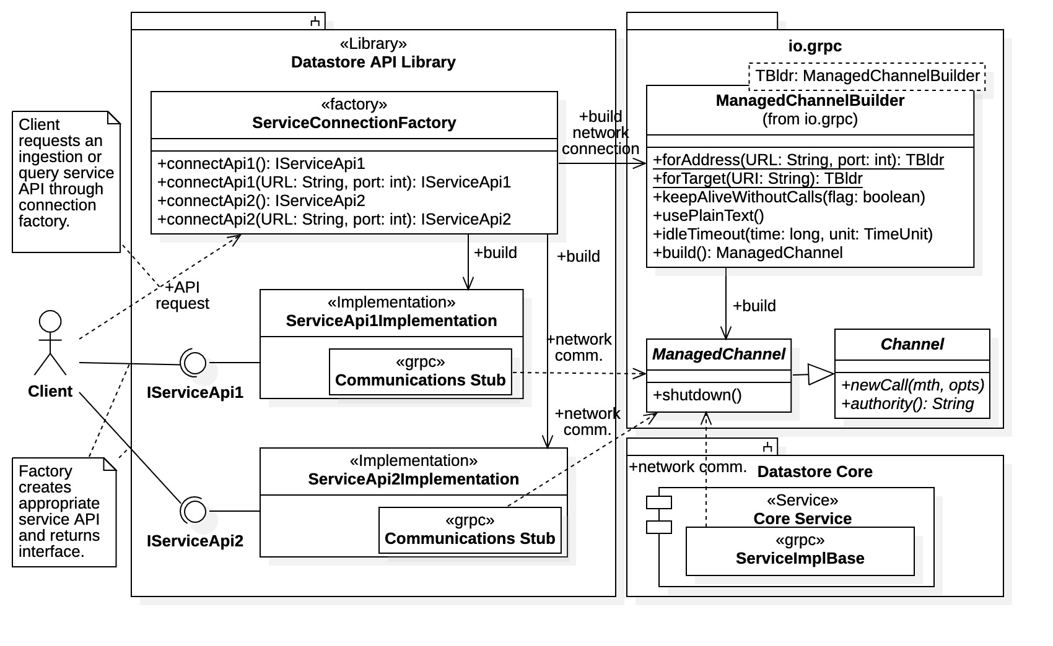

Figure 18: general Datastore API connection factory

Each API library contains a connection factory, denoted ServiceConnectionFactory in the diagram, which supplies an desired API interface implementation when requested. A client requests an interface by optionally choosing the default service connection, or by specifying the network address for a particular Datastore service deployment. The connection factory then established the gRPC communications framework by creating the network channel connection to the desired Datastore service (i.e., either the Ingestion Service or the Query Service) then creating the necessary communications stub(s). The desired interface implementation, either ServiceApiImplementation or ServiceApi2Implementation in the diagram, is created and fitted with the communications stub(s). The client is then returned the newly created interface object, either ServiceApi1 or ServiceApi2 in the example.

Note that the client sees only connection factory and the exposed interfaces IServiceApi1 and IServiceApi2, multiple implementations for each interface may be available. It is desirable to isolate clients from the actual interface implementations, the connection factory decides which implementation to deliver. The objective here is to establish concrete API library interfaces early in development, preferably narrow ones allowing only a minimum of well-defined operations. This facilitates implementation upgrades later in the development process without affecting the API definition and, hence, any client applications.

Some of the internal operations utilizing Java gRPC are shown in Figure 18. Note that the connection factory utilizes a ManagedChannelBuilder instance to configure and create a gRPC channel connection to the Datastore service. The channel builder is used to identify the service address, set security credentials, and configure the network transport (timeouts, message size limits, compression algorithms, etc.). Once all the parameters are established, the channel is created as a ManagedChannel instance. Note that ManagedChannel is a subclass of the superclass Channel, which contains the basic operations for network communications.

Each interface implementation maintains a least one gRPC communication stub. Communication stubs contains the remote procedure calls available from the service and generally implementations contain multiple stubs to implement both non-streaming and streaming operations. A communication stub maintains one Channel object used for gRPC message transport. Channels objects may be shared among communication stubs and, generally, each interface implementation maintains only one channel instance.

Grpc and Protocol Buffers

This appendix presents an overview of the gRPC Remote Procedure Call (RPC) network communications framework and its preferred interface definition support technology Protocol Buffers. This is not a comprehensive description; the focus is on the specific gRPC features employed by the Datastore communications framework. However, the coverage is broad enough to obtain a basic understanding of the gRPC framework and use of the Protocol Buffers meta language. That is, readers should obtain a basic understanding of direct gRPC communications with the Datastore.

The gRPC framework is essentially platform independent, supports most popular programming languages, and uses HTTP/2 as the underlying transport mechanism. Protocol Buffers, or “protobuf”, is the default Interface Definition Language (IDL) used by gRPC. Both the remote procedure call interface and the data messages that they exchange are defined using the protobuf “proto” meta-language. Structured data to be transported by gRPC is defined in the proto language and standard programming language realizations are generated using the protobuf compiler protoc. The proto meta-language is also capable of defining the gRPC interfaces for both clients and services.

The gRPC online [documentation](https://grpc.io/) contains further explanations [3]. A quick start guide for locally installing gRPC and Protocol Buffers is provided [here](https://grpc.io/docs/languages/cpp/quickstart/#install-grpc) [13] (the link is specifically for the C++ language but installs for all supported languages). Code [examples](https://github.com/grpc/grpc/tree/v1.54.0/examples) can be found on Github [14], while Java language code [examples](https://github.com/grpc/grpc-java/tree/master/examples) are found in a separate repository [15]. Additionally, the Java quick start guide is [here](https://grpc.io/docs/languages/java/quickstart/) [18].

For a more complete description of Protocol Buffers see the online [documentation](https://protobuf.dev/) [16]. The online documentation covers the proto meta language for defining communications messages and their service interfaces [17]. The Protocol Buffers compiler, protoc, is available on [Github](https://github.com/protocolbuffers/protobuf#protocol-compiler-installation) [18] where it can be downloaded, built, and installed (or by following the instructions in the gRPC quick start [13]). Note that Java gRPC plugin for service interface code generation is not provided int the build distribution but can be acquired separately [here](https://github.com/grpc/grpc-java/tree/master/compiler) [19]. (Java builds can be performed by project management utilities that internally manage code libraries which generally do not require local protobuf installations.) Protocol Buffers can also be installed through various system environment management utilities such as homebrew or invoked through standard project management utilities such as Maven [20] or Gradle [21].

Note that the Datastore is implemented in the Java language, correspondingly all programming language implementations presented in the main body are specifically for Java. However, this appendix provides examples for the Python and C++ languages to cover Datastore gRPC clients built in alternate languages. As to be seen, gRPC realizations can vary greatly between languages, they are generally quite different.

Protobuf gRPC Implementation

An illustration of a general Protocol Buffers gRPC implementation and its supported communication is shown in Figure 19. The figure depicts the case for communications between a Datastore API library and a Datastore core service, both of which are left unspecified. The Java protobuf convention is used for the example resources shown in the diagram, where the protobuf service interface has identifier Service. The basic concepts of gRPC network communications are demonstrated for both a synchronous implementation of remote procedure calls (RPCs) and an asynchronous implementation of remote procedure calls.

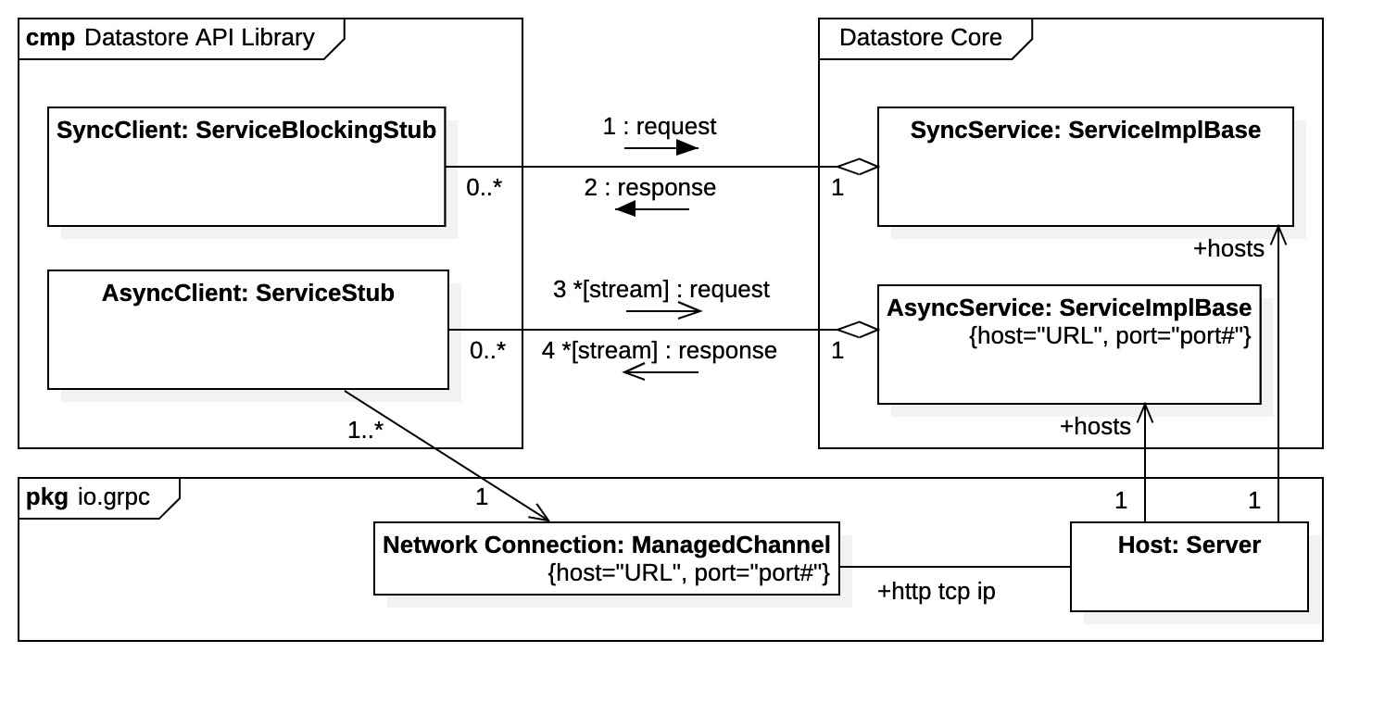

Figure 19: gRPC communications

Clients

Protocol Buffers generates “*communication stubs*” for clients. The communication stubs contain the remote procedure calls available for the service. There are different stub types supporting different communications models. For example, a “blocking stub” implements all remote procedure calls as blocking operations where operation exchange explicit data message instances. These stubs are generally used to implement synchronous communication with the service. A “non-blocking” stub supports the streaming remote procedure calls, that is, those procedure with the stream keyword in their definitions. All operations within a non-blocking stub are non-blocking. Rather than direct message exchange, the operations establish data streams between client and service. Although more complicated, non-blocking communication stubs can be used to implement asynchronous, multi-threaded communications with the service.

Clients implementing synchronous communications obtain a blocking communication stub. Within the diagram the blocking stub is named SyncClient with type ServiceBlockingStub. The communication stub contains all the non-streaming remote procedure calls. Analogously, clients implementing asynchronous communications will acquire a non-blocking communication stub, named AsyncClient with type ServiceStub. The non-blocking stub contains all the streaming remote procedure calls. In Java there is an additional stub type ServiceFutureStub (not shown in Figure 19). Details on communication stub acquisition are covered later.

Services

On the service side, Protocol Buffers provides a base class, of type ServiceImplBase, for receiving incoming messages and returning the corresponding responses. The base class, referred to as the service *implementation base*, provides function hooks for the service endpoints. Services override these functions to manage all incoming and outgoing RPC messages. Thus, a Datastore core service implements a child of this base class for both synchronous and asynchronous communications (as indicated in the diagram). Note that, as also indicated in the diagram, a single core service may support multiple client connections.

In the Python gRPC framework only one implementation base is available, the service implements asynchronous communication using the asyncio Python library. For Java gRPC implementation, again only one implementation base is available. The implementation base is always configured for streaming operations and the service may choose an asynchronous implementation using multi-threading support offered in the Java language SDK. The C++ gRPC framework, however, provides direct support for asynchronous communication, two distinct implementation bases are available, one for each paradigm.

As shown in the diagram, client *requests* are passed to the stub, transmitted across the network through the gRPC framework, then arrive at the implementation base where the message is recovered. The corresponding service *response* follows a complementary path where it is delivered to the stub and recovered by the client as a remote procedure call result. For the non-streaming case, the remote procedure call consists of a single request followed by a single response; the call does not release until the full operation is completed. For the streaming case, a data stream is opened between the client and the service. Data streams may be bidirectional or unidirectional. Multiple requests and responses may be exchanged until the stream is explicitly terminated. However, there are gRPC stream management protocols that must be respected, along with the additional data stream requirements defined by the core service and the specific remote procedure being invoked.

gRPC Resources

The gRPC framework contains library resources required of both clients and services. Many resources are language specific, for example, builder classes, interfaces for implementing data streams, and execution queues for asynchronous communications. However, in all implementations clients require gRPC channels for network connections and services require gRPC servers to host them.

Figure 19 indicates that the actual network communications are managed with a gRPC channel, a ManagedChannel instance in the diagram (the Java case). To obtain a communication stub, a channel connection must be created by the client specifying the desired service URL and port number. Each communication stub maintains a channel connection to the service, the service may support multiple connections to multiple clients. Channels need not be unique among communication stubs. Additionally, a single channel will support multiple data streams between a single client stub and the connected service.

Finally, as seen in Figure 19 each service must be hosted within a gRPC server. Server instances are created on the host platform and can be configured to support both synchronous and asynchronous communication. Individual service implementations attach to specific server ports on the host platform. The service provider can launch services through the hosting server, then managing service start and shutdown operations.

Streaming and Non-Streaming Operations

The gRPC framework provides support for both standard remote procedure calls and streaming remote procedure calls. In standard remote procedure call, the procedure is invoked and the operation blocks until completed, after which the response is returned. For a streaming gRPC operation, a remote procedure call establishes a data stream between client and service, the operation does not block. The stream remains open allowing client and service to transmit messages until explicitly terminated. In Figure 19, sequence 1 and 2 represent standard RPC communication and sequence 3 and 4 represent (bidirectional) streaming communication.

Within the proto meta language, streaming operations are explicitly identified with the stream modifier within a remote procedure call definition. Either the argument, the response, or both may be marked with the stream keyword. If both are marked, the remote procedure call establishes a bidirectional data stream between client and service, otherwise a unidirectional stream is created.

Both non-streaming and streaming communications often use the same protobuf messages. However, the implementations are quite different. Non-streaming (blocking) communication is straightforward and simple in gRPC, with a direct exchange of protobuf messages. Streaming communication typically involves the exchange of programming interfaces or iterators, which are used to establish the data stream. Streaming communications can be significantly faster, especially when using multi-threading, albeit at added complexity.

In most gRPC implementations, asynchronous communication is implemented with data streaming. That is, gRPC generally provides direct support for multi-threading in the streaming case, discussed more below. Thus, in gRPC, asynchronous communication implies streaming operations, although the converse is not required (i.e., streams can be single threaded). Additionally, gRPC typically offers clients the ability to assign separate execution thread to a blocking (non-streaming) remote procedure call, a hybrid type of communication.

Synchronous and Asynchronous Communications

The gRPC framework supports both synchronous and asynchronous communications between client and service. Synchronous operations are essentially standard remote procedure calls supported by a single execution thread. Asynchronous gRPC communication facilitate multi-threading of streaming remote procedure calls. Threads can be assigned to client requests and service responses over a single data stream. Thus, both client and service can spawn processing threads for message handling. Additionally, multiple streams can be established with repeated procedure calls.

In the Java gRPC implementation shown in Figure 19, synchronous communications are realized in the ServiceBlockingStub communications stub. The ServiceFutureStub (not shown) also implements synchronous communications; however, the operations are non-blocking. Operations there allow clients to assign execution threads to the non-blocking response (i.e., to be spawned when completed). The ServiceStub class supports full, asynchronous communications. There, multiple execution threads would run independently and must be synchronized externally by the client.

Full multi-threaded, asynchronous communications are available only for streaming remote procedure calls in gRPC (those defined using the stream keyword). Thus, we often equivocate the two paradigms when the context is clear. In Java gRPC, the service implementation base class (e.g., ServiceImplBase in Figure 19) *is* the asynchronous service implementation, services choose to realize the communications however they wish. In C++ gRPC, there are two separate service implementation base classes, one for each situation. In Python, the asyncio library must be applied to the single service implementation base class for asynchronous communication.

The Protobuf Language

A gRPC communication framework can be defined in the Protocol Buffers proto meta programming language [17]. It is a language and platform neutral system of specifying the supported remote procedure calls and their associated data messages. Here we demonstrate the basic syntax and grammar, while focusing on the language features used by the Datastore communications framework. The explanation proceeds by way of an example carried throughout the narrative.

Consider the proto code example shown in Figure 20; assume that the code is contained in file CommonMessages.proto. The file contains the definition of a protobuf message, GenericMessage, containing a named data set. The data set is realized as an aggregation of additional protobuf messages typed GenericData. The data represented within a GenericData message consists of an alarm condition and a data value. The data value may be typed as either Boolean, integer, long integer, or character string and is stored as a union using the oneof proto keyword. The alarm condition has type GenericAlarm, which is an enumeration of the constants NONE, MINOR, or MAJOR. Finally, the file also defines a response message GenericResponse consisting of a single Boolean field acknowledge, indicating whether the data set has been properly received and processed.

Referring to Figure 20 we see that protobuf messages are defined using the message protobuf keyword and enumerations are defined with the enum keyword. Note that every message field is defined by a name, a type, and an integer identifier. Many proto native types are identified: bool, uint32, uint64, and string. Fields representing aggregation (i.e., containing multiple instances) are defined with the repeated keyword modifier. Note that there are also compiler directives in the file header, namely syntax and option. The syntax specifier dictates that version 3 of the proto language is to be used. The option keyword supports a set of compiler options: the java_multiple_files option determines whether the compiler creates a unique file for each protobuf message, while the java_package option allows one to specify the Java package name containing all the defined message and enumerations. Finally, note that every field within a message is assigned an unsigned integer index. Thus, the general syntax for message field definition is

syntax = "proto3";

option java_multiple_files = true;

option java_package = "com.ospreydcs.generic";

/**

* A generic gRPC data message sent by a client. Contains a named data set.

* @param name name of dataset

* @param data the message data

*/

message GenericMessage {

string name = 1; // data set name

repeated GenericData data = 2; // data set

}

/** A data value instance within the message dataset. */

message GenericData {

GenericAlarm alarm = 10; // any alarm conditions

oneof value { // defined union

bool boolValue = 1; // Boolean value

uint32 intValue = 2; // integer value

uint64 longValue = 3; // long integer value

string stringValue = 4; // string value

}

}

/** Enumeration of all possible alarm conditions. */

enum GenericAlarm {

NONE = 0; // no alarms

MINOR = 1; // minor alarm condition

MAJOR = 2; // major alarm condition

}

/**

* A generic response to the generic message.

*/

message GenericResponse {

bool acknowledge = 1; // true if message received and acknowledged

}

Figure 20: proto example - CommonMessages.proto message and response definitions

datatype fieldname = index;

where index is the field index value. The index value is used internally by protobuf when serializing the message before transport.

syntax = “proto3”;

option java_package = “com.ospreydcs.generic”;

import “CommonMessages.proto”;

/**

* A service that accepts data sets in the form of GenericMessage’s and returns

* responses as GenericResponse messages which acknowledge receipt.

*

* Data may be transmitted individually using the sendMessage() operations,

* or it may be streamed using the streamMessage() RPC method.

*/

service GenericService {

rpc sendMessage(GenericMessage) returns (GenericResponse);

rpc streamMessage(stream GenericMessage) returns (stream GenericResponse);

}

Figure 21: proto example - GenericService.proto service definition

Figure 21 contains another code example defining a gRPC service interface, GenericService. Assume the source code is contained in the file GenericService.proto. The code example contains compiler options seen in the previous example plus the additional directive include instructing the compiler to include the contents of CommonMessages.proto. That is, the service interface GenericService requires all the messages defined in CommonMessages.proto. Although the situation is somewhat artificial (the example is small enough to be contained in a single file), it does illustrate the modularization of proto source files.

The example in Figure 21 defines a gRPC interface for a service which receives data sets contained within GenericMessage protobuf messages. The interface contains two operations (i.e., remote procedure calls) identified with the rpc keyword, sendMessage() and streamMessage(). Both operations take a GenericMessage argument containing the data set and return a GenericResponse result containing the acknowledgement. However, operations are supported very differently within gRPC. The sendMessage() operation is implemented as a standard remote procedure call accepting a single argument and returning a single response. The streamMessage() operation establishes a forward stream of GenericMessage messages as the request and a backward stream of GenericResponse messages as the response. The streaming operation maintains a bidirectional data stream where multiple data sets may be transmitted until the stream is explicitly terminated. As to be seen, the data stream is typically implemented with an exchange of programming interfaces or iterators (i.e., depending upon the language support).

The entire example presented above (i.e., both source files) can be represented concisely with the single UML diagram of Figure 22. The diagram also explicitly indicates the relationships between the protobuf messages and the gRPC service interface. For reference, the diagram also contains notes describing the proto language and the specific UML representation.

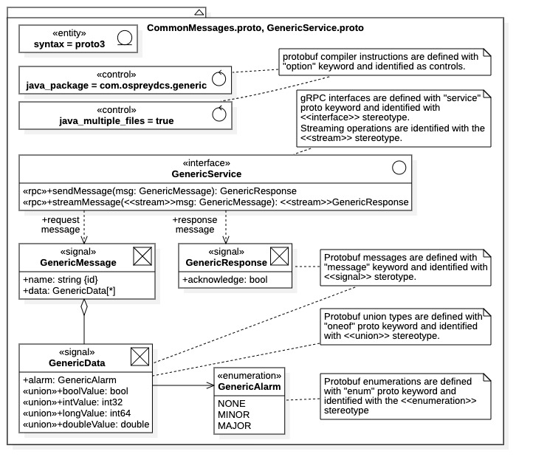

Figure 22: proto example - UML schematic

Protocol Buffers Implementation

Once the “Generic Service” gRPC communications framework is defined in the proto language, the Protocol Buffer compiler protoc is used to generate the programming language source code implementing the framework. The specific programming language is identified using protoc compiler options. The protobuf compiler is generally invoked twice, once to generate the protobuf message source file(s), then again to generate the gRPC service interface source file(s). The protoc generated source files then provide endpoints for both client and service applications. All protobuf generated source code uses the gRPC framework for message transport across computer networks.

Command Line Compiler

Protobuf compilation is a two-stage process when run from the command line. The protoc compiler must be invoked to generate the protobuf messages, then again to generate the client and service gRPC interfaces. Each invocation requires different compiler options and targets.

For protobuf message generation, the basic syntax for the command line Protocol Buffers compiler is given by the following:

protoc [OPTIONS] PROTO_FILES

where PROTO_FILES is a collection of the proto source file locations and the [OPTION] field is a list of compiler options. The target language is specified as a compiler option. The following are the currently supported language options:

--cpp_out=OUT_DIR Generate C++ header and source.

--csharp_out=OUT_DIR Generate C# source file.

--java_out=OUT_DIR Generate Java source file.

--kotlin_out=OUT_DIR Generate Kotlin file.

--objc_out=OUT_DIR Generate Objective-C header and source.

--php_out=OUT_DIR Generate PHP source file.

--pyi_out=OUT_DIR Generate python pyi stub.

--python_out=OUT_DIR Generate Python source file.

--ruby_out=OUT_DIR Generate Ruby source file.

The parameter OUT_DIR is the directory receiving the generated language files, this directory must exist prior to compilation (although any package subdirectories will be created). It is important to note that using one of the above options will generate only the Protocol Buffers messages contained within the given proto files collection (i.e., the data message identified with the message keyword). No gRPC interfaces are generated (i.e., the gRPC resources for remote procedure calls defined with the service keyword).

The client and service gRPC interfaces are generated using the –-grpc_out=OUT_DIR compiler option; this option must be used in conjunction with the --plugin=protoc-gen-grpc=PLUGIN_LOCATION option. Note that in the latter option both the plugin name (i.e., protoc-gen-grpc) and its location are specified within the option parameters. Thus, to generate the gRPC framework, the basic syntax for the protobuf compiler is given as follows:

protoc --grpc_out=OUT_DIR --plugin=protoc-gen-grpc=PLUGIN_LOCATION

The executable gRPC plugin found at PLUGIN_LOCATION specifies the programming language used in the generated source files. The parameter OUT_DIR is used as before.

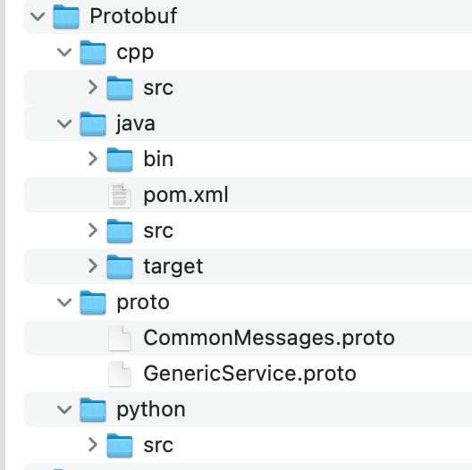

Figure 23: proto example - directory structure

To demonstrate the Protocol Buffers language options we compile the example code into three different programming languages: Python, Java, and C++. Assume first that our directory structure is that as shown in Figure 23 where the proto source files CommonMessages.proto and GenericService.proto are contained in the directory Protobuf/proto. Assume second that the gRPC system is installed locally and the Protocol Buffers compiler and gRPC plugins are on the local path (again, see [13] for local gRPC installation [instructions](https://grpc.io/docs/languages/cpp/quickstart/#install-grpc)). As shown above, compiling is a two-stage process; the protobuf messages and gRPC interface resources must be compiled separately.

Python Compilation

To generate a Python implementation for the Protocol Buffers example, execute the following two commands from the Protobuf/proto directory of Figure 23:

protoc -I . --python_out=../python/src CommonMessages.proto

protoc -I . --grpc_out=../python/src \

--plugin=protoc-gen-grpc=`which grpc_python_plugin` \

GenericService.proto

Note that the full path to the gRPC plugin is obtained using the UNIX command `which grpc_python_plugin`; the full path specification is generally required to ensure proper operation. The -I . option simply instructs the protoc compiler to look in the current directory for any referenced files, for example, targes of include directives within source files. Once completed, the above commands will have generated the following Python files:

* CommonMessage_pb2.py: All protobuf message implementations (from CommonMessages.proto)
* GenericService_pb2_grpc.py: The GenericService gRPC interface implementations.

Both files are in the Protobuf/python/src directory as instructed. The GenericService_pb2_grpc.py source file contains the interface implementations and resources for both clients and services. The “pb2” seen in the file names refers to the Python version of Protocol Buffers, not the protobuf languages version.

Java Compilation

To generate the Java implementation for the Protocol Buffers example, execute the following commands from the Protobuf/proto directory of Figure 23:

protoc -I . --java_out=../java/src ./CommonMessages.proto

protoc -I . --grpc-java_out=../java/src \

--plugin=protoc-gen-grpc-java=`which protoc-gen-grpc-java` \

GenericService.proto

Note that the Java language case is slightly different from the general case. Specifically, when generating the gRPC interface resources, one must explicitly identify the Java language in the output option (--grpc-java_out) and the gRPC plugin name identifier (protoc-gen-grpc-java).

The generated files are under the parent directory Protobuf/java/src as instructed in the command line. The compiler creates new subdirectories within the parent for output, as dictated by the Java naming standard for class packages and directory structures. Recall that we explicitly defined a package enclosure for all Java implementations using the proto compiler directive “option java_package = com.ospreydcs.generic”. Thus, the generated files will be contained in the package directory Protobuf/java/src/com/ospreydcs/generic.

The compiler directive “option java_multiple_files = true” is also included in the CommonMessages.proto file. This command instructs the compiler to generate separate source files for each protobuf message. Thus, the following files are contained in the Protobuf/java/src/com/ospreydcs/generic package directory:

* Protobuf message files:
  + message classes: GenericMessage.java, GenericData.java, GenericAlarm.java, GenericResponse.java
  + interface classes: GenericMessageOrBuilder.java, GenericDataOrBuilder.java, GenericAlarmOrBuilder.java, GenericResponseOrBuilder.java
  + protobuf resources: CommonMessages.java
* gRPC interface files:
  + GenericServiceGrpc.java

Here, the protobuf compiler generates two files for each protobuf message: a message class and a message interface. The interfaces are required by the Java protobuf implementation and are discussed below. Protobuf also generates an additional file, CommonMessages.java, containing protobuf resources associated with the original source file. The gRPC interface implementation for GenericService are contained in GenericServiceGrpc.java, the file contains resources required by both clients and services.

Note that the Protobuf/java directory within Figure 23 contains the file pom.xml and the additional directory target. These entities are used for building the example with the Maven utility. In that case, the pom.xml file contains the protobuf compiler settings and options, while the target directory will contain the generated Java source files. Details of a Maven project build are beyond the scope.

C++ Compilation

To implement the gRPC communications framework in C++, execute the following commands from the Protobuf/proto directory:

protoc -I . --cpp_out=../cpp/src CommonMessages.proto

protoc -I . --grpc_out=../cpp/src \

--plugin=protoc-gen-grpc=`which grpc_cpp_plugin` \

GenericService.proto

Notice that the commands follow the same general format as for the Python case.

The first command generates the protobuf messages. The following two C++ files are generated:

* CommonMessages.pb.h: The C++ header file containing message class definitions.
* CommonMessages.pb.cc: The corresponding C++ source file containing message implementations.

Both files are contained in the Protobuf/cpp/src directory. As is standard for the C++ language, the class and type definitions for the protobuf messages are contained in the *.h extension file, while the implementations are in the *.cc extension file.

The second command generates the gRPC implementation of the GenericService interface. It requires the local path availability of the Protocol Buffers plugin grpc_cpp_plugin for generating C++ gRPC interface implementations. Again, the UNIX command `which grpc_cpp_plugin` is used to obtain the full path of the plugin.

The C++ gRPC interfaces are generated within the following files:

* GenericService.grpc.pb.h: The C++ header file containing gRPC interface definitions.
* GenericService.grpc.pb.cc: The corresponding C++ source file containing interface implementions.

These files are also located in the Protobuf/cpp/src directory. The file contain resources for both clients and services.

Python Implementation

Messages

The Python implementation of the protobuf messages within Figure 20 is shown in Figure 24. The diagram is overly complicated because it includes the method by which the message classes are created. The message classes are listed at the top.

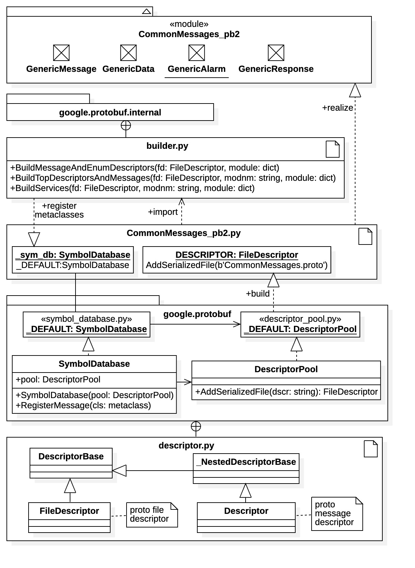

Figure 24: proto example - CommonMessages.proto Python implementation

The implemented message classes are contained within the CommonMessages_pb2 namespace, however, there is no explicit code defining them. Clients using the Python implementation may proceed without knowledge of the actual Python implementation, simply by treating the message classes as if they are standard Python classes with attributes defined in Figure 22. Readers uninterested in the message class implementation can skip to the next subsection.

Upon inspection of the CommonMessages_pb2.py file one would find that there is no code definition of the protobuf messages; that is, there are no Python class statements for the common messages. The protobuf messages GenericMessage, GenericData, GenericAlarm, and GenericResponse are created using Python meta classes and class builders. The protobuf messages appear as like-named Python classes within the CommonMessages_pb2 module namespace.

The diagram attempts to capture the mechanism by which this is done. Within the CommonMessages.py file one finds 2 global objects: 1) _sym_db (type google.protobuf.SymbolDatabase), the global database of protobuf meta classes, and 2) DESCRIPTOR, a file descriptor (type google.protobuf.descriptor.FileDescriptor) containing a serialized description of the CommonMessages.proto file. As indicated in Figure 24, there are then several lines of code. One line creates the DESCRIPTOR object. The subsequent lines instruct the Protocol Buffers internal builders to create the protobuf message classes from the DESCRIPTOR object. Note that the protobuf message classes are created in both the global namespace and the CommonMessages_pb2 module namespace.

Clients

The protobuf generated client resources are depicted in Figure 25. The gRPC client communications stub and service base class are contained in file GenericService_pb2.py. The communications stub is realized with the GenericServiceStub class and provides the client endpoints for the GenericService interface. It contains all remote procedure calls contained within the GenericService protobuf definition.

Referring to Figure 25, the communication stub contains two procedures, sendMessage() and streamMessage(). The operations are actually implemented as attributes of types UnaryUnaryMultiCallable and StreamStreamMultiCallable, respectively; due to the loose typing in Python the distinction is essentially without a difference. Clients can refer to these attributes just as if they were operations in a formal interface. Both can be invoked either synchronously or asynchronously as to be discussed below.

Communications stubs are available with from the GenericServiceStub constructor. Note that the constructor requires an argument of type Channel. Thus, it is necessary to first construct an appropriate channel object to create the network connection to the service. The type of communications, either synchronous or asynchronous, is determined by the choice of channel object. Also, any security credentials required by the service are included within the Channel object. Channel creation is discussed more below.

Services

The service endpoints are contained in the base class GenericServiceServicer, shown in Figure 25. Service implementations override this class to acquire the service endpoints and provide operations. To launch an implemented service, a gRPC server instance is required (i.e., an grpc.Server object). Python Server instances are created using the Python gRPC resources described below. An implemented service instance is then assigned to the server using the static function add_GenericServiceServicer_to_server() contained in the GenericService_pb2.py module.

The service must inherit from the GenericServiceServicer base class and override the two procedures, sendMessage() and streamMessage(). Note that the sendMessage() function takes a single GenericMessage argument while the streamMessage() function takes an iterator of GenericMessage arguments. Respectively, a single object of type GenericResponse is returned by operation sendMessage() and an iterator of GenericMessage objects is returned by operation streamMessage(). This is the essential difference between non-streaming and streaming remote procedure calls in Python. Note that each procedure also requires an argument of type ServerContext which contains process parameters for the hosting server instance, these are optional parameters offered to the server by the service.

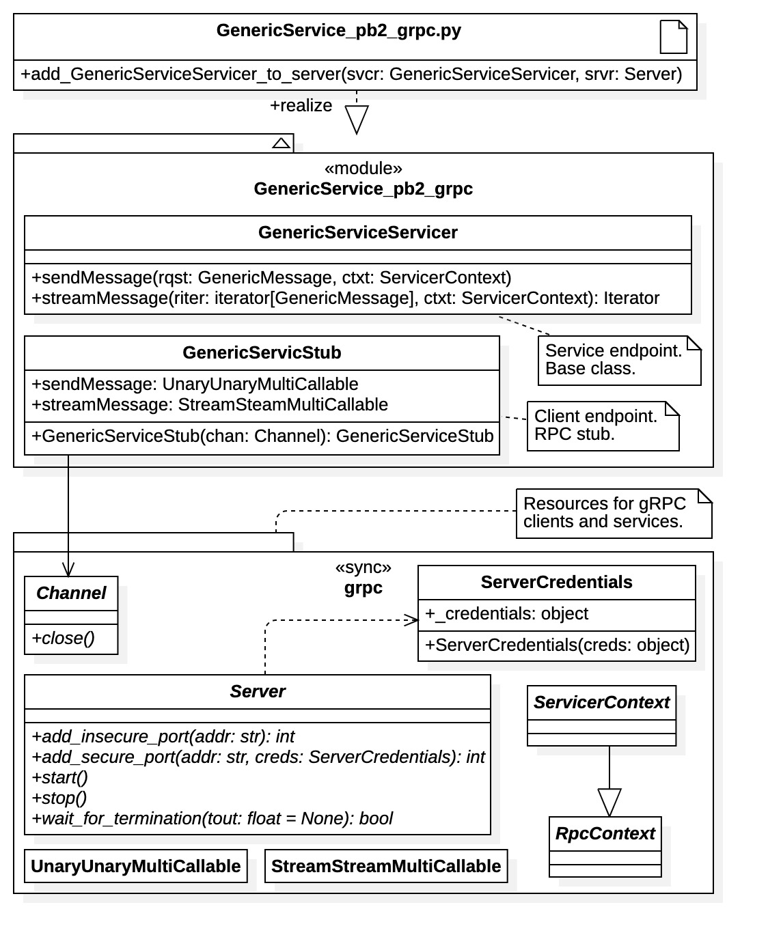

Figure 25: proto example - GenericService.proto Python implementation

To launch a service, an service instance must be created then registered with a gRPC server object (of base type grpc.Server), as described above. As shown in Figure 25, the Server abstract class has methods for assigning the service to a specific port with or without security credentials. The class also has methods for starting and stopping the service.

gRPC Resources

Figure 26 is a diagram showing the additional gRPC resources required for channel and server creation in Python. As shown in the figure, the Python package grpc contains the resources needed for synchronous communications while package grpc.aio contains the analogous resources for asynchronous communications.

##### Synchronous Communications

The package initialization file grpc/__init__.py (and, thus, in the grpc namespace) contains functions for creating both secure and insecure synchronous channels and synchronous server instances. Channel credentials, of type ChannelCredentials, are required to create channel objects. Recall that server credentials are assigned by port using ServerCredentials instances. Both credential classes have constructors for creating instances, the arguments passed to the constructors depend upon the type of credentials being used. For all server creation a thread pool executor is required, all other arguments are optional.

##### Asynchronous Communications

For asynchronous communications, analogous methods for channel and server creation are contained in the grpc.aio namespace, although their location is distributed within the modules grpc/aio/_channel.py and grpc/aio/_server.py, respectively. Again, credentials are required for channel creation. Note that all channel and server objects have the same class identifier, Channel and Server, respectively. Thus, to switch from synchronous to asynchronous communications clients and services import the desired namespace. Additionally, for asynchronous communication one must also import the Python asyncio library and follow the async Python syntax and convention. See the gRPC Python [code examples](https://github.com/grpc/grpc/tree/v1.54.0/examples) for specifics of each communications mechanism [14].

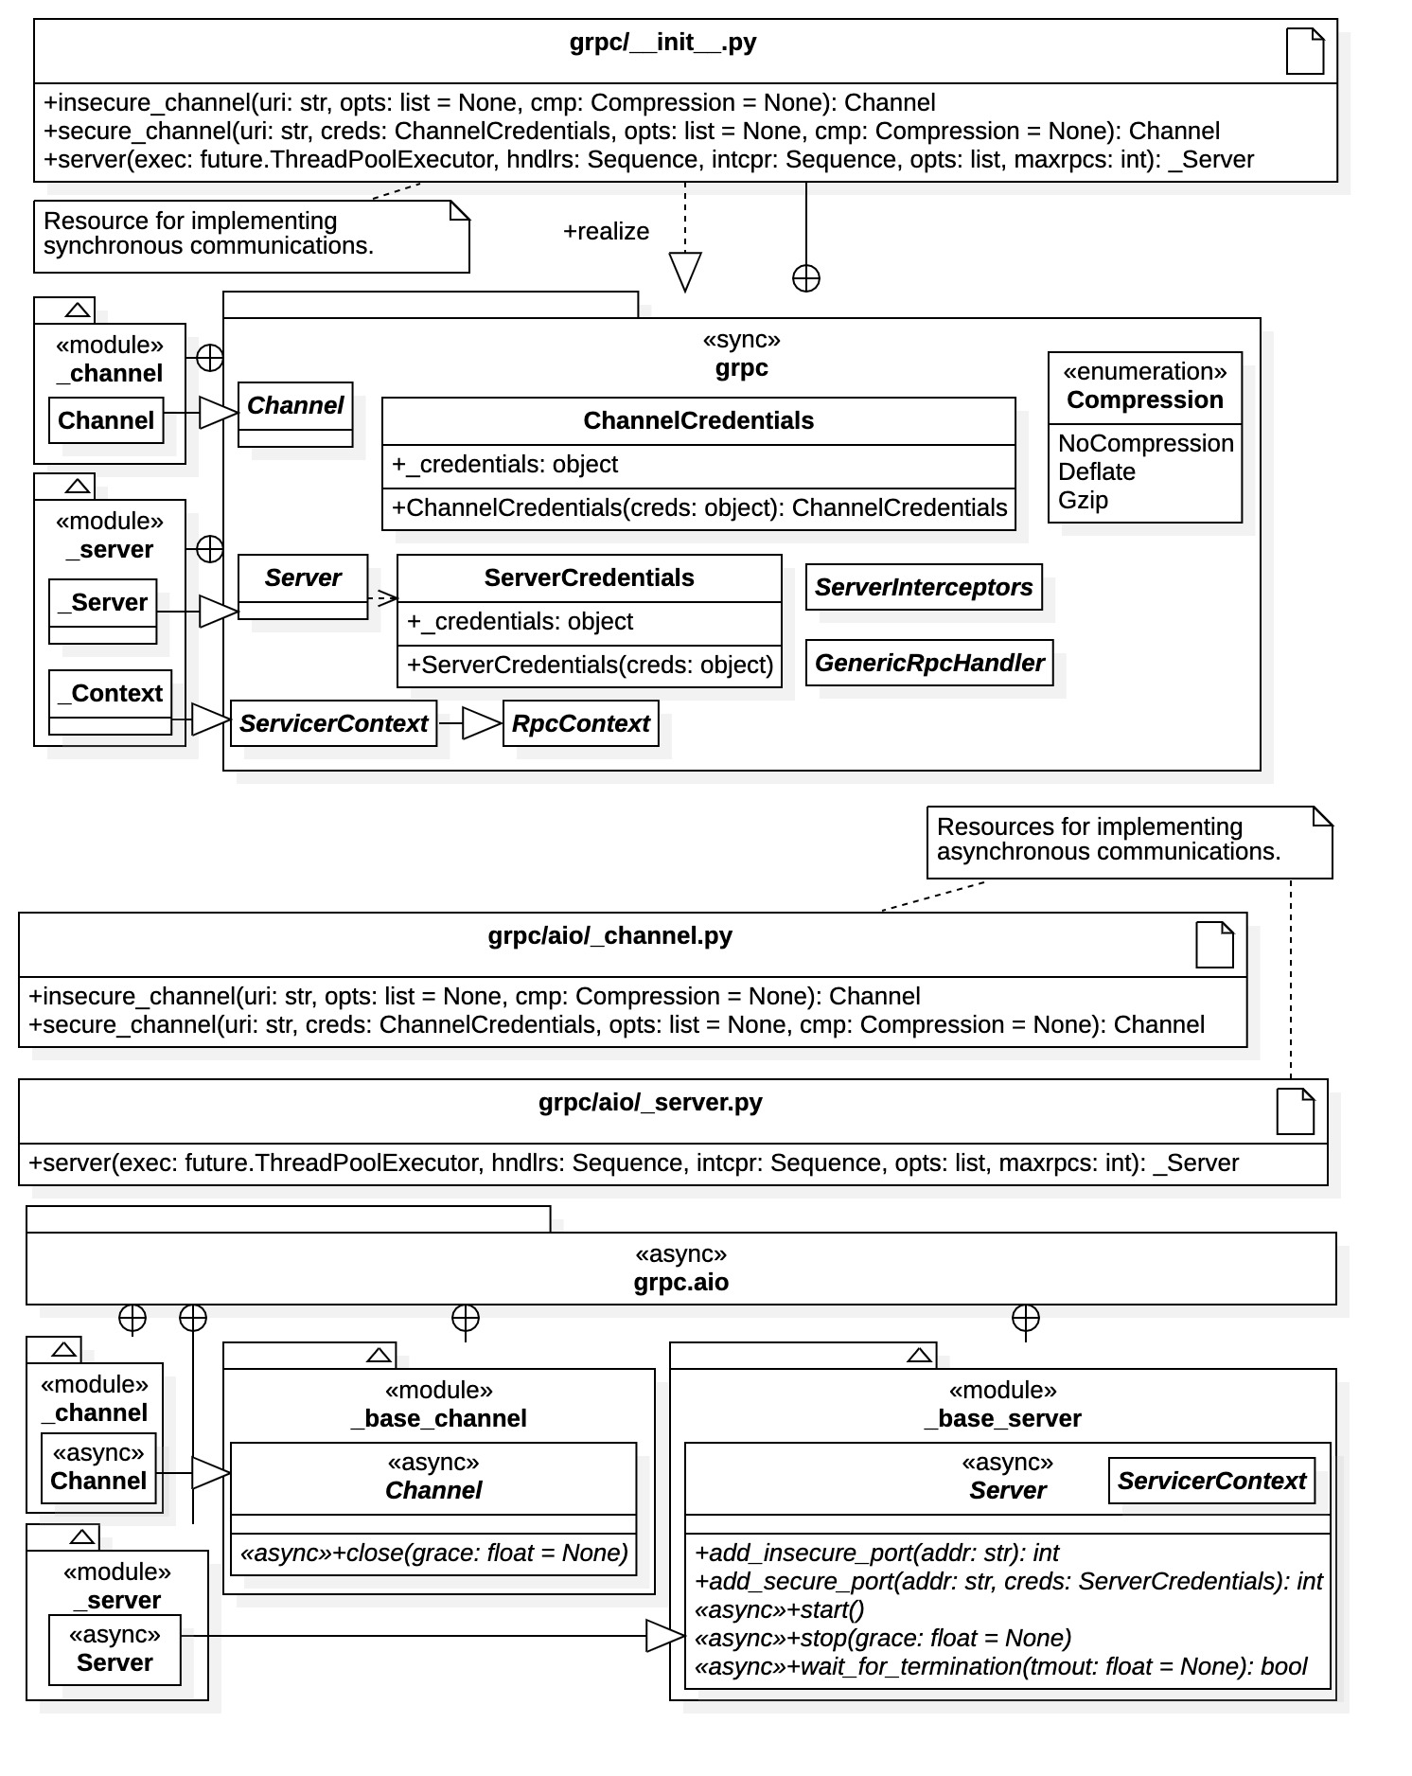

Figure 26: proto example - Python gRPC channel and server resources

Java Implementation

Compiling the example CommonMessages.proto in Java produces the implementation for the protobuf messages shown in Figure 27. The diagram also includes relationships and associations between resources to help identify roles and responsibilities. Additionally, notes are included to further identify resources and their functions.

Messages

Unlike the Python implementation, the protobuf messages are realized as concrete Java classes. The diagram includes dependencies contained in the external package library com.google.protobuf to demonstrate the protobuf mechanism. All protobuf generated message classes inherit from a common base class GeneratedMessageV3, used by the internal gRPC mechanism to recognize message classes.

One Java class and one Java interface is generated for each protobuf message (i.e., a protobuf message data structure). Seen in the diagram is the additional class CommonMessages which provides a static method for obtaining the gRPC file descriptor. It is interesting to comment that if we had set the compiler option java_multiple_files = false all resources defined in CommonMessages.proto would be implemented as enclosed static classes of CommonMessages. Also differing from the Python case is that Java message classes are immutable; once they are created, they cannot be modified. The message fields are implemented as private attributes of the message class, which provides no setter methods. Thus, the requirement for message builder classes in the Java implementation, as seen in Figure 27.

##### Message Builders

The immutability of the Java message classes necessitates the use of builder classes seen in Figure 27. Each message class contains an enclosed class Builder. Builder instances can be generated with the newBuilder() static methods within the enclosing message class. Message class attributes (protobuf message fields) are configured with the builder setter methods. A message class instance is the created *in toto* by invoking the build() method of the builder. Note that the setter methods for builders all return the builder this reference. This is a programming convenience so that setter calls may be chained.

##### Message Interfaces

For each message class a Java interface is also created. The interface is always named by the protobuf message identifier suffixed with “OrBuilder”; for example GenericMessageOrBuilder and GenericResponseOrBuilder are the interfaces for protobuf messages GenericMessage and GenericResponse, respectively. The interface defines all the attribute getter methods for the message. Thus, the interface is used to unpack a message class after transmission.

Both the protobuf message class and its corresponding builder expose the interface. Thus, message builders can be inspected before message instance creation.

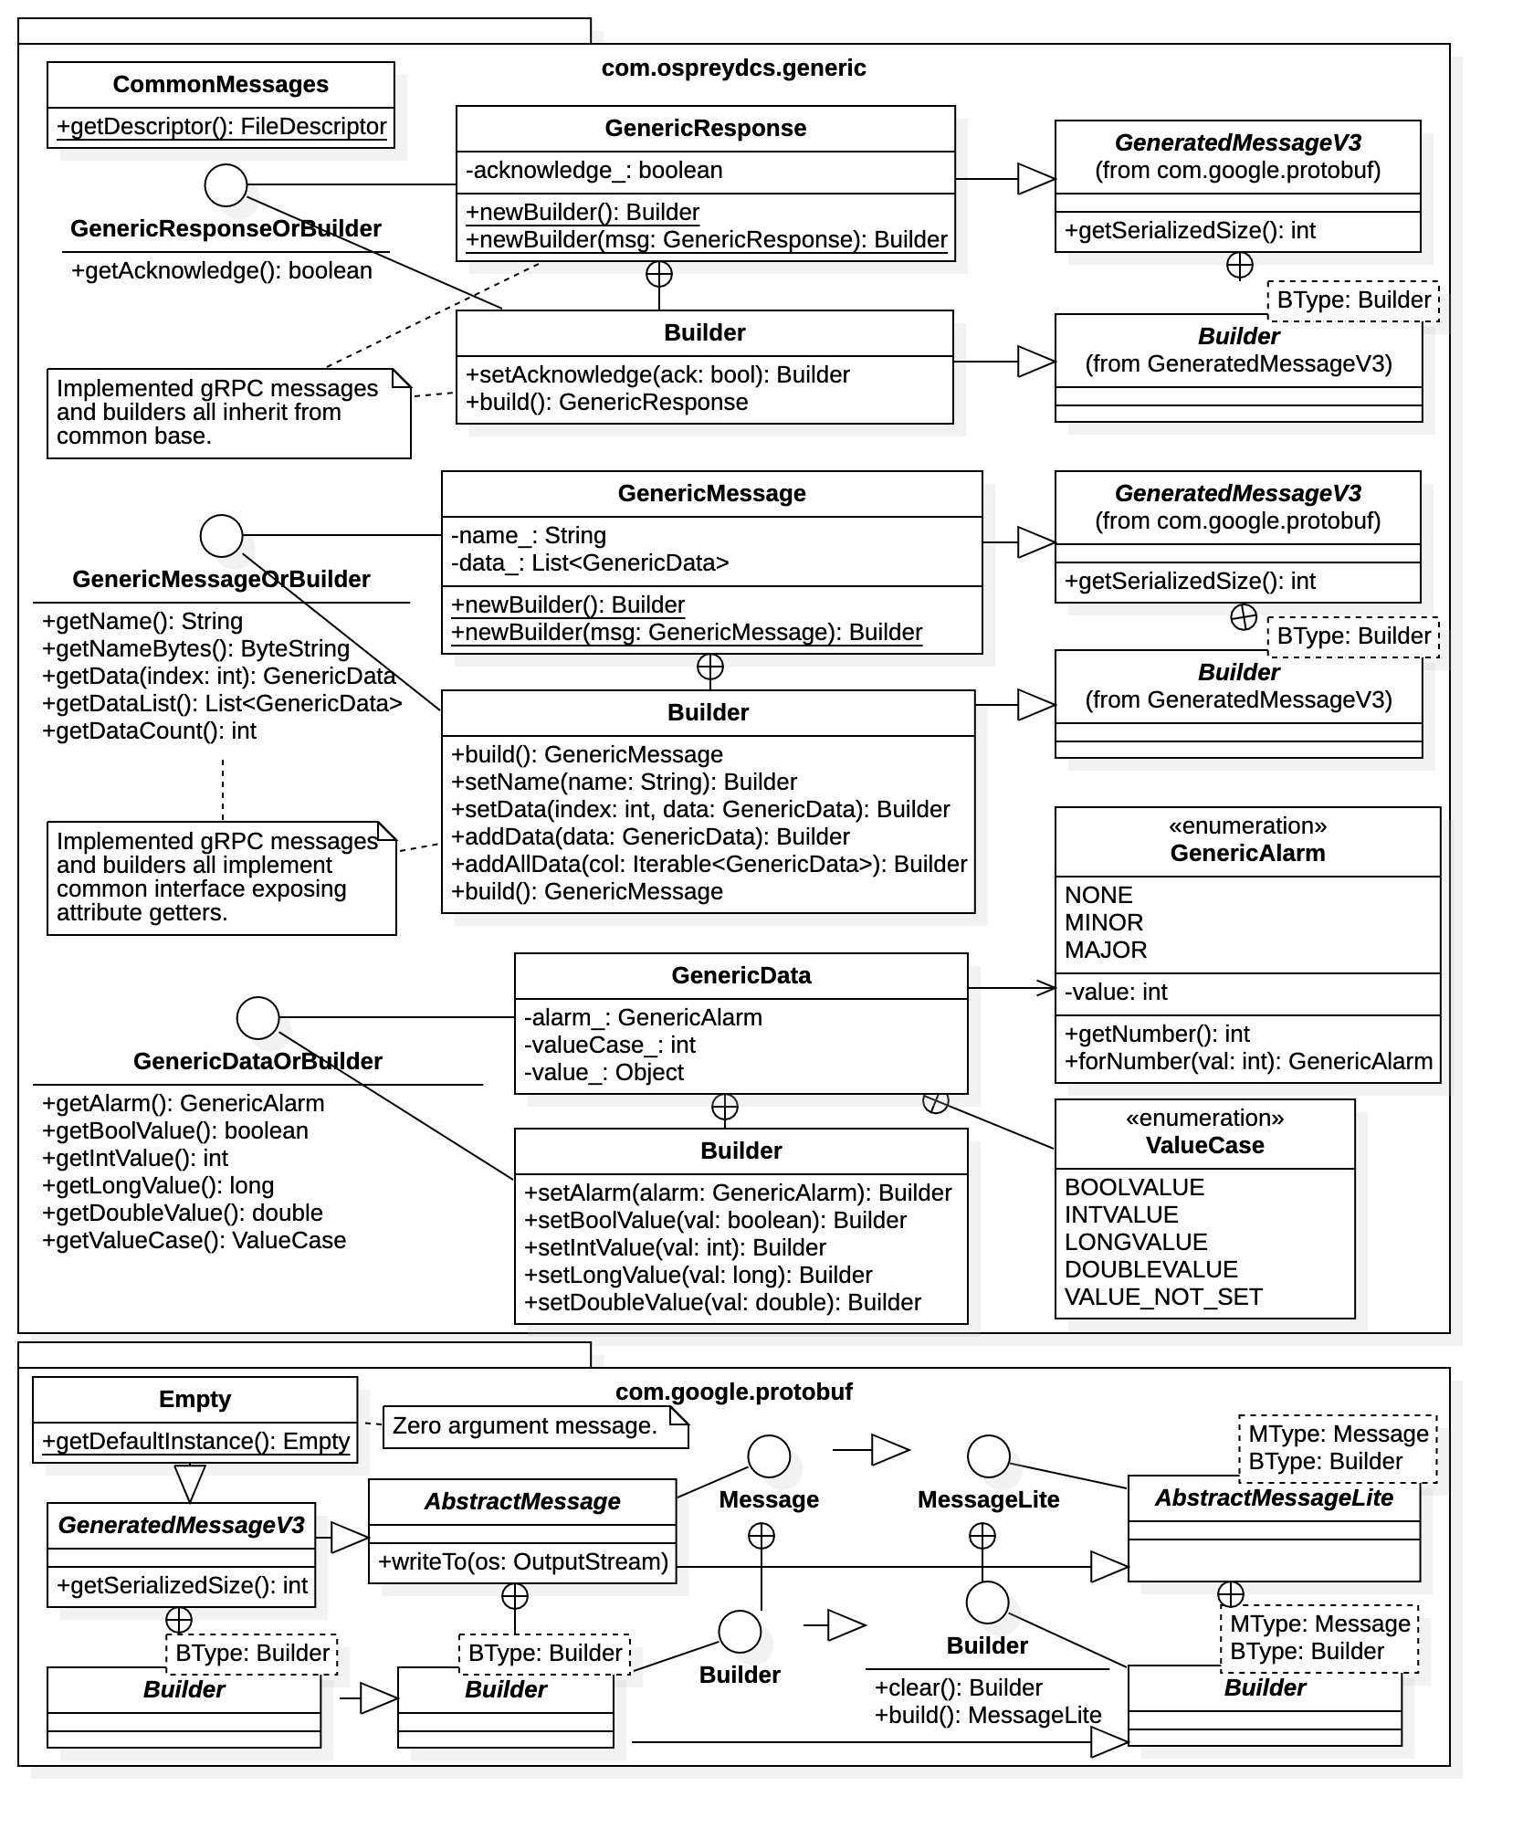

Figure 27: proto example - CommonMessages.proto Java implementation

##### Message Creation

From the GenericMessage class we see that aggregated message fields are implemented as ordered lists of type java.util.List<>. The lists containing instances of the field type, in this case GenericData instances. In our example, the protobuf message data field is defined as the class attribute data_ with type java.util.List<GenericData>.

From the builder class GenericMessage.Builder we see that individual GenericData instances may be appended to the list using the addData() method or set by index using the setData() method. Alternatively, the entire data set may be assigned atomically with the method addAllData() which accepts an iterator of GenericData objects, of type Iterable<GenericData>. From the GenericMessageOrBuilder interface we see that the data field elements may be retrieved individually by index with the getData() operation or collectively using the getDataList() operation. The same basic mechanism is used for all aggregated message fields in the Java gRPC implementation.

For union message fields (defined using the oneof keyword), the message field value is implemented as a Java Object type. This condition is seen for with the attribute value_ of the GenericData class. Note that Protocol Buffers creates the enclosed enumeration GenericData.ValueCase which lists all the fields of the union. Here, the enumeration constants identify attribute types. The message class attribute type is available through the interface operation GenericDataOrBuilder.getValueCase(). The attribute value is assigned using a typed setter method of the builder class.

Finally, note that the com.google.protobuf package contains the message class Empty, which is used for protobuf remote procedure call operations defined without arguments. In the Java protobuf implementation, remote procedure calls always require arguments; instances of the Empty class can be used to explicitly indicate the no argument condition. Note that the static method Empty.getDefaultInstance() can be used to obtain the default Empty instance; this instance may be used for all zero-argument remote procedure calls.

Clients

The Java implementation of GenericService.proto is shown in Figure 28. The diagram illustrates that the class GenericServiceGrpc contains the entire gRPC interface, for both clients and services. This class contains four enclosed static classes. The three classes GenericServiceBlockingStub, GenericServiceFuturesStub, and GenericServiceStub are the gRPC communications stubs for clients. The first communications stub provides clients blocking communications while the latter two offer non-blocking client communications, although GenericServiceFuturesStub is somewhat of a hybrid. As seen in the diagram all communications stubs are part of an inheritance hierarchy originating in package io.grpc. The abstract class GenericServiceImplBase is provided for services to attach their endpoint operations, discussed below.

Communications stubs of the desired type are available from the GenericServiceGrpc static methods newBlockingStub(), newFutureStub(), and newStub(). Each method requires an instance of a Channel object which establishes the network connection. Creation of Channel instances requires the use of a channel builder object, in this case a ManagedChannelBuilder object as shown in Figure 28. A ManagedChannelBuilder instance is available from the class static methods forAddress() and forTarget(). These methods provide builders for insecure channel connections (see Section 0 for information on builders for secure channel). The channel builder also contains methods for channel configuration, such as timeout limits and maximum message sizes (compression options are set on the Channel instance). Note that channel instances should be released when no longer needed, using the shutdown() method. This operation frees gRPC resources attached to the channel..

##### Synchronous Communication

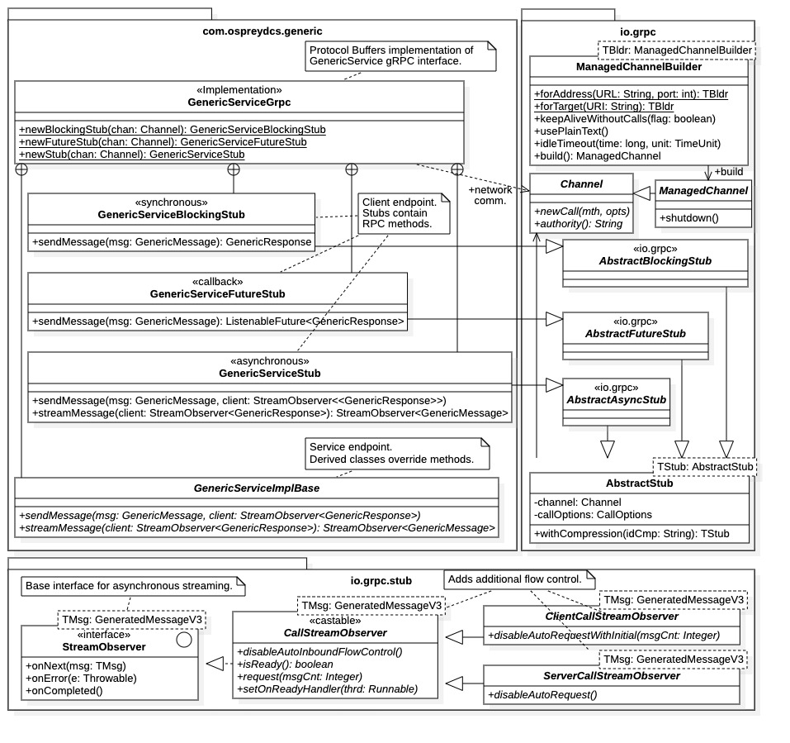

Figure 28: proto example - GenericService.proto Java implementation

Standard (non-streaming) RPC operations within gRPC are implemented as blocking, synchronous operations. Note that the streamMessage() operation of our example is available only within the streaming communication stub GenericService.GenericServiceStub. The synchronous communications stub GenericServiceBlockingStub contains only one method, sendMessage(). Its use is straightforward; it takes a GenericMessage argument and returns a GenericResponse instance, blocking until complete. Non-streaming, synchronous communications is quite simple in Java.

##### Callback Communication

The GenericServiceFuture communication stub may be used to implement callback communication. From Figure 28 we see that the stub contains only the non-streaming sendMessage() operation. However, here the remote procedure call does not block but, instead, returns a ListenableFuture<GenericResponse> interface. This condition allows clients to directly wait for completion, set up a completion notification thread, or set up a result processing thread. Note that callback communications can be considered a hybrid between synchronous communications and asynchronous communications.

The ListenableFuture<> interface is part of the Google concurrency library in the com.google.common.util.concurrent package. The interface allows clients to either block on the get() operation, or register an execution thread to spawn whenever the operation is completed. For the latter case, the ListenableFuture<> interface provides the operation addListener(Runnable, Executor>.

Remote procedure call responses can be recovered from the ListenableFuture<>.get() blocking operation. The client can implement independent response threads using the addListener() operation. Thus, the callback communications stub offers a limited form of asynchronous communication.

##### Asynchronous Communication

Streaming operations are available in the GenericServiceStub communication stub. In fact, all operations within the GenericService interface are available within this stub. However, here even the non-streaming operation requires the creation of a backward data stream from service to the client.

The Java gRPC implementation offers clients asynchronous communications *only for streaming operations*. Streaming communications always involve the exchange of StreamObserver<> interfaces to establish the data stream. Streaming remote procedure call invocations do not block, they exchange interfaces. Data is transmitted only a non-streaming argument.

Referring to the GenericServiceStub class, even the non-streaming operation sendMessage() returns a StreamObserver<> interface which is used to obtain the GenericResponse message response. For the streaming operation streamMessage(), the client must implement a class exposing the StreamObserver<GenericResponse> interface, used as the argument. The interface implementation must properly realize the onNext(GenericResponse) and onCompleted() operations shown in the Figure 28.

In response to the streaming remote procedure call streamData(), the client receives a StreamObserver<GenericMessage> interface, which is used to send data messages to the service with the onNext(GenericMessage) operation. Once all messages have been transmitted, the client signals completion by invoking the onCompleted() operation on the returned interface. The service should then respond in kind by invoking onCompleted() on the client’s StreamObserver<GenericResponse> interface. This terminates the data stream.

As shown in Figure 28 the package io.grpc.stub contains class implementations of the StreamObserver<> interface offering additional stream flow control. Clients may choose to implement their stream interfaces inheriting from a base class (e.g., CallStreamObserver<> or ClientCallStreamObserver<>). Clients can also cast StreamObserver<> interfaces received from the service to an appropriate type (e.g., CallStreamObserver<> or ServerCallStreamObserver<>). Note that these base classes offer the ability to set event handlers (i.e., Java Runnable instances) to be invoked whenever the service signals a ready event. This is a convenience when implementing asynchronous, multi-threaded communication.

Services

Within Figure 28, the GenericServiceImplBase is the service base implementation class. It provides the remote procedure call endpoints required by service implementations. In the Java gRPC realization there is only one type of service base implementation, it supports all service endpoints as streaming operations. Internally, gRPC provides an asynchronous implementation. Services may choose to implement their operations synchronously or asynchronous. However, the communications model is essentially dictated by the client when accessing the communications stub.

Referring to GenericServiceImplBase, there are 2 services endpoints, 1) sendMessage() for the non-streaming RPC operation, and 2) streamMessage() the streaming RPC operation. In the non-streaming case, the sendMessage() accepts two arguments, the message itself (of type GenericMessage), and the interface StreamObserver<GenericResponse>. The latter argument is used to send responses to the client.

In the streaming operation streamMessage(), a StreamObserver<GenericResponse> is passed in and the operation returns an interface StreamObserver<GenericMessage>. The procedure argument is, again, the client interface to send service responses. The StreamObserver<GenericMessage> interface returned by the service must be properly implemented to accept GenericMessage instances using the onNext(GenericMessage) operation. The client and service coordinate the stream completion using their respective onCompleted() operations within the exchanged interfaces. Any errors encountered during the data streaming on either side can be signaled using the onError() operation on either interface.

Note that Figure 29 provides a more detailed description of the GenericServiceImplBase base class for service implementation. In actuality, the base class method requirements are dictated by the enclosed interface AsyncService. (As previously mentioned, all service implementations are essentially asynchronous in the Java gRPC implementation.) The base class is also required to implement the io.grpc.BindableService interface, which is done within the generated Java code. The latter interface identifies the service implementation as a gRPC service which can be launched with gRPC server instances, to be discussed below.

gRPC Resources

Figure 29 lists some common gRPC resources required for both clients and services. The package io.grpc contains resources and methods for creating gRPC channels, gRPC servers, and security credentials. The utility class io.grpc.Grpc contains static methods that create builders for secure channels and servers. Security credentials are identified by class type and created with class constructors.

##### Channels

Network channel objects are created using channel builders. Thus, clients must first obtain a channel builder, which configures and then creates a channel. In Java gRPC, object of type ManagedChannel are used. Channel builders of type ManagedChannelBuilder are required to create these channels.

Channel builders producing insecure network channels are available from the ManagedChannelBuilder class. The class has static methods forAddress() and forTarget() which create ManagedChannelBuilder instances; the methods are identified in Figure 28. However, builder instances created by these methods will generate only insecure network channels.

To create secure network channels, a ManagedChannelBuilder instance must be obtained from the io.grpc.Grpc utility class. Channel builder objectsare created with the Grpc.newChannelBuilder() methods. They will be attached to the host address provided in the arguments. A ChannelCredentials object must also be provided, it establishes the security credentials for all subsequently created channels. The ChannelCredentials class is subtyped to identify the specific credentials used. For example, the type TlsSecurityCredentials is explicitly shown in Figure 29 to identify Transport Layer Security (TLS) credentials. Once a secure ManagedChannelBuilder instance is obtained it functions as before, but produces only secure channels with the credentials provided.

##### Servers

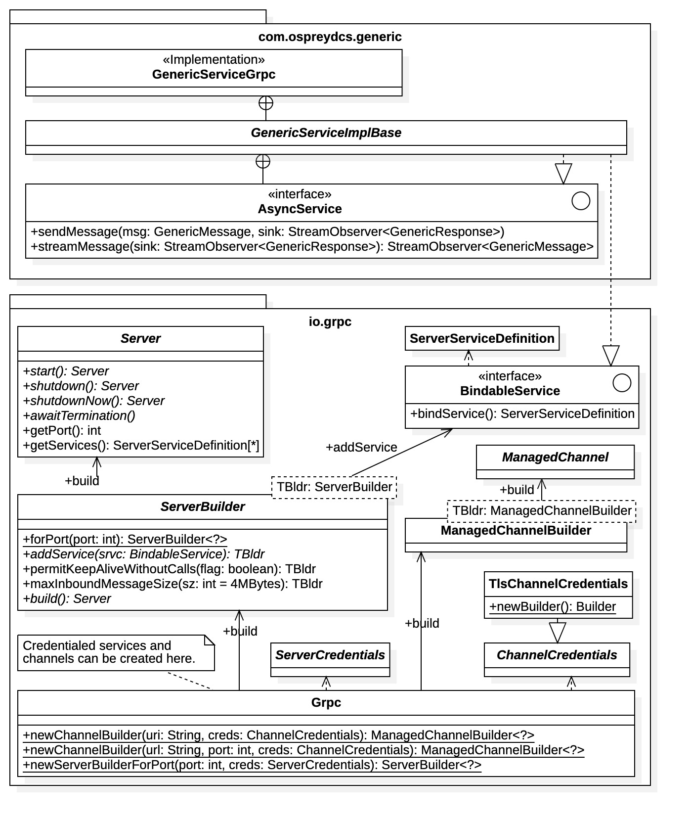

Figure 29: proto example - GenericService.proto required gRPC resources

Figure 29 lists essential resources required for service launch in the Java gRPC implementation. A gRPC server instance is required to launch a service. Server instances, of type io.grpc.Server, are obtained by server builder objects available in the io.gprc Java package. Once a Server object is configured and created, the service is assigned to a specific port address. The Server class provides methods for starting and stopping the attached service. The process is clarified with the help of Figure 29.

Server builder objects, of type io.grpc.ServerBuilder, are created with the Grpc.newServerBuilderForPort() static method. The method requires both a port address and security credentials for the servers to be build, which may be of type InsecureServerCredentials (not shown) indicating no security. Note that the ServerBuilder class also contains a static method for creating insecure ServerBuilder instances, analogous to the ManagedChannelBuilder class. After the ServerBuilder instance is obtained additional server configuration is possible, including timeout limits, server interceptors, and message size limits. The service instance must be attached to the server builder before the gRPC server is created. Once the service instance is attached to the builder, a hosting Server object may be instantiated with the build() method.

##### Credentials

All security credentials for channels and servers inherit from the abstract base classes ChannelCredentials and ServerCredentials, respectively. The specific types of credentials are determined by subclasses. For example, the Transport Layer Security (TLS) protocol for a channel is realized with the class TlsChannelCredentials, as indicated in the Figure 29.

Security credential classes generally require builders to instantiate credential instances. Builders are implemented as enclosed static classes within the credentials class. Then builder instances are available from static methods within the credentials class.

Whenever security is applied to communications, both channel and server must have compatible credentials.

C++ Implementation

The C++ gRPC implementations for the example in CommonMessages.proto and GenericService.proto are shown in the UML diagrams of Figure 30, Figure 31, and Figure 32. The diagrams are not exhaustive, or precise. The C++ gRPC implementation is complex due to the low-level nature of C++, only the essential aspects are given. Many of the precise language details are not presented in the diagrams. For example, most times variable types are precisely listed, but their character is not. Specifically, whether the variable is a pointer, a reference, a pointer reference, etc. Classified variables are also often neglected, such as those defined in the C++ standard library std (e.g., std::unique_ptr<>, std::shared_ptr<>, etc.). Many times, the variable character can be inferred by context, however, it is best to consult the C++ source code. The diagrams are meant to convey the basic features and essential requirements within the C++ implementation.

Messages

The C++ implementation of the CommonMessages.proto example of Figure 20 is contained in files CommonMessages.pb.h and CommonMessages.pb.cc. The classes and types contained in these files (primarily the header file) are shown in Figure 30. Note that all protobuf messages are implemented as C++ classes with the same name, and all inherit from the common base class google::protobuf::Message. The GenericAlarm enumeration is implemented as a C++ enumeration but inherits from the primitive type int and, thus, can be treated as an integer value.

The field attributes of message classes are private. As seen in Figure 30, their implementation is not straightforward, however, attribute values are generally accessed using class “getter” and “setter” functions. The attributes of a message class are always implemented as single enclosed data structure of type Impl_ and name _impl_ (specifically, an anonymous union named _impl_). The Impl_ data structure contains the required message fields plus one additional parameter, the size of the message data which is convenient when monitoring transmission. The _impl_ attribute is private but the enclosing class supplies accessor methods for getting and setting the attribute values.

Aggregated message fields, such as the field data in GenericMessage, are implemented with the google::protobuf::RepeatedPtrField<Element> template class. (Note that string fields are implemented with google::protobuf::internal::ArenaStringPointer class rather than C++ string pointers.) The RepeatedPtrField<> class provides functions for adding message instances to the field, in this case adding GenericData instances to the data field. It also provides functions to retrieve field values from populated message instances.

Referring to the message GenericData, note that message field unions (i.e., fields defined with the oneof modifier) are implemented as unions within the Impl_ data structure. The GenericData class also contains an enclosed enumeration ValueUnion which enumerates all union fields, in this case the possible types of the value_ attribute. The type of the value_ attribute is available with the value_case() function.

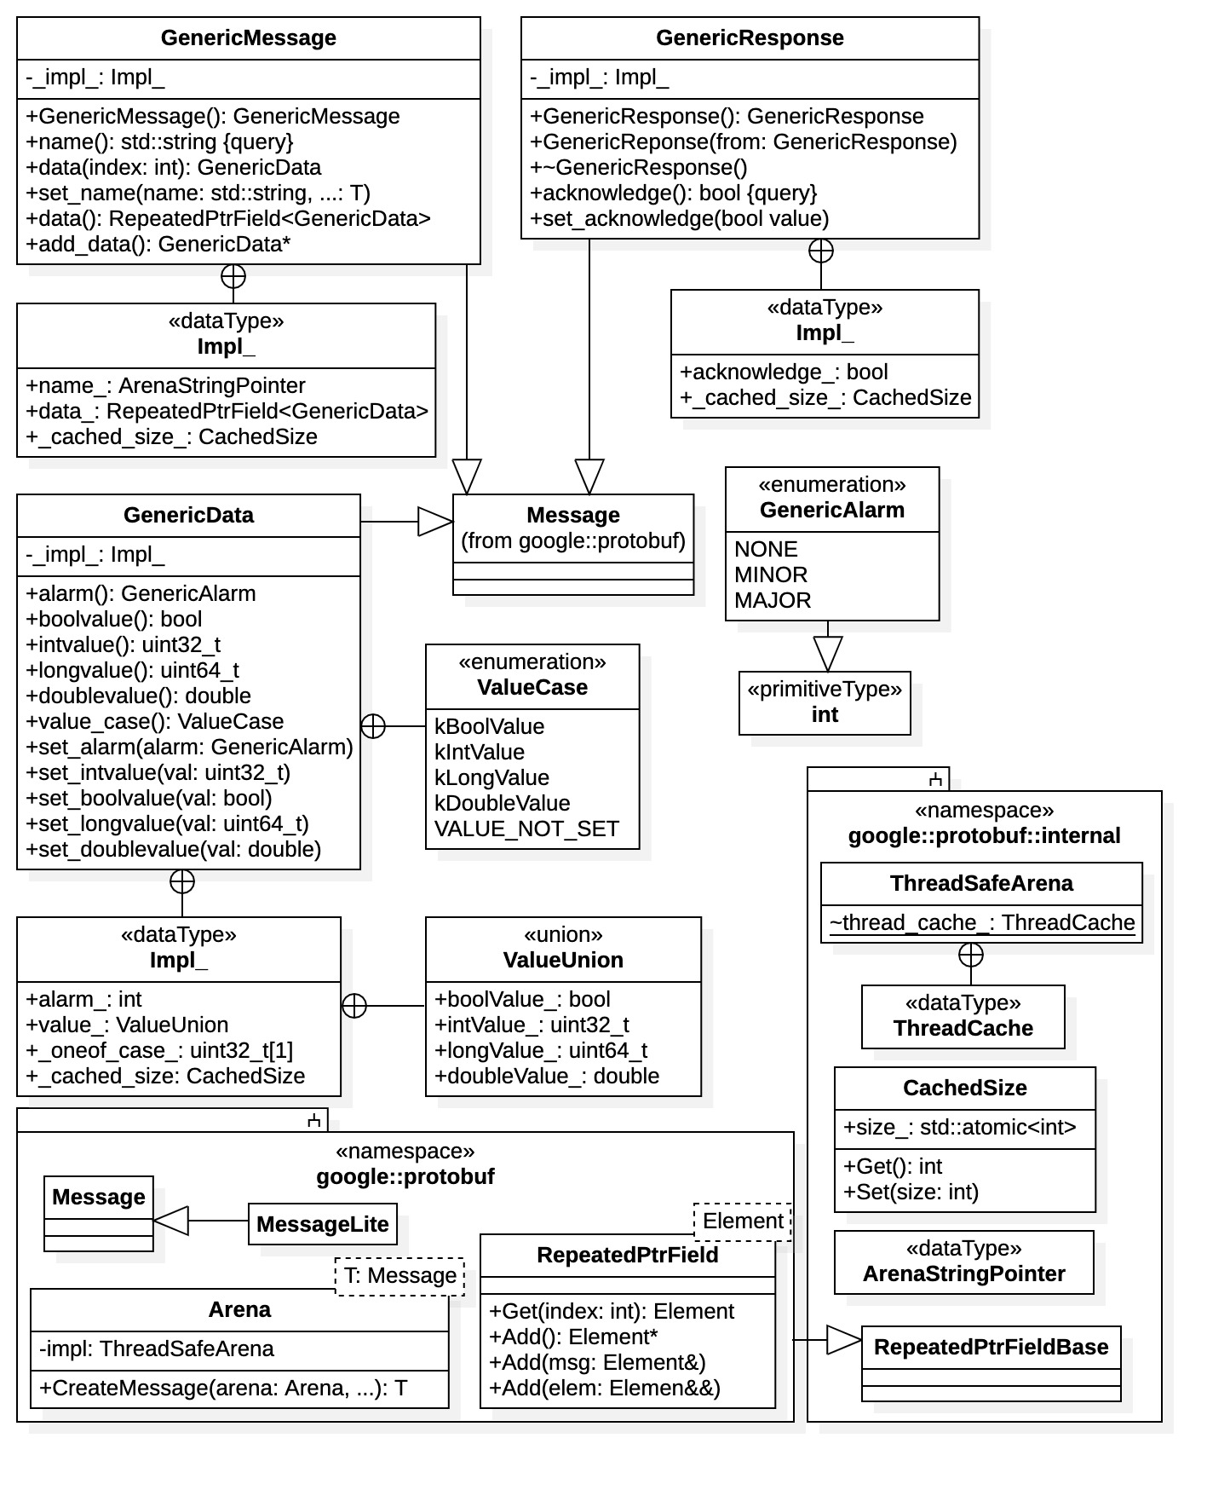

Figure 30: proto example - CommonMessages.proto C++ Implementation

All message classes contain constructors, including a default constructor, that may be used to instantiate message instances. For tighter control of memory resources, messages may also be constructed within a memory heap “arena,” of type google::protobuf::Arena. Instances of RepeatedPtrField may also be created with an arena.

Clients

Client resources for the C++ gRPC implementation are shown in Figure 31. Client gRPC resources are defined in header file GenericService.pb.grpc.h and implemented in source file GenericService.pb.grpc.cc. The diagram also lists many of the gRPC resources generally required by clients to establish network connections and perform RPC operations.

In Figure 31 we see the protobuf generated class GenericService realizes the gRPC interface defined in GenericService.proto. Highlighted in the diagram is the single static function NewStub() which creates the client communications stub. The stub itself is defined as the enclosed static class GenericService::Stub. The class GenericService also encloses the implementation base classes for services (shown in Figure 32). The rest of the diagram contains the gRPC resources necessary to support the communications stub connection and operations.

Unlike the Java gRPC implementation, the C++ implementation has only one type of communication stub, GenericService::Stub. Figure 31 uses a short-hand notation assigning template parameters W and R to the Stub class where, in fact, there are none. This is done simply for brevity. The template parameters are expanded with the bindings W -> GenericMessage and R -> GenericResponse shown in the diagram. Template parameter W indicates message types written by the client and template parameter R indicates message types read by the client.

The communications stub contains four operations, two for synchronous communications with the service, and two for asynchronous communications. Unlike the previous implementations, both the non-streaming operation sendMessage() and the streaming operation streamMessage() are explicitly available for both synchronous and asynchronous communications. The asynchronous operations are always identified with the prefix Async prepended to their original identifier, in this case AsyncsendMessage and AsyncstreamMessage.

All functions within the Stub class require an argument of type grpc::ClientContext. A ClientContext instance simply allows the client to assign additional connection parameters to a given operation, such as timeout limits, credential, and/or compression. ClientContext instances can be created from class constructors, including a default constructor. If no special connection requirements are necessary, an empty ClientContext instance may be offered (i.e., one from the default constructor). ClientContext instances may be used repeatedly.

##### Channels

To create an instance of the communications stub a client must first create the channel connection, represented by the class grpc::Channel. As shown in the Figure 31, static functions for creating channel instances are identified in the C++ header file create_channel.h within the grpc directory. The file contains multiple functions for creating secure channels with various types of security credentials, only the Secure Socket Layer (SSL) credentialing is explicitly shown in Figure 31. Functions for creating the various supported channel credential instances, of base type ChannelCredentials, are found in file credentials.h. Note that the grpc namespace contains the ChannelArguments class which can be used to set various channel properties, such as compression, timeout limits, and maximum message sizes.

##### Synchronous Communication

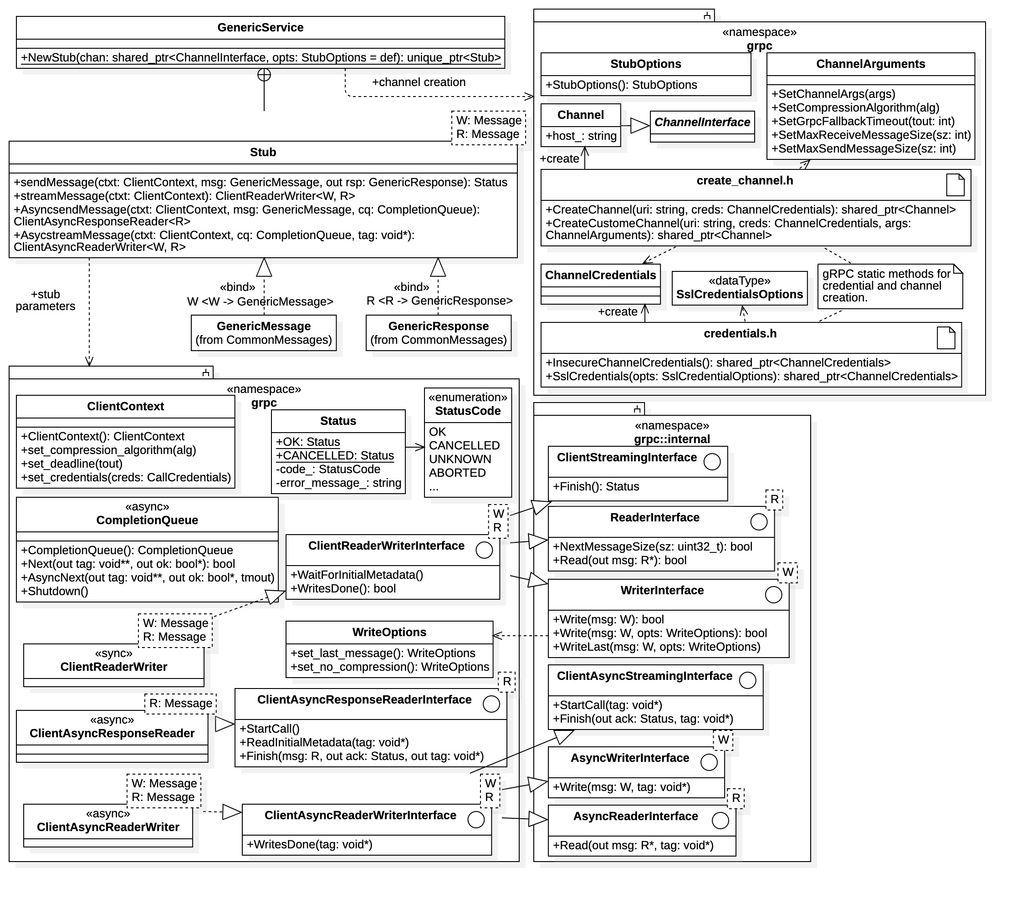

Figure 31: proto example - GenericService.proto client C++ implementation

The Stub class contains both the non-streaming sendMessage() operation and the streaming streamMessage() operation. Note that a ClientContext instance is always passed to any stub operation; this argument is used to add any optional conditions to the specific procedure call (e.g., compression, credentials, timeouts, etc.).

For the non-streaming synchronous remote procedure call sendMessage(), a GenericMessage argument (i.e., a C++ reference) is passed in along with a C++ pointer reference for the GenericResponse message to be received. The operation blocks and does not return until the response pointer is set. Once completed the operation returns a grpc::Status instance containing the condition of the result (e.g., OK, aborted, failed, etc.).

Synchronous bi-directional streaming is provided by the streamMessage() operation. The operation requires only a ClientContext instance as the single argument. The operation does not block, it simply establishes the data stream. To support the data stream, a grpc::ClientReaderWriter<W,R> template class instance is returned (specifically a pointer). The ClientReaderWriter<W,R> class functions as an interface to the service facilitating the data stream. It implements the grpc::ClientReaderWriterInterface<W,R> interface bound by W -> GenericMessage and R -> GenericResponse. Thus, it allows the client to transmit (write) GenericMessage instances to the service while simultaneously receiving (reading) GenericResponse instances as responses. Referring to Figure 31, clients perform the message passing with interface operations Write(W) and Read(R*), respectively. From the diagram, note that these operations are exposed in separate internal sub-interfaces using C++ multiple inheritance. The data stream is terminated when sending the final message with the WriteLast() operation then invoking Finish() once the response is received.

##### Asynchronous Communication

Asynchronous communications are essentially analogous to the synchronous communications described above, but with some added complexity. From the diagram we see that asynchronous operations require the addition of a grpc::CompletionQueue instance, which is used to monitor to the state of the asynchronous connection. Note that CompletionQueue instances may be created as needed using class constructors. They are passed as arguments to the asynchronous operations.

As before, the non-streaming AsyncsendMessage() operation requires an explicit GenericMessage instance as an argument (along with a ClientContext and a CompletionQueue). In this case, however, the operation does not block. Rather than setting a GenericResponse message pointer as with synchronous communication, instead the operation immediately returns a special grpc::ClientResponseReader<R> instance. Again, template parameter R is bound to GenericResponse. The client initiates the response stream by calling the StartCall() operation. The Finish() operation is then used to acquire the actual GenericResponse instance response. The client is free to implement a separate execution thread to recover the result.

The streaming AsyncstreamMessage() operation requires no explicit message argument, only a ClientContext, a CompletionQueue, and the special “tag” argument. Tags are used in C++ data streams to identify messages, in this case the first response of the service. The operation does not block, it simply establishes the bidirectional data stream. Accordingly, a grpc::AsyncClientReaderWriter<W,R>() instance is returned, which is used to manage the asynchronous data stream in conjunction with the CompletionQueue instance. The ClientAsyncReaderWriter<W,R> class operates analogously to the ClientReaderWriter<W,R> class, having similar functions. Note, however, that functions within the ClientAsyncReaderWriter<W,R> class contain the additional tag argument. As previously mentioned, this is a bookkeeping parameter used to identify messages within the data stream and their corresponding response; typically, an integer value is assigned.

Services

The service side C++ gRPC implementation for the GenericService.proto example is shown in Figure 32. The GenericService class contains the two enclosed classes: 1) GenericService::Service and 2) GenericService::AsyncService. The first is an abstract class which must be subclassed to implement a synchronous gRPC service, while the second is a concrete class implementing the asynchronous gRPC service. The diagram explicitly indicates that the synchronous service is implemented with the service subclass SyncServiceImpl; this is provided simply to demonstrate the requirement as noted in the diagram.

Both Service and AsyncService are represented as template classes in the diagram, with template parameters W and R. Again, this is notational short-hand as with the GenericService::Stub enclosed class. However, in these cases the template roles are reversed. Template parameters are expanded with the bindings W -> GenericResponse and R -> GenericMessage, as shown in Figure 32. That is, services are writing GenericResponse instances and reading GenericMessage instances.

The service side implementation for gRPC communications is directly analogous to the client side, with the message roles reversed. Note that all service operations require a grpc::ServerContext argument that can be used to pass optional instructions to the grpc::Server instance hosting the service (the Server class is described below). ServerContext instance can be created from class constructors and instances can be used repeatedly within service operations.

##### Synchronous Communication

Synchronous communications are implemented by inheriting from the base class GenericService:Service. Subclass are required to override the functions sendMessage() and streamMessage().

Referring to the GenericService::Service base class, the non-streaming remote procedure call sendMessage() accepts a GenericMessage input and then sets the pointer to the resultant GenericResponse instance. The operation blocks until the pointer is set. A grpc::Status instance is returned indicating the condition of the operation. The streaming operation, streamMessage(), returns an instance of gprc:ServerReaderWriter<W,R> (specifically an instance pointer), which is an implementation of the ServerReaderWriterInterface<W,R> interface and is used by the service to manage the data stream. It allows the service to read GenericMessage instances and write GenericResponse instances as responses.

##### Asynchronous Communication

Services must inherit from base class GenericService::AsyncService to implement asynchronous communication. Note from Figure 32 that AsyncService inherits from Service, the synchronous base class which includes the synchronous operations sendMessage() and streamMessage(). However, the AsyncService class override these operations replacing them with exception throwing implementations by default. AsyncService child classes can implement alternative behavior.

Seen in Figure 32, asynchronous service operations are always prefixed with the Request label prepended to the original remote procedure call identifier. In our case the asynchronous operations are identified by RequestsendMessage() and RequeststreamMessage() functions within the GenericService::AsyncService class. Asynchronous service communications requires the use of grpc::ServerCompletionQueue instances, which are a subclasses of the grpc::CompletionQueue class. The same ServerCompletionQueue instance can be used for both the CompletionQueue and ServerCompletionQueue typed arguments. As analogous to the client side, the ServerCompletionQueue is used to manage the data stream represented by ServerAsyncReaderWriter<W,R> instance retrieved from the RequeststreamMessage() operation, and also the ServerAsyncResponseWriter<W> instance retrieved from the RequestsendMessage() operation. Again, the asynchronous streaming service communications involve the use of tags to keep track of individual messages within the data stream.

##### Servers

Launching a gRPC service, either synchronous or asynchronous, requires the creation of a grpc::Server instance. Additionally, a grpc::ServerBuilder instance is required to create a Server instance. The ServerBuilder class is defined in header file grpcpp/server_builder.h. Instances of ServerBuilder can be created with the available default constructor. The server builder facilitates the configuration of various server parameters, such as compression, maximum message size, and timeout limits. It also attaches the service to the hosting server with the RegisterService() function, where it is assigned to a port address.

Server security credentials are required to register a service with a ServerBuilder instance. As with client credentials, security credentials are identified by type and credential classes inherit from the base class grpc::ServerCredentials. The file grpccp/security/server_credentials.h contains functions for creating server credentials, as indicated in Figure 32. The diagram explicitly shows the function SslServerCredentials() for creating Secure Socket Layer (SSL) credentials. Note that this function requires and argument of type SslServerCredentialsOptions for specifying SSL parameters. Other credential types follow a similar implementation. Insecure servers can be created using credentials from the InsecureServerCredentials() function.

As mentioned, the listening port for the service is also assigned by the builder. The builder can also create grpc::ServerCompletionQueue instances, which are required to implement asynchronous communication within the registered service. Note that most configuration functions within the ServerBuilder class return its this pointer. Thus, configuration operations can be chained.

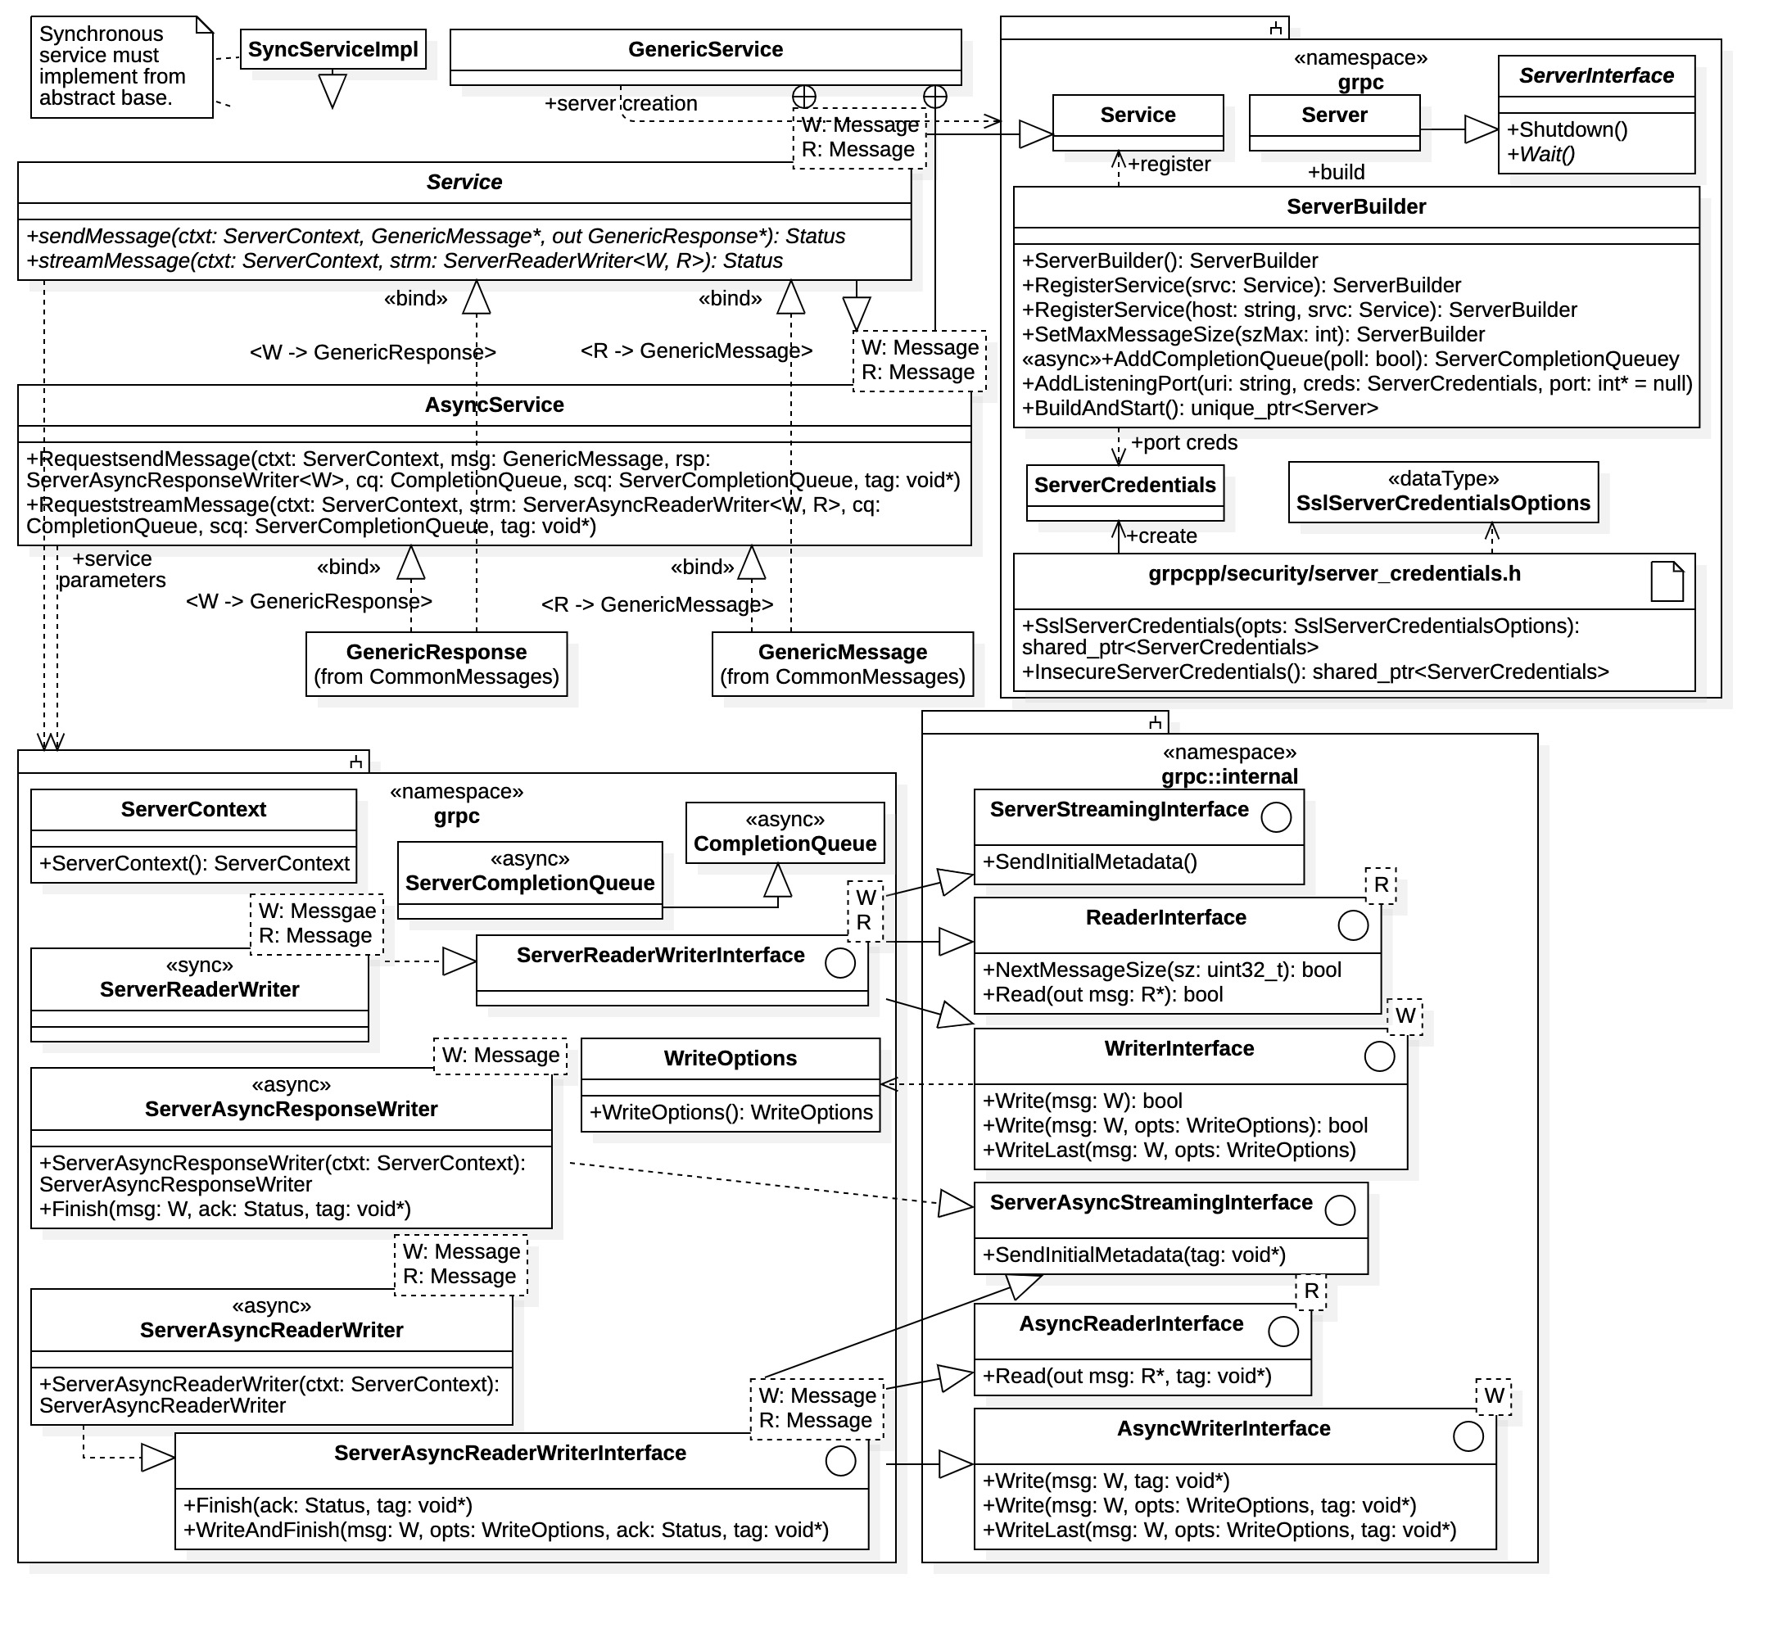

Figure 32: proto example - GenericService.proto service C++ implementation

Once the server is configured by the builder, the service is launched with the BuildAndStart() operation. This operation returns a pointer to the hosting server instance. The service can be explicitly shut down using the Server class Shutdown() function.

Summary

From the above examples we see that gRPC implementations can vary greatly depending upon the choice of programming language. The Python realization appears simplest. This is due to the high-level nature of the language and the loose typing. Since Python is scripted, resources are bound at run time and do not need to be explicitly identified. The Java realization has mid-level complexity. Java is a strongly typed, compiled language, but has many high-level features. Most gRPC resources are accessible in Java, however, at added complexity. All resources must be explicitly identified at compile time. The C++ implementation exhibits the most complexity and requires significant gRPC familiarity for both clients and services. This is especially obvious when directly inspecting the protobuf generated source code, the diagrams presented above only capture the minimum required for application. Note that although C++ is object-oriented, it is relatively low-level, providing the closest proximity to the supporting platform. Thus, although complex, C++ provides the tightest control over the underlying gRPC processes and resources.

It should be again noted that gRPC implementations are platform and language independent. For example, a service implemented in C++ and hosted on a Unix platform is available to any client, on any platform, implemented in any language. Thus, for performance, control, and maintainability, one may wish to implement a service in C++, which is compiled into native executable binary. However, a client unconcerned with performance, may choose to build the corresponding gRPC interface in Python, offering the greatest ease in implementation.